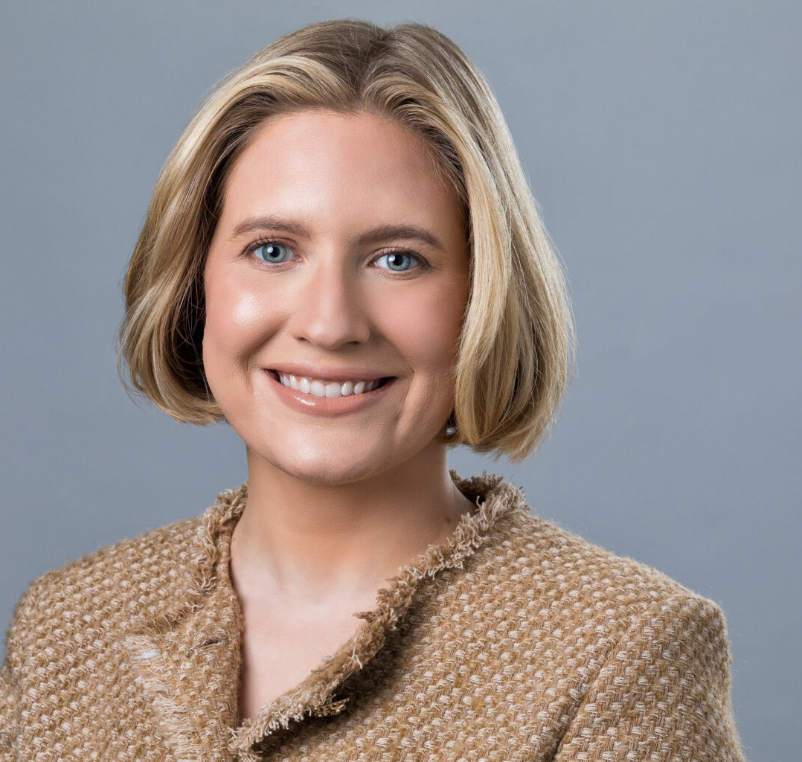

ANDI LEFOR

Associate

[Natural Resources](https://www.fennemorelaw.com/services/natural-resources-energy-and-environmental/)

[Phoenix](https://www.fennemorelaw.com/contact-us/phoenix/)

P: 602.916.5342 F: 602.916.5999

[alefor@fennemorelaw.com](mailto:alefor@fennemorelaw.com)

“

Tell me, what is it you plan to do with your one wild and precious life?

Mary Oliver

**ANDI LEFOR**

”

Andi Lefor is an Associate attorney who works in our firm’s Natural Resources, Energy and Environmental Law practice group from the Phoenix office. Her practice focuses on regulatory matters related to water law issues in the American West.

Andi’s previous experience includes representing business owners and employers in commercial litigation and transactional matters, concentrating on researching and drafting motions and

pleadings. She led the discovery process for several cases, and also worked on transactional matters for her clients, including revising agreements and assisting with compliance and policy issues for a national corporation.

Born and raised in Dickinson, North Dakota, Andi watched her father be active in the community – serving on hospital boards, in the state legislature, and more – and service to others is to this day ingrained in the family. Andi hopes to continue this legacy in her career as a lawyer, in service to her clients and the broader community. She enjoys playing to her strengths: reading and writing, communication, collaborating with others, and breaking down complicated problems into strategic solutions for her clients. In law school, Andi graduated first in her class.

Away from work, Andi reads classic literature and spends as much time as possible with her

husband, a songwriter and producer in the British-American trio [Raynes](https://www.raynesmusic.com/). The couple loves to host sumptuous dinner parties, but be warned: Andi makes a strong drink.

# EDUCATION

J.D., Sandra Day O’Connor College of Law, Arizona State University B.S., *summa cum laude,* University of Mary, Bismarck, ND

# AREAS OF PRACTICE

Natural Resources

# ARTICLES AND PRESENTATIONS

“‘Pulp Fiction’ and Beyond: The Future of NFT Litigation,” *USLAW Magazine*, March 2022

# PROFESSIONAL AND COMMUNITY ACTIVITIES

Member, Arizona Women Lawyers Association Volunteer, Homeless Legal Assistance Project

# ADMISSIONS

Arizona

United States District Court, District of Arizona