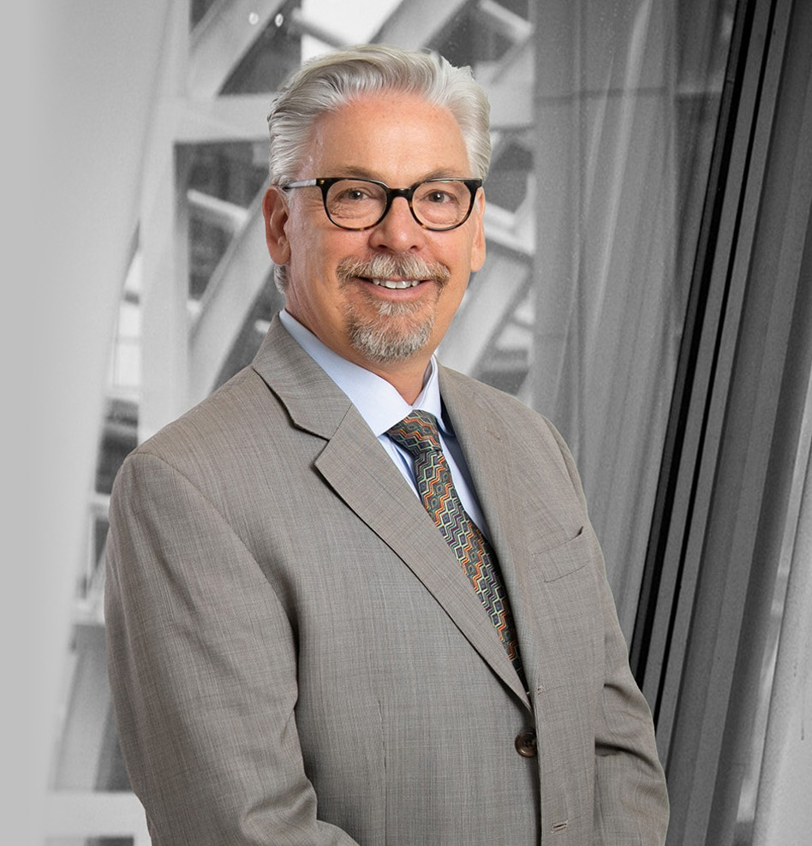

ANTHONY L. GIACOMINI

Of Counsel

[Business Litigation](https://www.fennemorelaw.com/services/business-litigation/)

[Denver](https://www.fennemorelaw.com/contact-us/denver-2/)

P: 303.764.3725 F: 303.291.3201

[agiacomini@fennemorelaw.com](mailto:agiacomini@fennemorelaw.com)

**ANTHONY L. GIACOMINI**

Tony Giacomini is an Of Counsel attorney in our Denver office where his practice focuses primarily on complex business litigation and catastrophic personal injury lawsuits.

Tony often plays a leadership role in class actions and multi-plaintiff “mass tort” matters where the firm’s clients are located in various states around the country. As a result, Tony has become involved in bankruptcies and probate actions in nearly every state in the United States.

He has lectured on the Class Action Fairness Act of 2005, which expanded federal jurisdiction over class action lawsuits and other multiparty claims. Tony has also presented to fellow lawyers his best practices for managing settlements of hundreds of individual claimants.

# EDUCATION

J.D., University of Denver, Sturm College of Law B.A., University of Colorado at Boulder

# AREAS OF PRACTICE

OTHER EXPERIENCE

Emerging Businesses and Technologies Business Litigation

Plaintiff Personal Injury

# REPRESENTATIVE CASES

Was part of a trial team that secured a combined $106 million judgment ($99 million in compensatory and punitive damages and $7 million in attorney fees and litigation costs)

against PNC Bank for breach of trust on behalf of 35 state life and health insurance guaranty associations, NOLHGA, and the Texas Special Deputy Receiver. The litigation arose out of a multi-state fraud scheme involving National Prearranged Services, Inc. (a Missouri-based

preneed funeral contracts seller) and its two related insurance companies domiciled in Texas. PNC’s appeal of judgment is currently pending.

Managed the individual settlements of more than 2,200 claimants who suffered various heart- related personal injuries (including death) from ingestion of a prescription drug widely prescribed for the treatment of Type 2 Diabetes. After a large settlement of these “mass tort” claims was reached, Tony’s job was to see that every claimant was qualified for settlement participation and later to ensure that the net settlement funds were properly distributed. As

such, Tony worked on behalf of his clients to collect their medical records and demonstrate proof of usage and injury, secure disability benefits where applicable, resolve claims for

reimbursement from health insurance providers, and represent them as special counsel in any probate and bankruptcy matters related to individual settlements.

Represented a group of auto dealerships facing a purported class action claiming that new cars were equipped and priced in violation of the Colorado Consumer Protection Act. After winning landmark reversals at the Colorado Court of Appeals and Supreme Court of the trial court’s initial approval of class treatment, Tony and the other trial team members once again defended against Plaintiffs’ renewed attempt at certification of two different proposed consumer classes. This five-year battle for class certification culminated in an extensive four- day evidentiary hearing. Agreeing with the dealership defendants that individual examinations of each car purchase file were necessary and class-wide inferences could not be made, the Jefferson County District Court denied Plaintiffs’ Second Motion for Class Certification on Rule 23 superiority and predominance grounds.

Represented plaintiffs in multiple state class actions brought against regional phone provider

U.S. West (now Century Link) for installation delays experienced by 250,000 customers. The cases resolved when settlements were reached for $36 million in client damages and $7.2 million in attorney’s fees.

Was part of a trial team that twice successfully defeated class certification on behalf of the Old Line Life Insurance Company in a consumer/uniform business practices case filed in state court in California. The matter settled prior to trial.

Sued a regional brokerage firm on behalf of multiple state insurance guaranty associations following the liquidation of Midwest Life Insurance Company. The claims were for fraud and breach of fiduciary duties. After three successful jury trials in Colorado, Washington and a three-month trial in Iowa, the brokerage firm agreed to settle the cases for a combined $30 million.

# AWARDS AND HONORS

*Best Lawyers in America®*, Personal Injury Litigation: Plaintiffs, Mass Tort Litigation/Class Actions – Plaintiffs, 2016-2025

*Colorado Super Lawyers®*, 2012-2022

Star in Colorado-Plaintiff, *Benchmark Litigation,* 2012-2015

Barrister‘s Best Class Action/Mass Tort Lawyer (Plaintiff) by *Law Week Colorado,* 2011, 2012

# ARTICLES AND PRESENTATIONS

Featuring, “Colorado Cases To Watch: A Midyear Report – Defamation Question looms for Class Action Attorneys,” Law360, June 5, 2023

Presenter, “Pharmaceutical Mass Tort Cases: Key Issues from a Plaintiff Perspective,” *Law Education Institute, Inc*., January 2014

Presenter, “Litigation Conference for Attorneys and CPAs,” *Colorado, Inc.,* December 2011

Presenter, “Class Action Update: Today’s Trends & Strategies for Success”, *National Business Institute,* November 2006

Presenter, “Annual Fall Torts Update and Litigation Boot Camp,” CLE in *Colorado, Inc*., Various Dates

# PROFESSIONAL AND COMMUNITY ACTIVITIES

Fellow, Litigation Counsel of America

Board of Directors, Colorado Visiting Nurse Association Board of Directors, Colorado Lawyers Committee

# ADMISSIONS

Colorado

U.S. Court of Appeals, Third Circuit

U.S. Court of Appeals, Tenth Circuit

U.S. District Court, District of Colorado

U.S. District Court, Eastern District of Missouri

U.S. District Court, Eastern District of Pennsylvania

U.S. District Court, Western District of Pennsylvania

U.S. District Court, Western District of Wisconsin