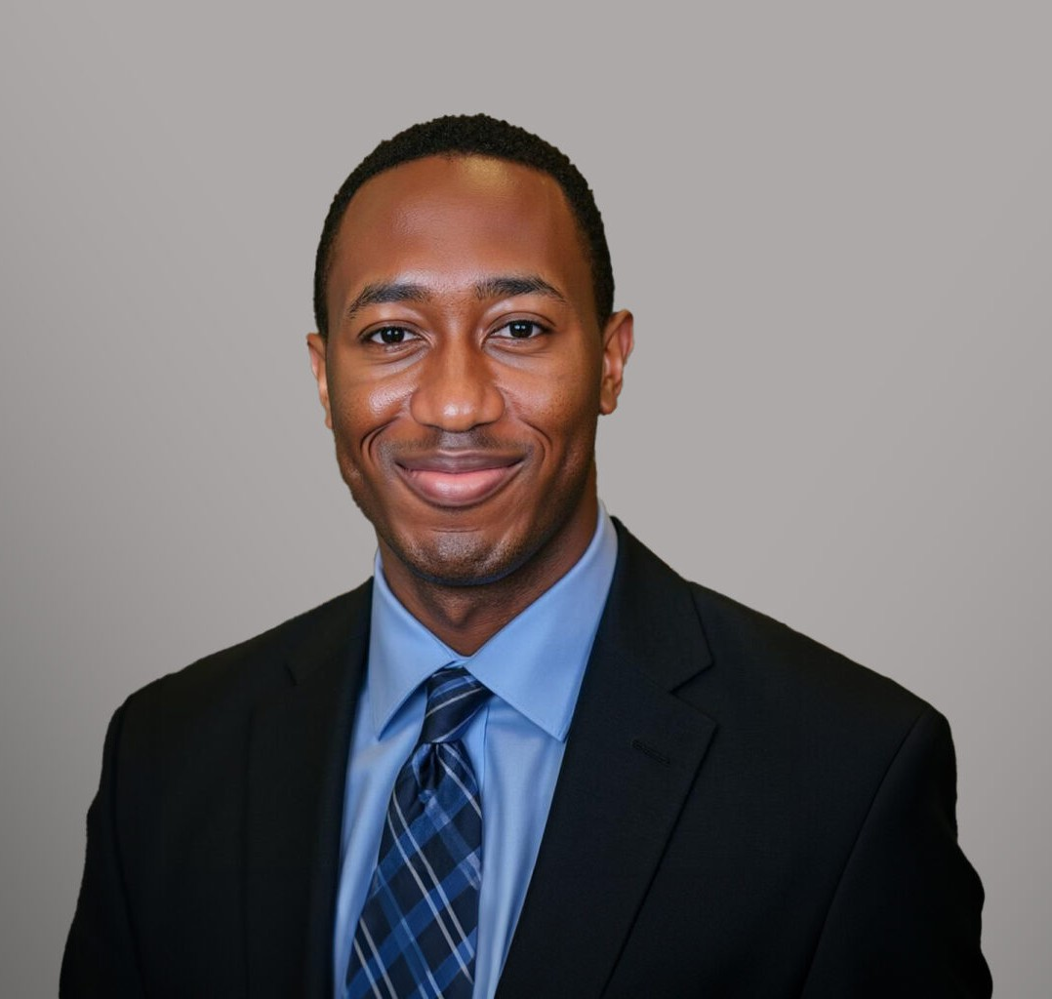

BRANDON PEEVY

Associate

[Business Litigation](https://www.fennemorelaw.com/services/business-litigation/)

[Las Vegas](https://www.fennemorelaw.com/contact-us/las-vegas/)

P: 702.692.8001 F: 702.692.8099

[bpeevy@fennemorelaw.com](mailto:bpeevy@fennemorelaw.com)

# BRANDON PEEVY

Brandon Peevy is an associate attorney in Fennemore’s [Business Litigation](https://www.fennemorelaw.com/services/business-litigation/) practice group.

Brandon received his J.D. from the University of California, Los Angeles School of Law. During his time in law school, Brandon served as the Vice President of Judges on the UCLA Moot Court Honors Board as well as the Chief Managing Editor for the Journal of International Law and Foreign Affairs and a Managing Editor for the Journal of Law and Technology. He also volunteered in two legal clinics while at UCLA: the First Amendment Amicus Clinic and the El Centro Legal Clinic.

Prior to joining Fennemore as an associate, Brandon served as a summer associate in Fennemore’s Las Vegas Office as well as a legal extern at the United States Attorney’s Office for the Central District of California.

# EDUCATION

J.D., University of California, Los Angeles, School of Law B.A., Pomona College

# AREAS OF PRACTICE

Business Litigation

# PROFESSIONAL AND COMMUNITY AFFILIATIONS

Member, Christian Legal Society Member, Federal Bar Association

# ADMISSIONS

Nevada