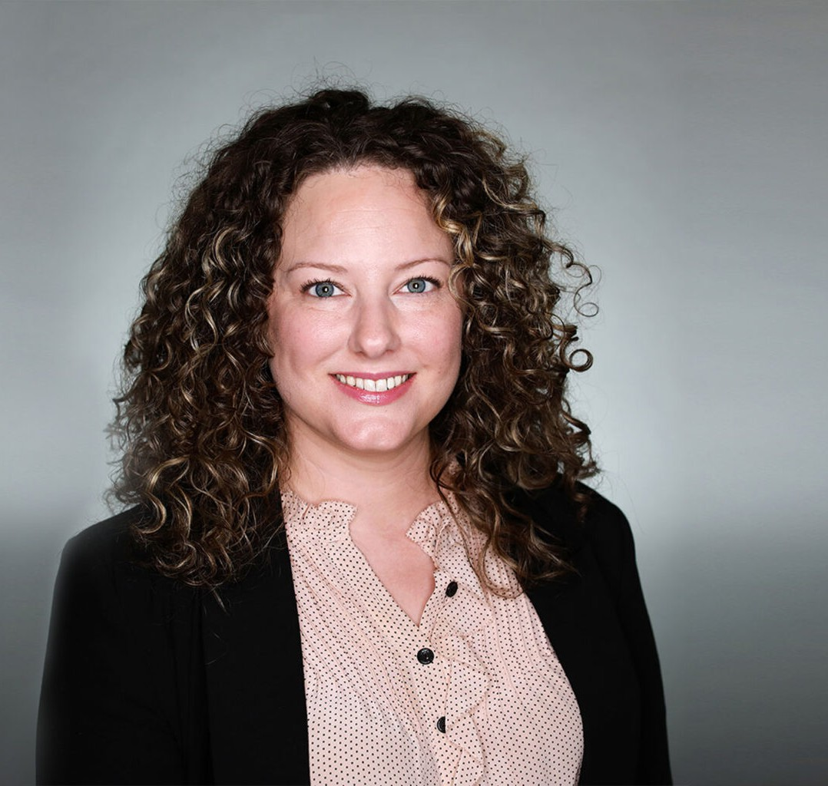

CHELSIE ADAMS

Director

[Business Litigation](https://www.fennemorelaw.com/services/business-litigation/)

[Las Vegas](https://www.fennemorelaw.com/contact-us/las-vegas/)

P: 702.791.8237 F: 702.791.8238

[cadams@fennemorelaw.com](mailto:cadams@fennemorelaw.com)

“

Well done is better than well said.

-Benjamin Franklin

**CHELSIE ADAMS**

”

Chelsie is a trial attorney in our business litigation practice group representing enterprises and individuals in commercial and business litigation matters. With broad experience in federal and state courts, arbitration, and regulatory proceedings, Chelsie frequently represents litigants in construction disputes including claims involving defects and delays, differing site conditions, insurance and indemnification, prompt payment statutes, and liens.

A fourth-generation Nevadan with roots that run deep in her community, Chelsie has an affinity for counseling the entrepreneurs, general contractors, and subcontractors shaping the Las Vegas skyline. Drawing upon her courtroom experience, Chelsie employs a collaborative and considered approach to case management, leveraging technology to efficiently work through the discovery process and enhance courtroom proceedings.

A pop culture maven and gastronome, Chelsie is the one to ask what to stream and where to

dine. She credits her time outside the office enjoying the performing arts, spoiling her nieces and nephews, and exploring the dramatic vistas of the West with giving her the energy to create innovative solutions.

Chelsie is a proud alumna of Leadership Henderson Class of 2021.

# EDUCATION

J.D., Willamette University College of Law B.A., Nevada State College

# AREAS OF PRACTICE

**OTHER EXPERIENCE**

Litigation

Business Litigation

# ARTICLES AND PRESENTATIONS

[Interview, “A conversation on lessons learned & life in the law with attorney Chelsie Adams,”](https://www.fennemorelaw.com/so-long-as-you-have-grit-and-a-growth-mindset-the-opportunities-in-law-are-endless/) [Fennemore Blog, March 16, 2023](https://www.fennemorelaw.com/so-long-as-you-have-grit-and-a-growth-mindset-the-opportunities-in-law-are-endless/)

# AWARDS AND HONORS

*Best Lawyers in America*®, Ones to Watch – Commercial Litigation, Litigation – Construction, 2023 – 2025

*Best Lawyers in America*®, Ones to Watch – Litigation – Real Estate, 2025 “Legal Elite,” *Nevada Business Magazine,* 2018-2020

# PROFESSIONAL AND COMMUNITY ACTIVITIES

Member, State Bar of Nevada

Volunteer, Legal Aid Center of Southern Nevada, Children’s Attorney Project

# ADMISSIONS

Nevada