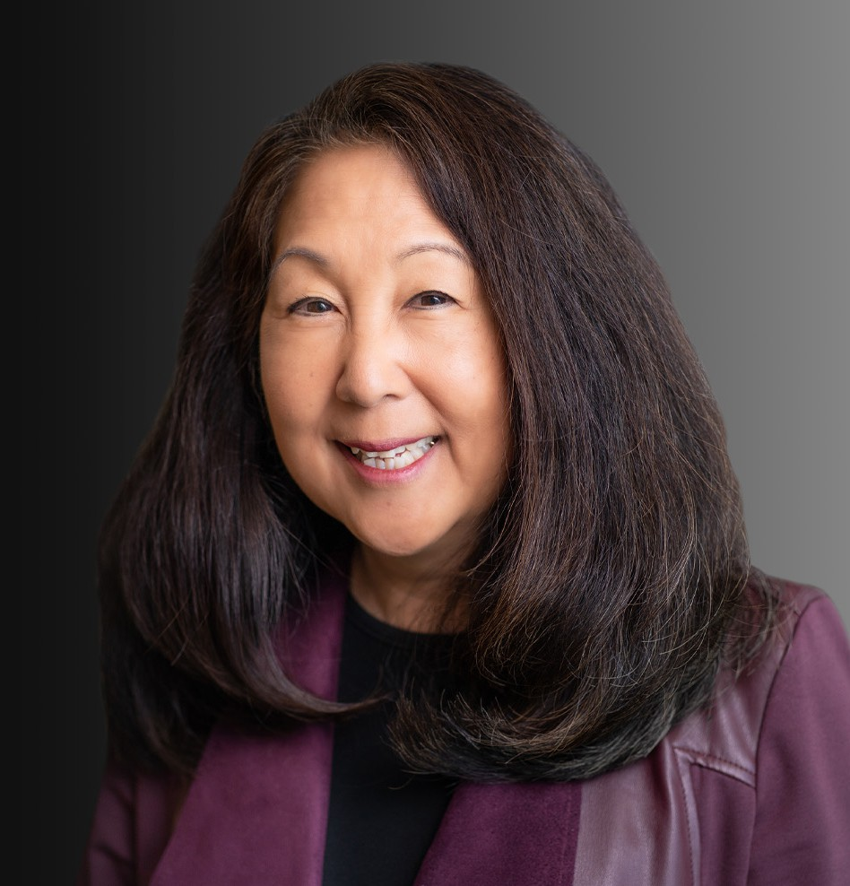

CHRISTINE K. NOMA

Of Counsel

[Natural Resources](https://www.fennemorelaw.com/services/natural-resources-energy-and-environmental/)

[Oakland](https://www.fennemorelaw.com/contact-us/oakland/)

P: 510.834.6600 F: 510.834.1928

[cnoma@fennemorelaw.com](mailto:cnoma@fennemorelaw.com)

“

The future belongs to those who believe in the beauty of their dreams.

- Eleanor Roosevelt

**CHRISTINE K. NOMA**

”

With extensive experience in environmental litigation and compliance and employment law, Chris is an empathetic and pragmatic counselor who represents clients with zealous advocacy.

## Environmental Law

Chris provides environmental compliance counseling and represents clients in cost recovery

litigation, representing both plaintiffs and defendants in CERCLA, RCRA, nuisance and trespass litigation and defense of Clean Water Act lawsuits (a.k.a. citizen’s suit stormwater complaints), as well as disputes involving, real estate purchases/sales, industrial and drycleaner contamination

claims, and claims related to service stations and underground storage tanks. She advises and represents clients before various government regulatory agencies, including the U.S. EPA, California Department of Toxic Substances Control (DTSC), and the California Regional Water Quality Control Board (RWQCB). Chris prosecutes and defends cost recovery claims for owners and operators of contaminated property. For clients selling, acquiring or developing contaminated real property, Chris provides counsel and legal services on a range of matters, including due diligence audits, site investigations, remedial action plans, remediation standards, and indemnity provisions. She also represents parties in obtaining defense and insurance coverage for environmental claims.

## Employment Law

Chris represents employers defending wrongful termination, wage and hour disputes, and

employment discrimination cases in all areas, including claims of sex, age, race, and disability discrimination and harassment. She has represented employers in administration hearings before the Department of Fair Employment and Housing, the Department of Industrial Relations, and Cal OSHA. Chris has presented employment law seminars for employer groups including the City

of Oakland, Northern California Human Resources Council, Oakland Board of Realtors, the Oakland Metropolitan Chamber of Commerce, and private employers. She has also advised businesses regarding personnel practices and the preparation of employment manuals.

## Mediation Experience

Chris is experienced in alternative dispute resolutions and serves as a mediator for the United States District Court, Northern District of California. She has completed the United States District Court, Northern District of California Alternative Dispute Resolution and Early Neutral Evaluation training programs. Additionally, she received the Bar Association of San Francisco Certificates of Completion for training in mediation and arbitration.

# EDUCATION

J.D., University of California, San Francisco, Hastings College of the Law B.S., University of California, Berkeley

# AREAS OF PRACTICE

**OTHER EXPERIENCE**

Public Agency Natural Resources Real Estate

Employment & Labor

# AWARDS AND HONORS

Northern California Super Lawyers®, 2004-2007, 2014-2022

Forever Influential Women in Bay Area Business, *San Francisco Business Times,* 2016 Inaugural Hall of Fame Diversity Award, California Minority Counsel Program, 2014 Distinguished Legal Services Award, Alameda County Bar Association, 2014

Wendel Rosen’s Environmental Practice Group selected as one of top three in the San Francisco Bay Area in The Recorder’s 6th Annual “The Best” survey, 2012

Certificate of Honor, Board of Supervisors, City & County of San Francisco Asian Law Caucus, 40th Anniversary Leadership Committee, 2012

AV® Preeminent™ Peer Review Rated (the highest rating available), by Martindale-Hubbell

# ARTICLES AND PRESENTATIONS

Speaker, “Career Week: Environmental Law Careers,” Alameda County Bar Association, December 14, 2022

Speaker, “Battling Bias: Female Law Firm Partners,” Alameda County Bar Association, July 24, 2018

Speaker, “Immigrant Worker Protection Act: The Challenge of Complying with Conflicting State and Federal Laws,” The American Foundry Society (AFS), April 10, 2018

Speaker, “Employment Law Update & Resources,” City of Oakland, January 25, 2018

Speaker, “A Baby Boomer, a Gen X-er and a Millennial Walk Into a Law Firm,” California Minority Counsel Program Annual Business Conference, October 26, 2017

Speaker, “Crash Course on Employment 101,” Oakland Women’s Retailer Group, September 11, 2017

Speaker, “Higher than a Kite? Bringing the Workplace Down to Earth,” Wendel Rosen Client Seminar, August 23, 2017

Speaker, “Developing California’s Industrial Properties: Environmental Strategies for Real Estate Transactions,” Wendel Rosen Client Seminar, January 10, 2017

# PROFESSIONAL AND COMMUNITY ACTIVITIES

Treasurer and Past President, Asian American Bar Association Law Foundation Member, Board of Directors, Asian American Bar Association Law Foundation Board of Directors, Asian American Bar Association of the Greater Bay Area Member, Asian American Bar Association of the Greater Bay Area

Chairperson, Environmental Bar Section, Alameda County Bar Association

Member, Executive Board, Environmental Law Section, Alameda County Bar Association

Chairperson, Board of Directors, East Bay Diversity Bar Coalition, Alameda County Bar Association

Member, Board Representative, East Bay Diversity Bar Coalition, Alameda County Bar Association

Member, Board of Directors, Alameda County Bar Association President, Board of Directors, Midori Kai, Inc.

Advisor, Language Court Interpreter Advisory Committee, Peralta Community College District Member, Board of Governors, University of California, Hastings Alumni Foundation

Member, Fellow, American Bar Association

Co-Chair, 40th Anniversary Campaign, Asian Law Caucus Former Member, Board of Directors, Asian Law Caucus Founding Member, Fred T. Korematsu Institute for Civil Rights President, Legal Assistance for Seniors

Member, Board of Directors, Legal Assistance for Seniors Evaluator, Judicial Advisory Committee, Senator Barbara Boxer

Evaluator, Judicial Nominees Evaluation Commission, State Bar of California Member, Executive Committee, Conference of Delegates, State Bar of California

# ADMISSIONS

California