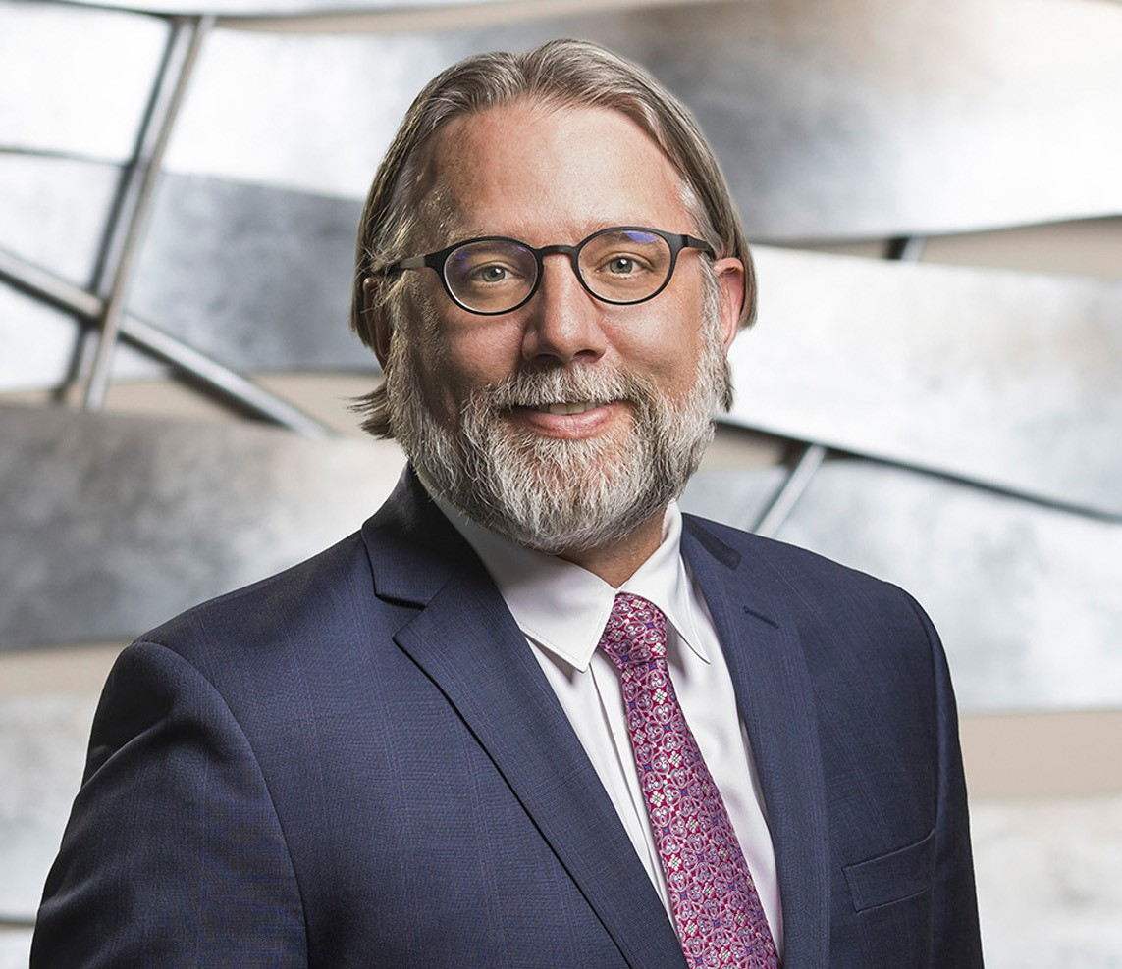

DANIEL C. STEIN

Director

[Business Litigation](https://www.fennemorelaw.com/services/business-litigation/)

[Fresno](https://www.fennemorelaw.com/contact-us/fresno/)

P: 559.432.4500

F: 559.432.4590

[dstein@fennemorelaw.com](mailto:dstein@fennemorelaw.com)

“

Always bear in mind that your own resolution to succeed is more important than any one thing.

- Abraham Lincoln

”

# DANIEL C. STEIN

Dan Stein is a director who works in our Business Litigation practice group out of our Fresno office.

An experienced lead trial attorney, Dan has favorably litigated numerous trials and arbitrations to verdict to help clients successfully navigate challenging lawsuits. He represents clients in a wide range of complex litigation matters, including cases involving the California Environmental Quality Act(“CEQA”), cost recovery cases under the California and Federal Superfund laws, as well as other general business/commercial litigation cases, eminent domain, probate, and construction litigation. Dan represents clients in both civil prosecution and defense cases. Dan is a member of the Fresno County Bar Association and the Environmental Law Section of the California Bar Association.

Growing up in Maine, Dan has always had a strong connection to nature, and in college, he studied politics and philosophy, especially as it relates to environmental issues and advocacy. At the end of college, a professor said to Dan: “I know your future, and it’s going to the Vermont

Law School to become a litigator.” Dan actually took a gap year and fought this proposed

direction, until ultimately becoming exactly what his mentors in both college and law school had envisioned for his life and career. Dan practices with a steadfast belief that, as lawyers, we are

also counselors at law to clients. In order to fulfill that role and obligation, he connects with his clients in meaningful ways to better understand them and their goals to craft effective strategies that will help solve their legal challenges. As a zealous advocate, he listens and believes in the people he works for – and he likes to win.

Outside of work, Dan still unplugs in the outdoors where he loves fly-fishing, hunting, hiking, golfing and spending time working on his growing collection of bonsai trees. Dan and his fiancé are both accomplished musicians with Dan playing in two bands; one a bluegrass outfit full of

high energy and fast rhythms, and the other a folk-rock band featuring Dan’s guitar work and smooth harmonies.

# EDUCATION

J.D., Vermont Law School

M.S.E.L., Vermont Law School B.A., Catawba College

# AREAS OF PRACTICE

Business Litigation Eminent Domain

# PROFESSIONAL AND COMMUNITY ACTIVITIES

Member, California Bar Association

Member, Environmental Law Section of the California Bar Association Member, Fresno County Bar Association

Member of Real Property and Trust and Estates Sections of the Fresno County Bar Association Member of the Board of Directors, Fresno Philharmonic Orchestra

# ADMISSIONS

California

U.S. District Court, Central District of California

U.S. District Court, Eastern District of California

U.S. District Court, Northern District of California