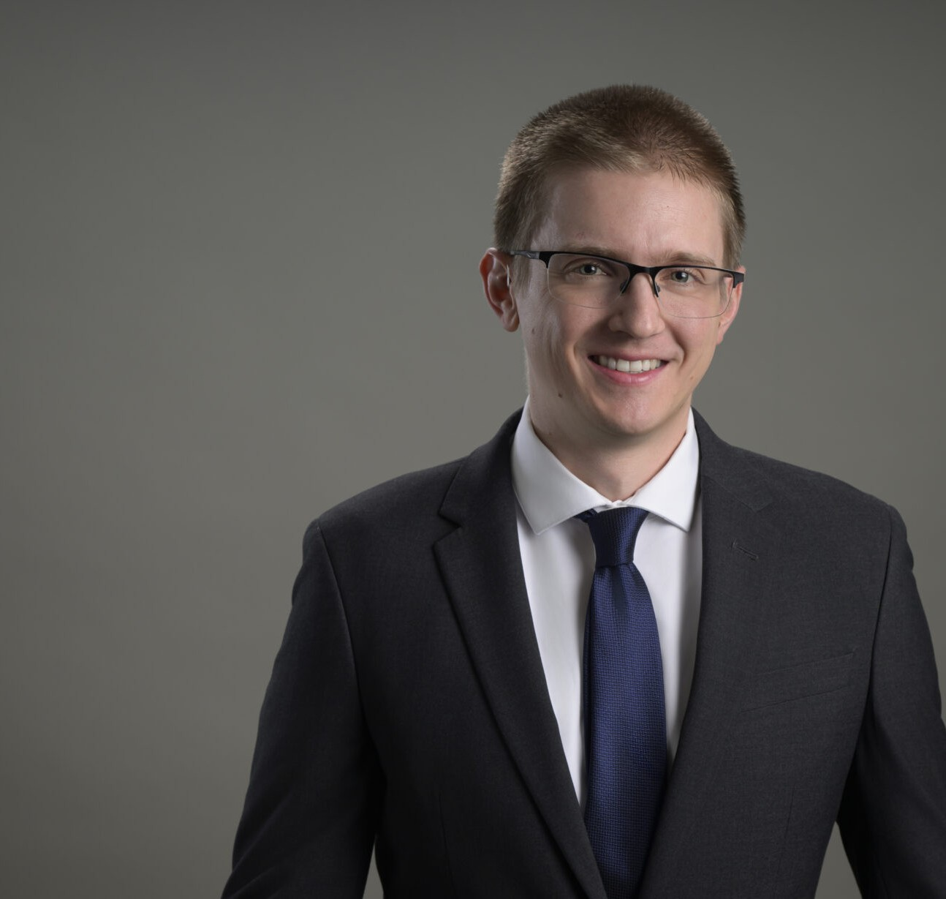

EVAN KLOUSE

Associate

[Natural Resources](https://www.fennemorelaw.com/services/natural-resources-energy-and-environmental/)

[Reno](https://www.fennemorelaw.com/contact-us/reno/)

P: 775.788.2201 F: 775.786.1177

[eklouse@fennemorelaw.com](mailto:eklouse@fennemorelaw.com)

# EVAN KLOUSE

Evan focuses on natural resources and environmental law, where he applies his engineering knowledge to address the complex legal challenges faced by clients in these sectors. His analytical skills and practical approach make him a vital resource for clients navigating

regulatory, environmental, and operational issues.

Evan’s prior experience includes roles in underground mine engineering and public works civil engineering . These positions have provided him with a deep understanding of the technical and operational aspects of the natural resources sector, which he now leverages in his legal career.

In addition to his professional pursuits, Evan is passionate about outdoor activities such as hiking, running, and swimming. He also enjoys playing guitar and spending time with his family.

# EDUCATION

J.D., University of Arizona James E. Rogers College of Law, *summa cum laude*

B.S., University of Nevada, Reno, *summa cum laude*

# AREAS OF PRACTICE

Natural Resources Business & Finance

# ADMISSIONS

Arizona Nevada