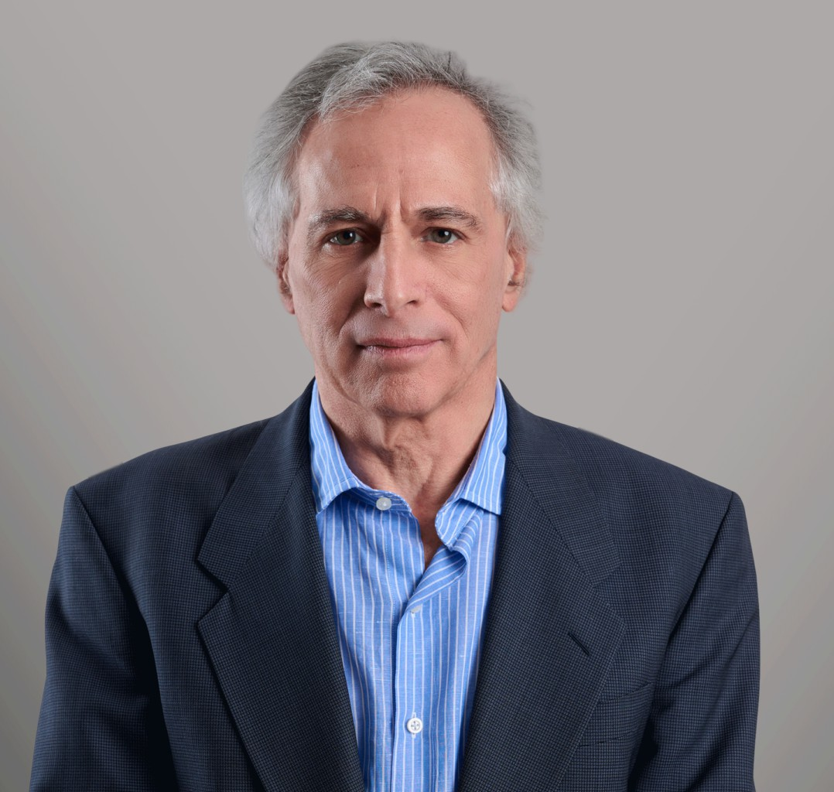

JAMES P. SAVITT

Director

[Business Litigation](https://www.fennemorelaw.com/services/business-litigation/)

[Seattle](https://www.fennemorelaw.com/contact-us/seattle/)

P: 206.749.0500 F: 206.749.0600

[jsavitt@fennemorelaw.com](mailto:jsavitt@fennemorelaw.com)

“

Thunder is good, thunder is impressive; but it is the lightning that does the work

Mark Twain

”

# JAMES P. SAVITT

Jim Savitt specializes in the trial and creative resolution of substantial disputes for a diverse client base, including Fortune 500 companies and major e-commerce firms. While much of his practice has focused on intellectual property, corporate, and commercial matters, Jim believes that knowing how to win a case – developing and executing a strategy to prevail by motion if possible and by trial if not – is the most important skill of a lawyer handling complex litigation.

Before joining Fennemore, Jim was a co-founder of Savitt Bruce & Willey LLP, a highly regarded litigation boutique in Seattle, and previously was a partner in Perkins Coie. Jim began his career with Paul, Weiss, Rifkind, Wharton & Garrison in New York City before finding his way to the Great Northwest. He is a graduate, *magna cum laude*, of the Georgetown University Law Center.

Outside of the office, Jim served as the Chairperson of the Pike Place Market Preservation &

Development Authority (which owns and operates Seattle’s famed Pike Place Market) and is a past President of the Federal Bar Association of the Western District of Washington.

# EDUCATION

J.D., Georgetown University Law Center, *magna cum laude*

B.A., Cornell University

# AREAS OF PRACTICE

Business Litigation Intellectual Property

Cannabis Business

# REPRESENTATIVE MATTERS

***Pike Place Market Preservation & Development Authority v. Pike Place Fish Company.*** Action to enforce crucial trademark for Seattle’s most famous landmark and attraction; prepared motion for preliminary injunction that enabled settlement in which defendant conceded our client’s trademark rights and ownership and relinquished its claims to disputed marks.

***Dental Health Services v. Miller.*** Defended departing executive against trade secret theft claims; obtained dismissal of all claims with prejudice following discovery.

***Move Inc. (Realtor.com) v. Zillow.*** Defended senior executive against misappropriation claims in largest trade secret action brought in Washington; defended client in muti-week spoliation trial, obtained summary judgment on purported trade secret document, and then obtained favorable settlement.

***Quackenbush v. Lehua USA.*** Prosecuted trade secret theft and trademark infringement claims for major cannabis industry player, and defended against employment and defamation claims; obtained preliminary injunction ordering the immediate return of intellectual property and equipment, and the cessation of use of client trade secrets and

trademarks, and then a permanent injunction against trade secret or trademark use and the dismissal of all claims against our clients.

***Alliance Packaging v. Altivity Packaging, et al.*** Prosecuted patent infringement claims relating to retail product packaging; prevailed at Markman hearing, defeated defendant’s summary judgment motions and prevailed on motions for partial summary judgment and motions dismissing counterclaims, and then obtained favorable settlement.

***Straitshot Communications v. Telekenex, Inc..*** Prosecuted corporation’s claims for trade secret misappropriation, tortious interference, Consumer Protection Act violations, and breach of

employment agreements and of duty of loyalty; obtained mutil-million judgment at jury trial.

***Amazon v. Expedia.*** Defended claims and prosecuted counterclaims for breach of linking and co-branding agreement between national e-commerce giants; defeated motions for summary judgment, developed counterclaims, and then obtained favorable settlement.

***Moomjy v. HQ Sustainable Maritime Inc.*** Defended class action against public offering underwriters alleging claims under sections 11 and 12 of Securities Act; brought motion to dismiss and then obtained favorable settlement dismissing all claims against clients without any payment on claims.

***Weld v. Dawson.*** Defended claims for breach of fiduciary duty, minority shareholder

oppression, and violations of Blue Sky laws against senior corporate officer; obtained dismissal of all claims against client on motion to dismiss.

***Garrett v. Swedish Health Services.*** Defended group of physicians against claims for breach of fiduciary duty and contractual obligations arising out of joint venture; obtained dismissal of all claims against client by summary judgment and also favorable settlement from co-defendant on affirmative claims.

***Bank One v. Westar Financial Services.*** Defended breach of contract and lender liability claims relating to multi-billion dollar auto lease securitization portfolios, and prosecuted counterclaims for securities fraud and breach of contract; obtained preliminary injunction, obtained dismissal of all claims against bank by summary judgment, and then obtained favorable settlement on counterclaims.

***Stilwell Value Partners v. First Financial Northwest.*** Defended claims against inspector of elections alleging improprieties in corporate election following proxy fight; obtained summary judgment dismissing key elements of claims, and then dismissal of all claims with prejudice as part of favorable settlement involving no concessions from client.

***Investigations regarding Washington Mutual Bank.*** Represented former Washington Mutual officers in regard to investigations by FDIC, United States Attorney, and United States Senate Permanent Subcommittee on Investigations regarding failure of Washington Mutual Bank, including testimony before United States Senate subcommittee.

# ARTICLES AND PRESENTATIONS

Co-Author, “[Statutes of Limitation: Washington, Practical Law](http://us.practicallaw.com/w-000-2463),” Thomson Reuters, January 7, 2021

Presenter, “Finessing the Fine Print: Agreements to Arbitrate and Covenants not to Compete,” Washington Association of Corporate Counsel, 2014

Presenter, “Covering Your Bases: Practical Tips to Deal with and Avoid Litigation,” Washington Association of Corporate Counsel, 2013

Chair and Presenter, “Annual Federal Practice CLE,” Federal Bar Association of the Western District of Washington, 2005-2007

Contributing Author, “Litigating Year 2000 Cases,” West Group, 1999 Speaker at Continuing Legal Education seminars

# AWARDS AND HONORS

Selected to *Best Lawyers in America*, 2014-2025

Ranked in *Chambers USA Guide to Leading Lawyers*, 2013-2024 Selected to *Washington Super Lawyers*, 2003-2024

Selected to *Washington Super Lawyers Top 100* List, 2007, 2010-2024 Litigation Counsel of America (LCA), Fellow

American Bar Foundation, Life Fellow

Named “Lawyer of the Year” by *Best Lawyers in America* for Bet-the-Company-Litigation in Seattle, 2021

Named one of “Washington’s Most Amazing Attorneys,” *Washington CEO* magazine, 2006 Selected to Washington Rising Stars, 2000

AV Preeminent Rating from Martindale-Hubbell (5.0 out of possible 5.0 peer review rating)

10.0 Rating from Avvo.com

# PROFESSIONAL AND COMMUNITY ACTIVITIES

Chairperson, Pike Place Market Preservation & Development Authority, 2009-2013 Councilmember (Mayoral appointee), 2006-2018

President, Federal Bar Association of the Western District of Washington, 2011-12 Member, Board of Directors, Delta Society, Inc., 1991-1997, 2001-2007

Member, Board of Trustees, Washington Biotechnology Foundation, 1997-2005

President of the Board, Tribes Project, Inc., 1999-2001 Member, Leadership Tomorrow, 1996-1997

Member, Section of Litigation, American Bar Association, 1999-present Member, Diversity Law Institute

Member, Trial Law Institute

# ADMISSIONS

Washington

United States Supreme Court

United States Court of Appeals, Ninth Circuit

United States District Court, Western District of Washington United States District Court, Eastern District of Washington United States District Court, Southern District of New York United States Court of Federal Claims