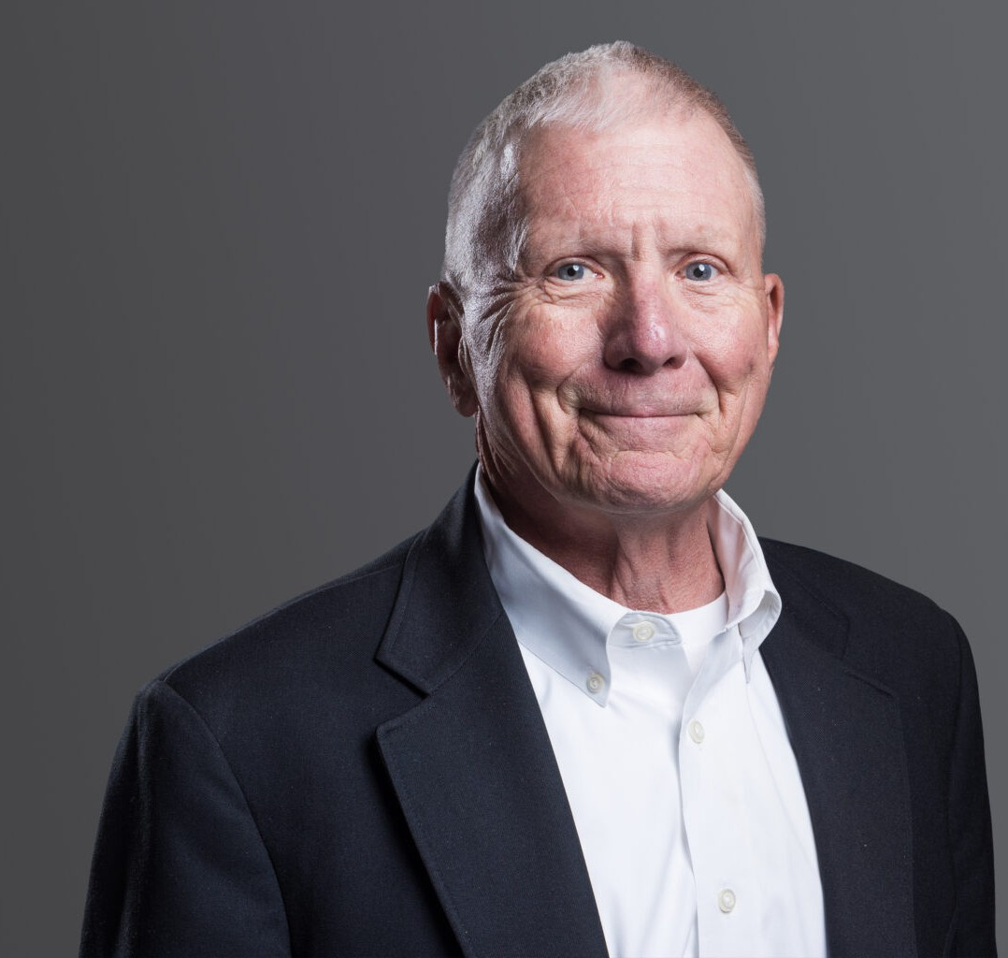

JAMES R. CAGE

Of Counsel

[Business Litigation](https://www.fennemorelaw.com/services/business-litigation/)

[Denver](https://www.fennemorelaw.com/contact-us/denver-2/)

P: 303.813.3809 F: 303.291.3201

[jcage@fennemorelaw.com](mailto:jcage@fennemorelaw.com)

**JAMES R. CAGE**

For more than 45 years, Jim has provided outstanding representation in complex litigation matters before federal and state courts and administrative tribunals.

Experienced and highly versatile, Jim counsels plaintiffs and defendants in general commercial, banking, civil, construction, employment, and equine litigation. He offers specific experience in matters involving shareholder disputes, contracts, receiverships, employment discrimination, and labor relations, as well as occupational health and safety concerns.

An expert in equine law, Jim’s practice encompasses business risk management, contracts, liability waivers, and regulatory matters, as well as personal injury and malpractice defense of the equine industry.

Jim also serves as a strategic advisor on issues related to agricultural law, intellectual property, product liability, breach of duty, bad faith, real estate disputes, and securities fraud.

With an extensive knowledge of both the law and its practical applications in the commercial marketplace, Jim works with individual and corporate clients to resolve disputes through trial, appeal, arbitration, or mediation.

Before joining the firm, Jim was the lead partner in the Denver-based law firm of Cage Williams

P.C. for 17 years. He has earned an “AV” Preeminent rating for both legal ability and ethical standards from Martindale-Hubbell, the directory’s highest rating for attorneys.

Outside the courtroom, Jim enjoys spending time with his family, as well as a variety of horseback-related activities including polo, fox hunting, trail riding, and breaking and training horses. He is a lecturer and instructor and donates pro bono legal services to religious,

educational, and nonprofit organizations.

# EDUCATION

J.D., University of Missouri-KC, with distinction Managing Editor, Law Review

B.S., Southwest Missouri State University

# AREAS OF PRACTICE

Business Litigation

# PROFESSIONAL AND COMMUNITY AFFILIATIONS

Member, Colorado Bar Association Member, Colorado Cattlemen’s Association Member, Colorado Contractors Association Member, Denver Bar Association

Member, Denver Metro Chamber of Commerce Member, National Western Scholarship Trust Member, National Western Stock Show

Member, Roundup Riders of the Rockies

# AWARDS AND HONORS

Benchmark Litigation: Local Litigation Star – General Commercial Litigation, Construction Litigation, and Intellectual Property Litigation 2020 – 2024

Best Lawyers®: Commercial Litigation and Litigation – Banking and Finance, 2023 – 2025

Colorado Super Lawyer: Civil Litigation, 2008, 2010 – 2015; 2020; General Litigation, 2021 – 2022 Martindale-Hubbell Rating: AV® Preeminent™

# ADMISSIONS

Colorado

U.S. Court of Appeals, District of Colorado