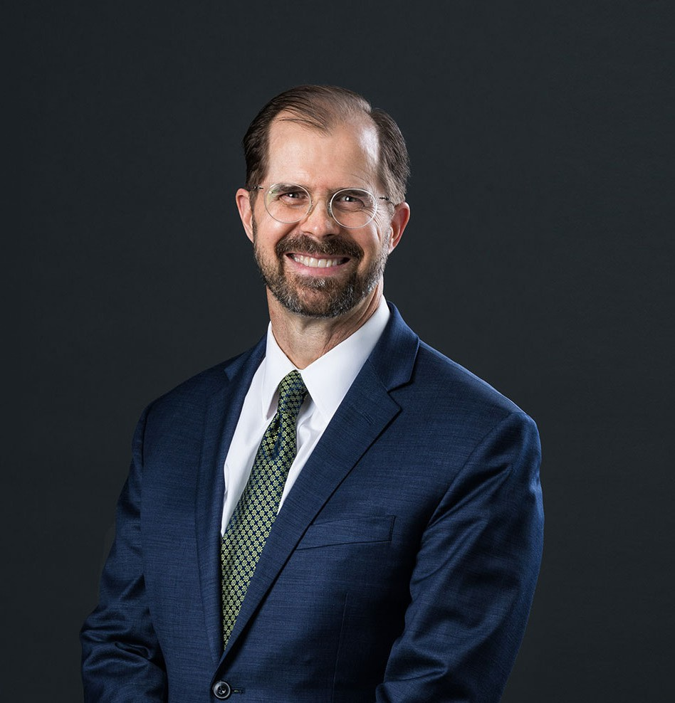

JEFFREY S. PITCHER

Director

[Real Estate](https://www.fennemorelaw.com/services/real-estate/)

[Phoenix](https://www.fennemorelaw.com/contact-us/phoenix/)

P: 602.916.5307 F: 602.916.5507

[jpitcher@fennemorelaw.com](mailto:jpitcher@fennemorelaw.com)

“

The way to get started is to quit talking and begin doing.

-Walt Disney

**JEFFREY S. PITCHER**

”

Jeff Pitcher is a director in our real estate practice group where he works as a transactional attorney and an outside general counsel. His practice focuses on institutional and other lenders, and his experience covers a wide range of both conventional and complex lending

transactions, including real estate and transactional finance and financial restructuring. He represents some of the country’s largest financial institutions, as well as local community banks and credit unions, in originating complex secured real estate loans, construction loans, warehouse lines of credit and a variety of other asset-based lending transactions.

From a very early age, Jeff knew that he wanted to be an attorney – with the ability to help people through a lawyer’s specific skill set. Throughout his career, Jeff has acquired extensive experience in multi-state and multi-party real estate and lending transactions, including loans secured by shopping centers, office buildings, multifamily properties, industrial facilities, residential communities, hotels, grocery stores, mini-storage facilities and other real estate and related assets. Jeff also assists lenders and CMBS Special Servicers in intelligently and creatively managing their existing loan portfolios and related risks, crafting specialized loan participations and syndications, making loan modifications, negotiating and documenting workouts, procuring deeds in lieu of foreclosure, obtaining the appointment of qualified receivers and executing both judicial and non-judicial foreclosures. He takes great pride in helping his clients meet their objectives and goals.

In addition, Jeff advises and negotiates on behalf of property owners and owners of master- planned and mixed-use developments, retail, medical, industrial and office buildings, and other types of commercial real estate on a variety of issues involving property purchase and sale

transactions, real estate development and commercial leasing.

Married with four grown children, outside of work you’ll probably find Jeff planning his next travel adventure. Japan is perhaps his favorite place on earth, and fluent in Spanish, the country of Spain also holds a special place in his heart.

# EDUCATION

J.D. ,Brigham Young University, J. Reuben Clark Law School B.A., University of Utah

Associate Editor, *Brigham Young Journal of Public Law*

# AREAS OF PRACTICE

Real Estate Business & Finance

Financial Restructuring

# REPRESENTATIVE CASES

## Leasing

Represented the Arizona Department of Administration on behalf of the Arizona Department of Health Services in connection with the sublease of St. Luke’s Medical Office Building

Represent the Arizona Department of Administration on behalf of the Arizona Department of Health Services in the connection with the sublease of the Tucson Convention Center

Represent a commercial developer for 15 years in the acquisition, development and leasing of various multi-tenant industrial facilities including a four building, 340,000 square foot,

development in Phoenix, Arizona

Represented the owner of a multi-tenant medical office building for the past fifteen years

## Lending

Represents special servicers in loan workouts, mediation, loan sales and foreclosures of residential properties across Arizona, Nevada and Utah

Represented a commercial lender on a $50 million loan on a golf course and fractional- interest project. He also represented a lender in the foreclosure of a $95 million resort.

Represent the lender in connection with the drafting and negotiation of more than 40 real estate secured loans, loan amendments and loan participations in the last two years including most recently, a $125 million construction loan, $19.5 billion, term loan, and a $6.5 million construction loan

Represent the lender in connection with the drafting and negotiation of a $20.5 million real estate secured construction loan

## Acquisition and Development

Assisted the buyer in connection with the $60 million acquisition of an approximately 900,000 square foot warehouse building

Assisted the buyer in connection with the $65 million acquisition of a mixed use office complex

Represent the developers in connection with sale and purchase of more than 450 residential subdivision lots this year

# AWARDS AND HONORS

*Best Lawyers in America®*, Real Estate Law, 2013-2025

*The Legal 500 US*, Energy-Renewable/Alternative, 2014-2015

Ranking Arizona: The Best of *Arizona Business*,” Construction and Real Estate Law, 2011

AV® Preeminent™ Peer Review Rated (the highest rating available), by Martindale-Hubbell

# ARTICLES AND PRESENTATIONS

Featuring, “Here’s How a Developer Became a Big Name in the Receivership Business,” CoStar, May 30, 2023

Quoted, “Your Business & the Law Attorneys help businesses stay on top of social and regulatory change,” inBusiness, May 2022

Lecturer, “Commercial Real Estate Loan Documentation from Start to Finish”, National Business Institute, 2016, 2018

Contributing Author, “Trigild Deskbook, a Guide to Receivership & Foreclosure, Seventh Edition”

Lecturer, Arizona School of Real Estate and Business, on various real estate, lending and workout topics

Jeff regularly provides his clients with in-house seminars and presentations on topics requested by the clients, addressing topics that include current loan issues and underwriting best

practices. Jeff also works with clients to provide legal updates and related training. Jeff regularly presents in-firm continuing legal education to associates and paralegals.

# PROFESSIONAL AND COMMUNITY ACTIVITIES

Member Greater Phoenix Economic Council

Member and former Chairman of the Mesa Economic Development Advisory Board

# ADMISSIONS

Arizona Utah