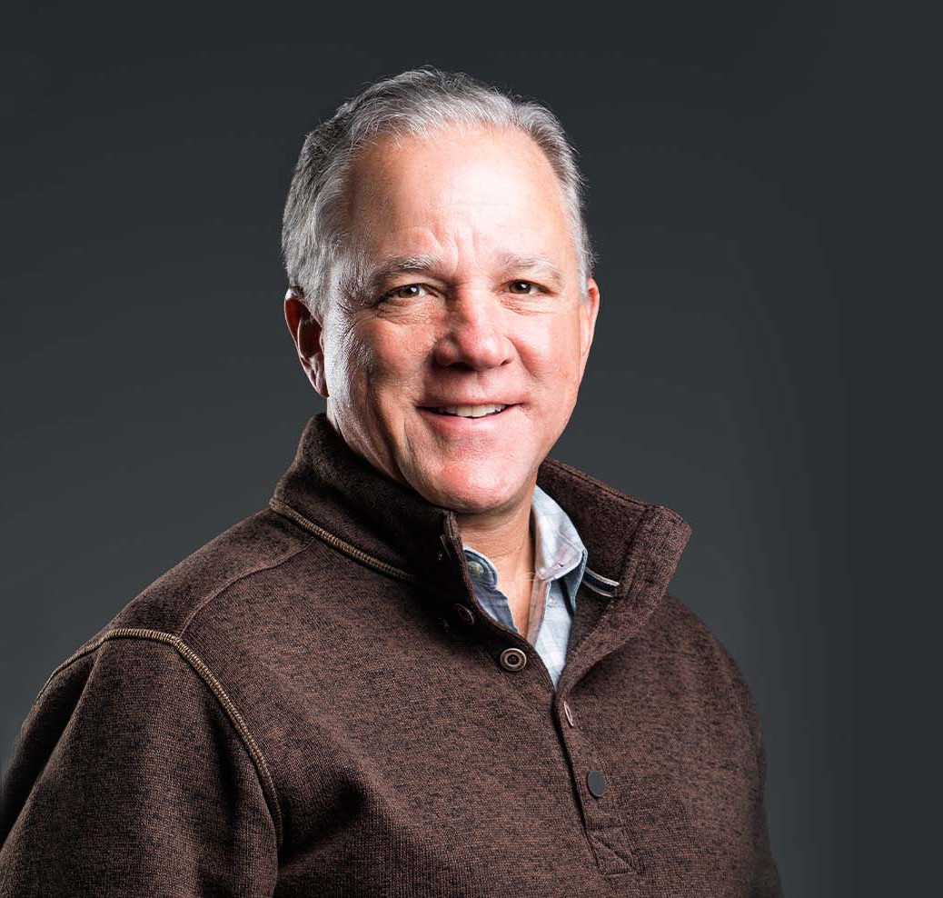

JOHN P. KAITES

Of Counsel

[Business & Finance](https://www.fennemorelaw.com/services/business-and-finance/)

[Phoenix](https://www.fennemorelaw.com/contact-us/phoenix/)

P: 602.916.5498 F: 602.916.5698

[jkaites@fennemorelaw.com](mailto:jkaites@fennemorelaw.com)

**JOHN P. KAITES**

John focuses his practice in global security, business and finance, business and government negotiations and transactions, litigation and regulatory compliance. He began his legal career as Assistant Attorney General for the State of Arizona in the Organized Crime and Racketeering Division. John also worked as a prosecutor for the Maricopa County Attorney’s Office and then served three terms in the Arizona Legislature.

During his tenure in the Arizona Legislature, John was the Chairman of the Senate Banking & Insurance Committee and Senate Judiciary Committee. He authored and was instrumental in passing the Securities Litigation Reform Act, the Interstate Banking & Branching Act, and the Privilege of Self Critical Analysis for Product Liability Act.

Prior to his legal career, John was a broadcaster in Pennsylvania and Arizona. He is a seminary graduate, and occasionally serves as a pastor. John and his family enjoy time together riding horses, hiking, biking, golfing and playing tennis.

# EDUCATION

J.D., Duquesne University School of Law B.A., Allegheny College

Certificate in Christian Studies, Fuller Theological Seminary

# AREAS OF PRACTICE

OTHER EXPERIENCE

Business and Government Negotiations and Transactions Global Security

Litigation

Regulatory Compliance Business & Finance

Business Litigation

# AWARDS AND HONORS

*Best Lawyers in America®,* Government Affairs Practice, 2023-2025

# ARTICLES AND PRESENTATIONS

Quoted, “‘A Wonderful Hero:’ Longtime Friend, Former Driver of John McCain Remembers Senator’s Life,” Fox News Insider, August 26, 2018

# PROFESSIONAL AND COMMUNITY ACTIVITIES

Member, The Order of Barristers Member, State Bar of Arizona

Member, Maricopa County Bar Association Member, Board of Trustees, Whitworth University

Member, Board of the Arizona Chamber of Commerce Member, Board of Directors, Arizona Commerce Authority

Former President, Industrial Development Authority of Maricopa County Former President, Downtown Urban Community Kids

Former President, Scottsdale Christian Academy Board of Trustees

# ADMISSIONS

Arizona

U.S. District Court, District of Arizona

U.S. Court of Appeals, Ninth Circuit