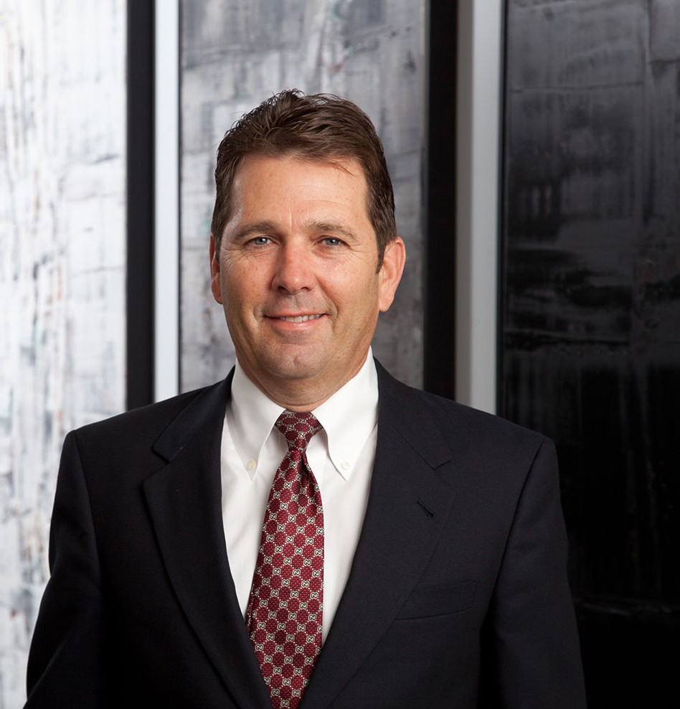

JOHN R. JEFFERIES

Director

[Business Litigation](https://www.fennemorelaw.com/services/business-litigation/)

[Phoenix](https://www.fennemorelaw.com/contact-us/phoenix/)

P: 602.916.5313 F: 602.916.5513

[rjefferies@fennemorelaw.com](mailto:rjefferies@fennemorelaw.com)

# JOHN R. JEFFERIES

Randy practices in the areas of federal and state procurement and government contract law, as well as building and construction law. He has negotiated and litigated construction claims at the city, county, state and federal levels on behalf of general contractors and specialty

subcontractors. At the federal level, Randy has litigated claims involving defective

specifications, constructive changes, acceleration, excusable and compensable delays, differing site conditions, terminations for default, and structured settlements for terminations for the convenience of the government. He also has been involved with bid protests before the Comptroller General of the General Accounting Office, having represented both awardees and protestors.

At the local level, Randy has pursued claims against city, county and state entities in Arizona, California, New Mexico, Utah and Nevada, and has been involved in a number of bid protests involving the Arizona Procurement Office and the Arizona Department of Transportation. He also handles private construction litigation and arbitration matters involving disputes between

owners, general contractors and subcontractors, as well as performance and payment bond claims.

# EDUCATION

J.D., University of Utah, S.J. Quinney College of Law B.A., University of Notre Dame

Order of the Coif

# AREAS OF PRACTICE

OTHER EXPERIENCE

Litigation

Business Litigation

Construction Law Real Estate

# AWARDS AND HONORS

*Best Lawyers in America®,* Commercial Litigation, Construction Law, Litigation – Construction, Litigation – Real Estate, 2005-2025

*Southwest Super Lawyers®,* Construction Litigation, 2009-2016, 2020

*Best Lawyers in America®*, Lawyer of the Year, Construction Law, 2018

*Arizona’s Top Lawyers,* Construction Litigation, AZ Business Magazine, 2014

AV® Preeminent™ Peer Review Rated (the highest rating available), by Martindale-Hubbell

# PROFESSIONAL AND COMMUNITY ACTIVITIES

Member, Public Contracts Section, American Bar Association Member, State Bar of Arizona

Member, State Bar of Nevada

Past Member, Board of Governors, Construction Law Section, State Bar of Arizona

# ADMISSIONS

Arizona Nevada