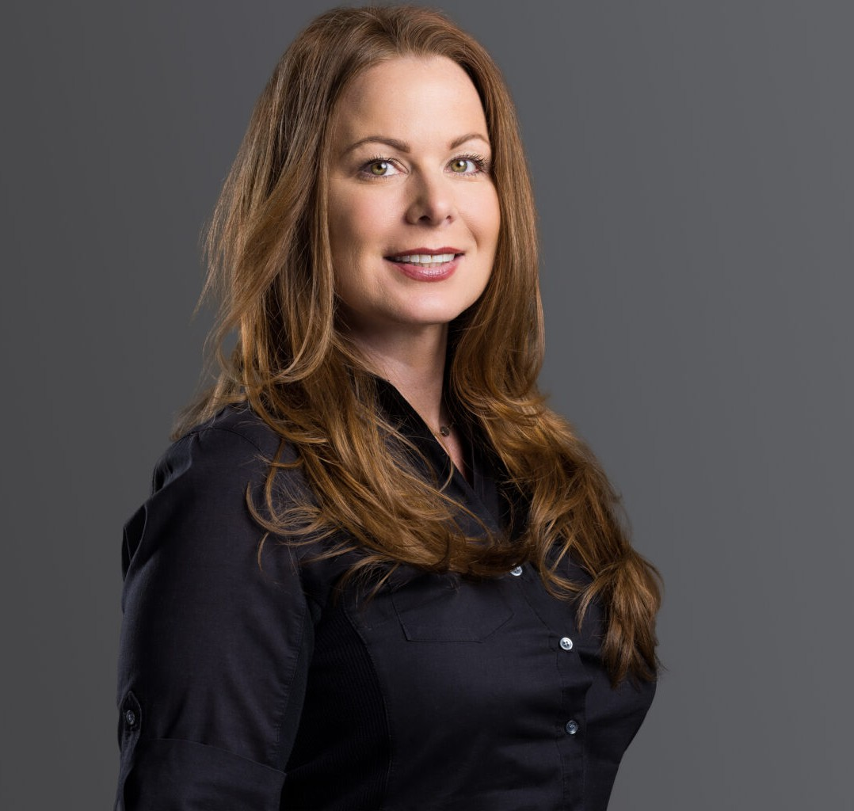

JULIE SPRECHER

Paralegal

[Business Litigation](https://www.fennemorelaw.com/services/business-litigation/)

[Phoenix](https://www.fennemorelaw.com/contact-us/phoenix/)

P: 602.916.5190 F: 602.916.5609

[jsprecher@fennemorelaw.com](mailto:jsprecher@fennemorelaw.com)

**OVERVIE**“**W**

You're never too old to dream a new dream.

”

Julie Sprecher is a paralegal who works out of our Phoenix office where her work focuses on supporting construction-related matters such as construction defect litigation, as well as toxic tort, wrongful death, transportation law and product liability.

Julie brings great enthusiasm to her work as an avid researcher, with an appreciation for indisputable black and white facts.

Outside of work, Julie travels as often as possible, and as an artist, she enjoys experiencing the arts, along with creating her own.

# EDUCATION

Paralegal Certificate, John F. Kennedy University

# AREAS OF PRACTICE

Business Litigation Construction Law

# PROFESSIONAL AND COMMUNITY ACTIVITIES

Inductee, Lambda Epsilon Chi (LEX)

John F Kennedy University, Honors Society

# ADMISSIONS

*\*Not licensed to the practice of law*

# LANGUAGES

American Sign Language, Conversant American Sign Language, Proficient