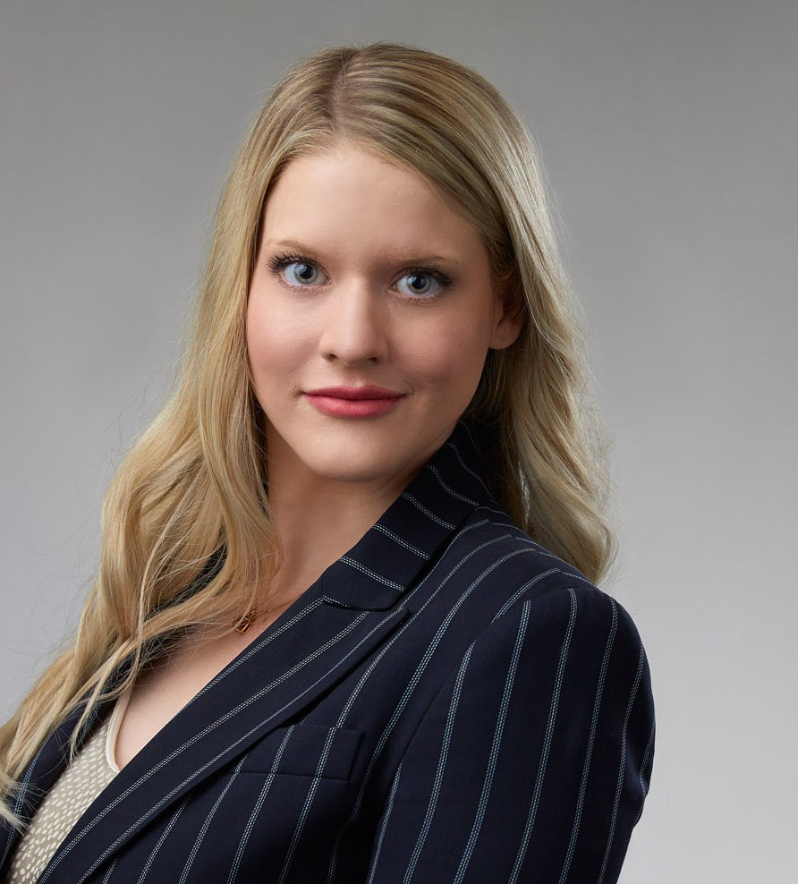

KENDALL LOVELL

Associate

[Business Litigation](https://www.fennemorelaw.com/services/business-litigation/)

[San Diego](https://www.fennemorelaw.com/contact-us/san-diego/)

P: 619.344.2972 F: 619.615.2180

[Las Vegas](https://www.fennemorelaw.com/contact-us/las-vegas/)

P: 702.692.8003 F: 702.692.8083

[klovell@fennemorelaw.com](mailto:klovell@fennemorelaw.com)

“

Tyranny like hell, is not easily conquered; yet we have this consolation with us that the harder the conflict, the more glorious the triumph.

-Thomas Paine

”

**KENDALL LOVELL**

Kendall Lovell is an associate in our San Diego office who works in our Business Litigation practice group. Kendall’s practice is concentrated in commercial litigation and intellectual property. She advises clients on a variety of corporate needs, including litigation strategy, discovery, and motion practice. In addition, she represents clients in matters involving copyright, trademark, and trade secret protection and enforcement, as well as patent litigation. Kendall also has experience in appellate practice defending an appeal for clients through federal and state appellate courts, and is skilled in legal writing and research, editing, trial, legal document

preparation, data science and public speaking.

During her career, Kendall has grown to love the “chess game” of law: balancing strategy, budgetary constraints, and what’s best for the sustainability of her client’s business. She believes that her start in neuropsychology opened her mind to the many endpoints and connections between human behavior and cognitive function. This myriad of statistical data requires similar strategic analysis and decision making in the legal world, which she applies to all of her client

work to find the best approach to keep their business on the winning side of the board.

Outside of work, Kendall is passionate about animal advocacy and rescue, and before his passing, her medical alert service bulldog, “Butters,” gained fame on Instagram. She’s

dedicated to animal rescue, and sits on the board of a bulldog rescue foundation. To destress, Kendall practices meditation and gentle yoga.

# EDUCATION

J.D., University of San Diego School of Law B.S., Saint Mary’s College of California

# AREAS OF PRACTICE

Business Litigation Intellectual Property Construction Law

# AWARDS AND HONORS

*Best Lawyers in America*®, Ones to Watch – Commercial Litigation, Litigation – Construction, 2023 – 2025

# ARTICLES AND PRESENTATIONS

Author, “[Thursday Thoughts with Kendall Lovell: Protecting Intellectual Property in the Era of](https://www.fennemorelaw.com/thursday-thoughts-with-kendall-lovell-protecting-intellectual-property-in-the-era-of-ai/) [AI](https://www.fennemorelaw.com/thursday-thoughts-with-kendall-lovell-protecting-intellectual-property-in-the-era-of-ai/),” Fennemore Blog, April 18, 2024

Featured, “[How to Get a Business License in California,](https://www.usatoday.com/money/blueprint/business/business-formation/how-get-business-license-california/)” USA Today, January 12, 2024

[Interview, “A Conversation On Leadership & Life In The Law With Attorney Kendall Lovell,”](https://www.fennemorelaw.com/disabled-is-not-a-dirty-word-but-there-is-still-a-lot-of-stigma-attached-to-it/) [Fennemore Blog, October 7, 2022](https://www.fennemorelaw.com/disabled-is-not-a-dirty-word-but-there-is-still-a-lot-of-stigma-attached-to-it/)

Author, “CRISPR/Cas-9 Technologies: A Call for a New Form of Tort”, San Diego International Law Journal, Vol. 19, Iss. 2, 2018

# PROFESSIONAL AND COMMUNITY ACTIVITIES

Vice-Chair, Standing Committee on Judicial Ethics, State Bar of Nevada Member, San Diego International Law Journal

President, University of San Diego Law School, Women’s Law Caucus Member, Howard D. McKibben Inn of Court

Co-Chair, Golf Tournament Committee for Lawyers Club

# ADMISSIONS

Nevada California