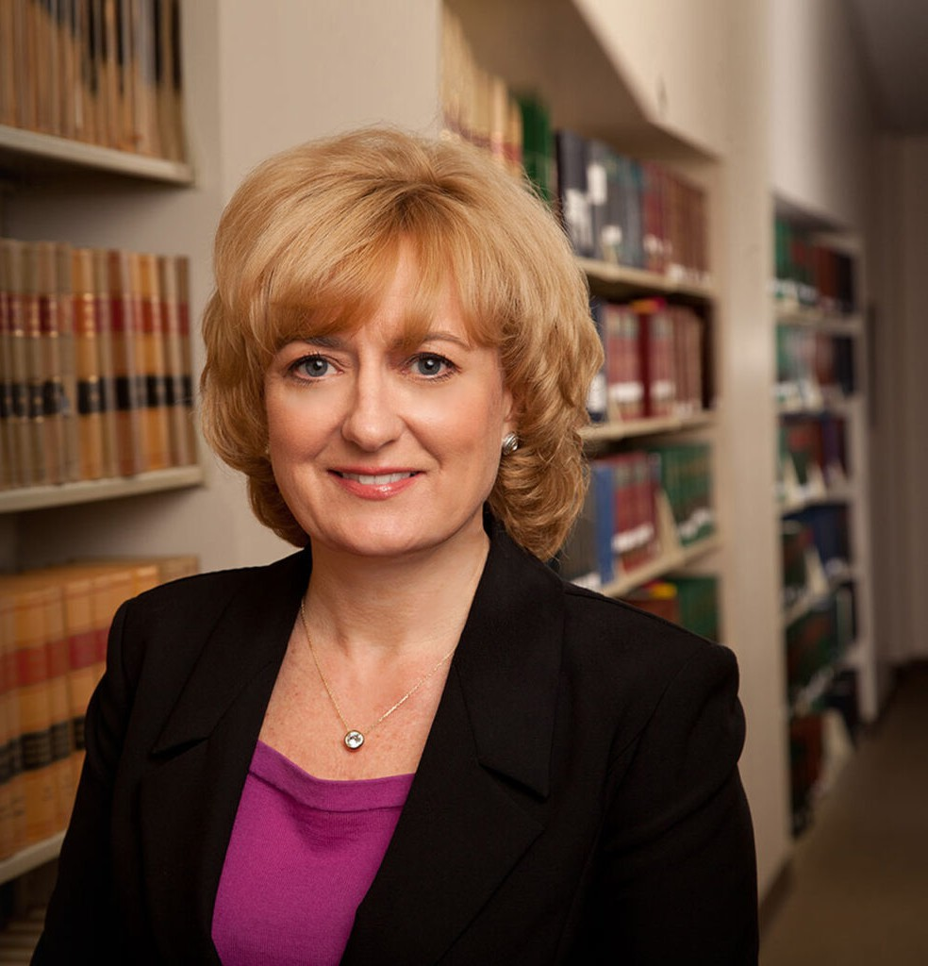

LESLIE BRYAN HART

Director

[Business Litigation](https://www.fennemorelaw.com/services/business-litigation/)

[Reno](https://www.fennemorelaw.com/contact-us/reno/)

P: 775.788.2228 F: 775.788.2229

[lhart@fennemorelaw.com](mailto:lhart@fennemorelaw.com)

# LESLIE BRYAN HART

Leslie practices litigation in state and federal court with an emphasis on disputes involving contract litigation, and disputes between lenders and borrowers.

Leslie’s practice and clients are from a variety of fields, which means that every case and client is another opportunity for her to learn about a new industry or business. She savors that variety, and her ability to work with clients and guide them to solutions to their legal issues.

On the weekends, Leslie spends time with her family, roots for the University of Nevada, and hikes and bikes in the mountains around Reno.

# EDUCATION

J.D., Santa Clara University School of Law B.A., Arizona State University

# AREAS OF PRACTICE

OTHER EXPERIENCE

Appeals Litigation

Trusts and Estates Litigation Business Litigation

# AWARDS AND HONORS

*Best Lawyers in America®,* Lawyer of the Year, Litigation – Labor and Employment, 2018 and 2024

*Best Lawyers in America®,* Commercial Litigation; Commercial Transactions/UCC Law; Litigation – Banking and Finance; Litigation – Labor and Employment; Litigation – Real Estate,

2013-2025

*Mountain States Super Lawyers®,* Business Litigation, 2020 “Legal Elite,” *Nevada Business Magazine,* 2015-2018

*Northern Nevada’s Top Attorneys, Nevada Business Magazine,* 2011-2012

# PROFESSIONAL AND COMMUNITY ACTIVITIES

Member, State Bar of Nevada

Member, Washoe County Bar Foundation

Member, Second Judicial District Court’s Bench/Bar Committee Vice President and Board of Directors, Washoe Legal Services Member, Northern Nevada Women Lawyers Association Member, American Bar Association

Member, Various Federal and State Court Committees Lawyer Representative, U.S. District Court, District of Nevada Immediate Past President, Washoe County Bar Association

# ADMISSIONS

Nevada

U.S. District Court, District of Nevada

U.S. Court of Appeals, Ninth Circuit

U.S. Supreme Court