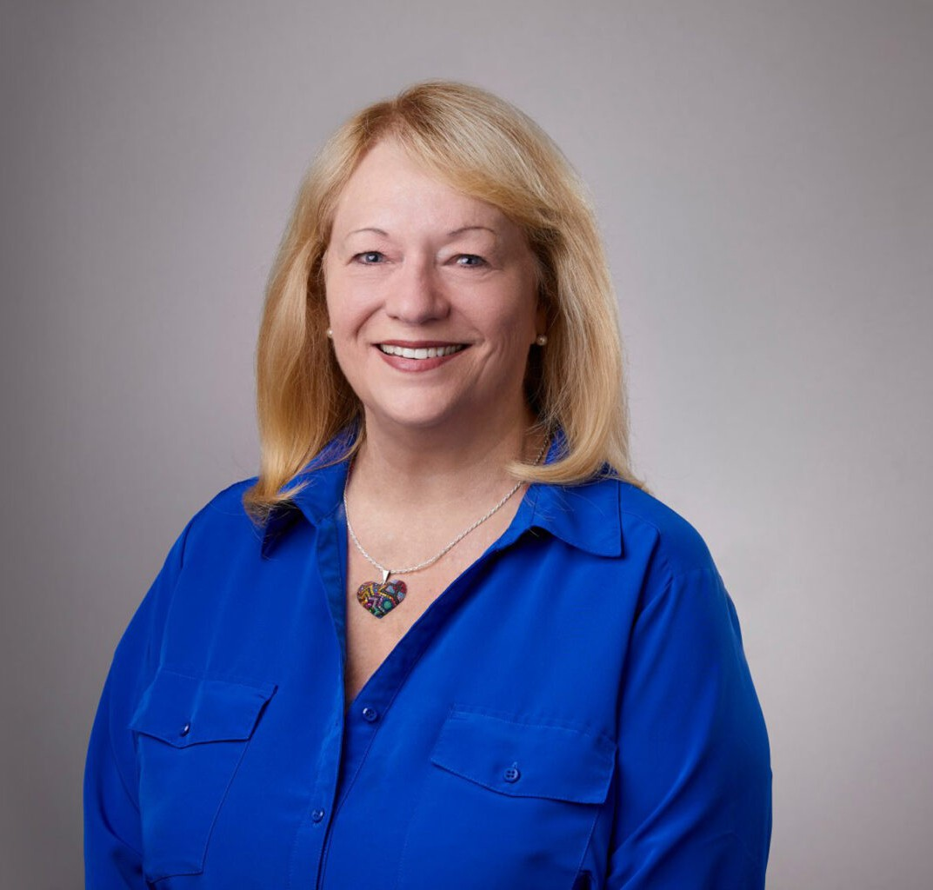

MARLENE ALLEN MURRAY

Director

[Business Litigation](https://www.fennemorelaw.com/services/business-litigation/)

[San Bernardino](https://www.fennemorelaw.com/contact-us/san-bernardino/)

P: 909.723.1765

F: 909.890.9877

[mallenmurray@fennemorelaw.com](mailto:mallenmurray@fennemorelaw.com)

“

Learn to do good. Seek justice. Treat people fairly. Help the oppressed . . . .

Argue their cases for them in court.

-Isaiah 1:17

”

# MARLENE ALLEN MURRAY

Marlene Allen Murray is a director in our San Bernardino office who handles all aspects of litigation (including business, commercial, real estate, and general), receivership law, environmental law, water law, employment law, corporate, banking, insurance coverage and defense, appellate advocacy, estate planning, probate, and trust litigation. Marlene has extensive trial experience and has argued several cases before the Court of Appeal. She has

served as a Judge Pro Tem in both Riverside County and Orange County, and currently serves as a mediator for the Court of Appeal and the Riverside County Superior Court.

A known problem solver, Marlene has a reputation of getting complicated disputes resolved by whatever means necessary, including strategies such as Alternative Dispute Resolution (ADR), so her clients can get on with their businesses and lives. Marlene really enjoys litigation – where every case is different – and as a seasoned mediator, she has a way of finding out “what’s really going on” in a disagreement, so she can get things resolved in a practical way.

Marlene is “AV” rated by Martindale-Hubbell* and has been admitted to practice in the United States Supreme Court, the Ninth Circuit Court of Appeal, and all United States District Courts of California. While attending Loyola Law School in Los Angeles, she worked as a law clerk for the Fourth Appellate District Court of Appeal in Santa Ana. After graduating in 1986, she worked for several years in Orange County and was a partner in two firms. While in Orange County, she served as Vice-Chair of Development for the March of Dimes and was active in the Orange County Bar Association, William P. Gray Inn of Court, Orange County Women Lawyers, Financial Women International, National Association of Women Business Owners, Robert Morris &

Associates, and the Orange County Bankruptcy Forum.

Since moving to Riverside in 1989, Marlene has been a member of the Leo A. Deegan Inn of Court (Riverside), Joseph B. Campbell Inn of Court (San Bernardino), the Riverside County Bar Association, the San Bernardino County Bar Association, the Inland Empire Bankruptcy Forum, and the Inland Empire chapter of Financial Women International. She currently serves on the Riverside County Bar Association Judicial Evaluation Committee and the Riverside County Bar Foundation Steering Committee. She also served as the Chair of the Legislation and Elections

Committee of the American Judges Association and is Past-President and General Counsel for CREW-I.E. (Commercial Real Estate Women – Inland Empire). She also serves as legal advisor for the Assistance League of Riverside and The Grove Community Church.

Always on the lookout for new challenges, Marlene was President of the YWCA of Riverside County in 2013 and served on its Executive Board for six years. She was also an Executive Board member of the Riverside Art Museum where she served on its Planned Giving Committee and as legal advisor. She was also the Treasurer and served on the Executive Board of the Riverside Children’s Theatre for several years. Marlene has been a member in the California Receivers

Forum, and prior to beginning her legal career, she worked as a bank auditor, an administrative assistant for the California State Legislature, and has served as the Campaign Treasurer for numerous judges and political candidates.

Newly married, Marlene enjoys concerts and music (think classic rock, blues, and southern rock), and she and her husband (John) enjoy traveling and trying new restaurants. Marlene’s son is an accomplished musician, as well as an attorney. Her daughter and son-in-law are high school teachers who also love photography and traveling. Her son-in-law is a talented musician, as

well.

Business Litigation Business & Finance

Employment & Labor Real Estate

Estate Planning Trusts & Estates

Eminent Domain

# EDUCATION

J.D., Loyola Law School, Los Angeles

B.A., California State University, Fullerton, *magna cum laude*

Business Litigation Business & Finance

Employment & Labor Real Estate

Estate Planning Trusts & Estates

Eminent Domain

# AREAS OF PRACTICE

**OTHER EXPERIENCE**

ADR

Receivership Law Water Law Business Litigation Business & Finance

Employment & Labor Real Estate

Estate Planning Trusts & Estates

Eminent Domain

# ARTICLES AND PRESENTATIONS

Featuring, “Should You Consider Social Media When Evaluating Job Candidates?” Society for Human Resource Management, June 9, 2023

Featuring, “Snooping on social media: What employers can and can’t do,” Philadelphia Business Journal, April 25, 2023

[Interview, “You must have a disciplined mindset and perseverance in order to achieve you](https://www.fennemorelaw.com/you-must-have-a-disciplined-mindset-and-perseverance-in-order-to-achieve-your-goals/) [goals,” Fennemore Blog, May 5, 2022](https://www.fennemorelaw.com/you-must-have-a-disciplined-mindset-and-perseverance-in-order-to-achieve-your-goals/)

Quoted, “California’s 4-day Week Bill: A Good Or Bad Idea?” International Business Times, April 15, 2022

Author, “First District Court Finds Reasonable Use Determination Requires Consideration of All Competing Water Users”, *California Water Law & Policy Reporte*r, April 2018

Author, “CIGA: Covering Claims When an Insurance Company Becomes Insolvent”, *Riverside Lawyer*, May 2017

Colorado River Water Could Transform Desert Land Into Farmland in the Coachella Valley”,

*California Water Law & Policy Reporter*, August/September 2016

National Association of Church Business Administrators, Presentation of Seminar at Cal Baptist University entitled “Legal Issues for Non-Profit Organizations”

Speaker at Appraisal Institute Annual Conferences (2015 and 2016) Rotary Club, Guest Speaker, Riverside, California

Financial Women International, Guest Speaker Orange County Barristers, Guest Speaker

Presentations of Legal Seminars on Banking, Commercial Litigation, Real Estate and Bankruptcy (Creditor) topics Speaker at CalCIMA Conference (2018)

# AWARDS AND HONORS

Top 10 Probate and Estate Trial Lawyers, The National Trial Lawyers, August 2024

# PROFESSIONAL AND COMMUNITY ACTIVITIES

Member, The State Bar of California Member, Riverside County Bar Association

Member, Riverside County Bar Association Judicial Evaluation Committee Member, Riverside County Bar Association Foundation Steering Committee Member, San Bernardino County Bar Association

Member, Leo A. Deegan Inns of Court, Riverside, California

Former Member, Joseph B. Campbell Inn of Court, San Bernardino, California Former Chair of Legislation and Elections Committee, American Judges Association Business Litigation

Business & Finance

Employment & Labor Real Estate

Estate Planning Trusts & Estates

Eminent Domain

# ADMISSIONS

California

U.S. Court of Appeal, Ninth Circuit

U.S. District Court, Central District of California

U.S. Supreme Court