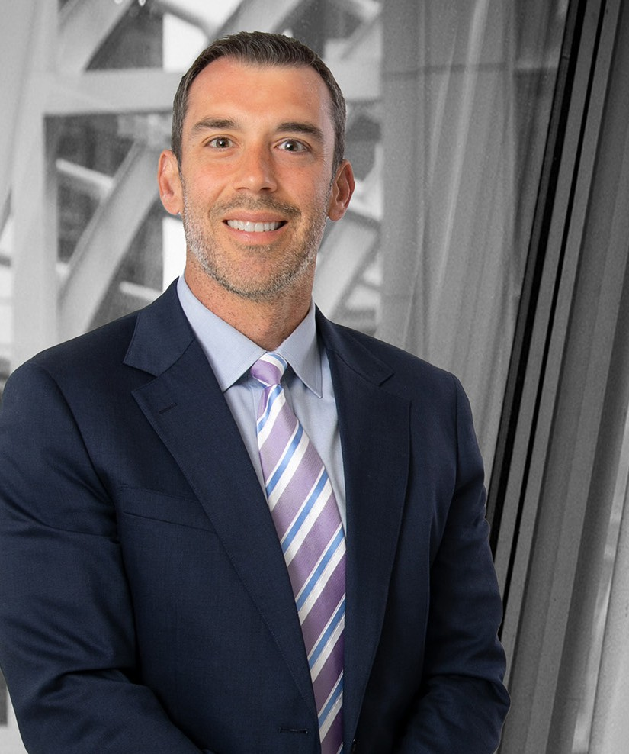

MICHAEL P. ROBERTSON

Director

[Business Litigation](https://www.fennemorelaw.com/services/business-litigation/)

[Denver](https://www.fennemorelaw.com/contact-us/denver-2/)

P: 303.764.3723 F: 303.291.3201

[Basalt](https://www.fennemorelaw.com/contact-us/basalt/)

P: 970.431.9060 F: 303.291.3201

[mrobertson@fennemorelaw.com](mailto:mrobertson@fennemorelaw.com)

“

I think people really underestimate the power of just wanting to do it, and

hard work, and competitive spirit, and preparation.

--Joe Burrow

”

**MICHAEL P. ROBERTSON**

Michael is a seasoned trial attorney with over 15 years of experience representing a diverse array of clients in high-stakes litigation matters. Michael’s litigation practice includes representing both plaintiffs and defendants in complex commercial disputes, fiduciary matters, and real estate litigation. Michael has successfully litigated matters in state and federal courts across the country for clients spanning from family businesses to Fortune 500 companies and the Denver Broncos Football Club.

In addition to his litigation practice, Michael also serves as outside general counsel to multiple privately-held businesses. Through his corporate practice, Michael advises clients on all types of corporate governance, risk avoidance, and insurance coverage issues.

Michael is consistently recognized as a top commercial litigator by publications including *Best Lawyers in America and Colorado Super Lawyers*. When not practicing law, Michael enjoys coaching youth sports for his three children. Michael is also a WSET-certified sommelier, and enjoys lecturing on wine-related topics and curating wine lists for food and beverage

establishments.

# EDUCATION

J.D., University of Miami School of Law

B.A., Louisiana State University

# AREAS OF PRACTICE

**OTHER EXPERIENCE**

Trusts and Estates Litigation Real Estate Litigation

Accountant Malpractice Business Litigation

Family Office & Private Client Attorneys

# REPRESENTATIVE CASES

Represented the trustees of the Patrick D. Bowlen Trust in litigation concerning Pat Bowlen’s estate plan and plan for succession of the ownership and control of the Denver Broncos Football Club.

Serves as general counsel for investment firm specializing in real estate development and syndicated investments. In addition to providing advice on day-to-day corporate matters, Michael has also served as lead trial counsel in multiple proceedings involving business and real estate disputes.

Represented the Denver Broncos Football Club in numerous matters, including disputes with former ticket holders and national litigation involving pain medication prescriptions. In addition to serving as litigation counsel to the Broncos, Michael also routinely advises the club on general organizational matters and drafts policies for the club’s use and dissemination.

Represented plaintiff guaranty associations and special deputy receiver in highly-complex litigation against multiple bank trustees, professional accounting firms, and other institutional defendants arising out of a nationwide fraudulent scheme perpetrated by a prearranged funeral service provider and its affiliated life insurance companies. Michael’s clients received significant recoveries through settlement and a jury verdict of $391 million against PNC Bank. Following the Eighth Circuit’s remand of the case against PNC, Michael played a critical role in securing a combined $106 million judgment ($99 million in compensatory and punitive damages and $7 million in attorney fees and litigation costs) against PNC Bank for breach of trust. PNC’s appeal of judgment is currently pending.

Represented DCP Midstream, one of the nation’s largest natural gas processing companies, in a multimillion-dollar breach of contract dispute involving complex oil and gas accounting

issues. Michael’s client obtained a favorable jury verdict following a six-day jury trial, which included a seven-figure award in favor of DCP on its counterclaim.

Represented start-up tax consulting firm in a complex trade secret and non-compete dispute. Michael’s work as lead counsel on this matter resulted in his client obtaining a favorable pre-trial settlement.

Participated in confidential representation of Fortune 500 company to conduct internal investigation into potential internal controls failure and misreporting to an outside auditor.

# AWARDS AND HONORS

*Best Lawyers in America®,* Commercial Litigation, 2023-2025

*Colorado Super Lawyers®, Rising Star*, 2016-2023

# ARTICLES AND PRESENTATIONS

[Interview, “The Opportunities Available at Fennemore are Seemingly Endless,” Fennemore](https://www.fennemorelaw.com/the-opportunities-available-at-fennemore-are-seemingly-endless/) [Blog, July 14, 2022](https://www.fennemorelaw.com/the-opportunities-available-at-fennemore-are-seemingly-endless/)

# PROFESSIONAL AND COMMUNITY ACTIVITIES

Colorado Trial Lawyers Association

Young Alumni Committee, University of Miami School of Law Denver Bar Association

Boulder Bar Association Colorado Bar Association

# ADMISSIONS

Colorado

U.S. Court of Appeals, Tenth Circuit

U.S. District Court, District of Colorado