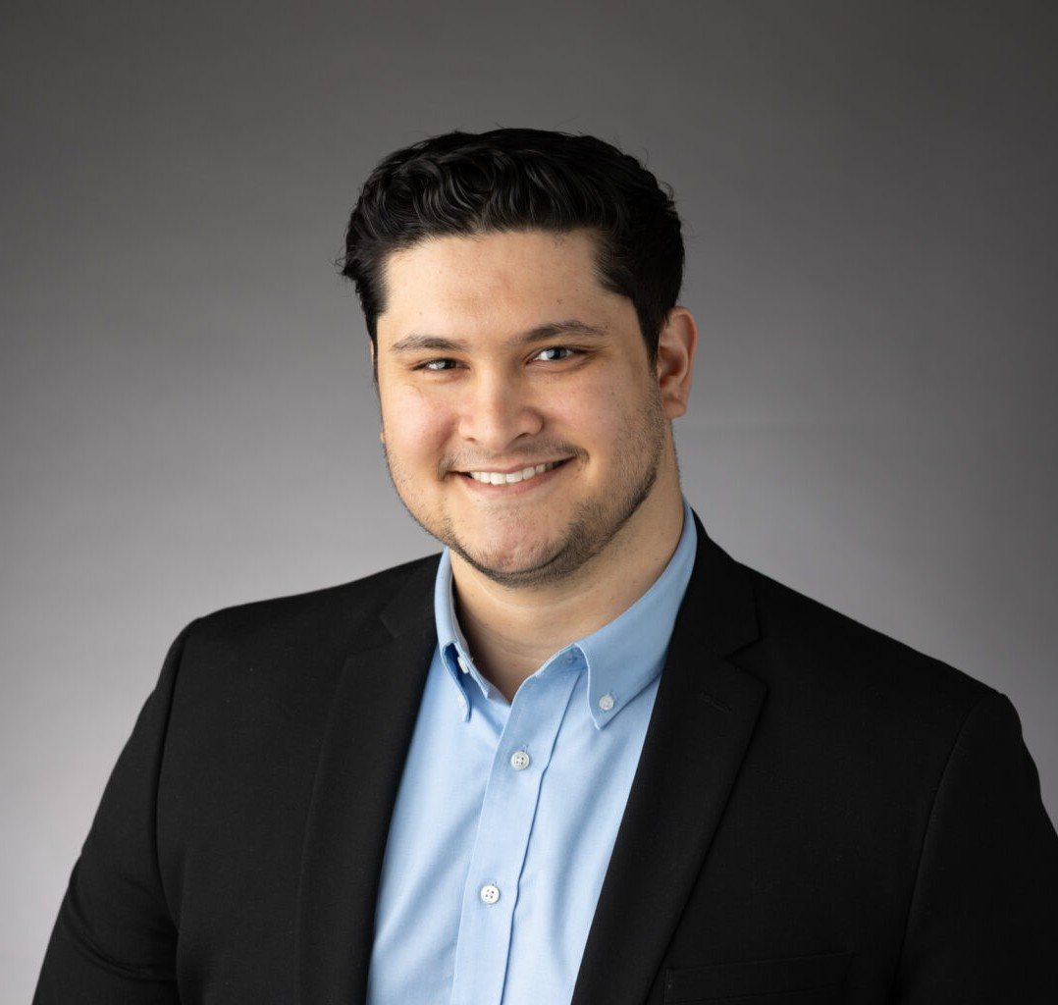

RAHMAT OMARI

Associate

[Business Litigation](https://www.fennemorelaw.com/services/business-litigation/)

[Oakland](https://www.fennemorelaw.com/contact-us/oakland/)

P: 510.622.7530 F: 510.622.7571

[romari@fennemorelaw.com](mailto:romari@fennemorelaw.com)

# RAHMAT OMARI

Rahmat Omari is an Associate Attorney in Fennemore’s [Business Litigation](https://www.fennemorelaw.com/services/business-litigation/) and [Trust & Estates](https://www.fennemorelaw.com/services/trusts-estates/) groups. Rahmat assists clients in navigating complex disputes, from will contests to breach of contract matters.

Rahmat earned his law degree from the University of California, College of the Law, San

Francisco (formerly UC Hastings). There, he was a member of the Moot Court Team, competed in the ABA National Appellate Advocacy Competition, and served as a teaching assistant in the Legal Research and Writing Department. While in law school, he was a judicial intern for the Honorable Virginia M. George of the Contra Costa County Superior Court.

Rahmat enjoys strength training, martial arts, and golf in his spare time.

# EDUCATION

J.D., University of California, College of the Law, San Francisco, *magna cum laude*

B.A., University of California, Berkeley

# AREAS OF PRACTICE

Business Litigation Trusts & Estates

# AWARDS AND HONORS

CALI Awards: Wills & Trusts, Legislative & Administrative Regulation, Advanced Evidence Seminar

# PROFESSIONAL AND COMMUNITY AFFILIATIONS

Judicial Intern, Honorable Virginia M. George, Contra Costa Superior Court, 2022 Member, UC Law SF, Moot Court (formerly UC Hastings), 2022-2023

# ADMISSIONS

California