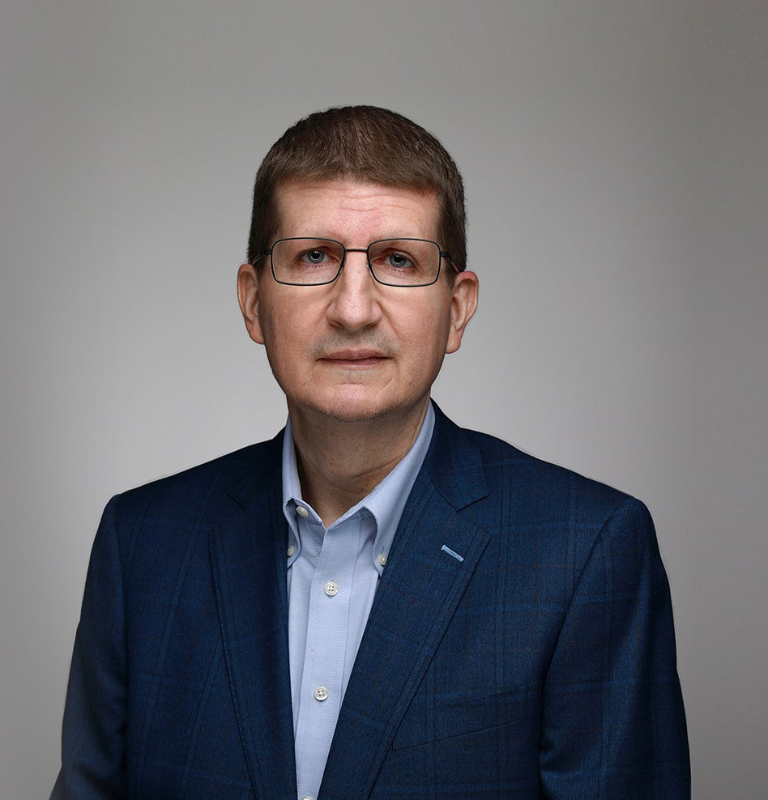

SCOTT H. THOMAS

Of Counsel

[Natural Resources](https://www.fennemorelaw.com/services/natural-resources-energy-and-environmental/)

[Phoenix](https://www.fennemorelaw.com/contact-us/phoenix/)

P: 602.916.5427 F: 602.916.5627

[sthomas@fennemorelaw.com](mailto:sthomas@fennemorelaw.com)

**SCOTT H. THOMAS**

Scott’s practice focuses primarily on regulatory compliance, administrative, enforcement and legislative issues. He practices environmental law with an emphasis on surface water and ground water quality issues, including NPDES/AZPDES permits, Section 404 dredge and fill permits, surface water quality standards, and Arizona aquifer protection permits.

Scott also has experience working on matters involving solid and hazardous waste, underground storage tank, environmental due diligence, NEPA, Endangered Species Act, TSCA, environmental auditing and TRI/EPCRA matters.

He is particularly proud of the strong relationships he forges with his clients, some of whom he’s worked with for decades. When he’s not working, Scott enjoys reading, traveling, hiking and watching sports.

# EDUCATION

J.D., University of Virginia School of Law

B.A., with high distinction, University of Virginia Notes Editor, *Virginia Law Review,* 1987-1988 Phi Beta Kappa

# AREAS OF PRACTICE

OTHER EXPERIENCE

Environmental Land Use

Renewable Energy and Clean Tech Natural Resources

Mining Law

# REPRESENTATIVE CASES

Secured formal determinations from the Corps of Engineers that no jurisdictional waters under the Clean Water Act existed in the area of proposed mine expansions, allowing those expansions to proceed without the need for federal permits.

Oversaw multiple cycles of a comprehensive environmental audit program for a company with sites in Arizona and Texas.

Assisted numerous mining, industrial and real estate clients in securing necessary permits for facility construction and/or expansion. Examples include several large master-planned communities in the Phoenix area and construction or expansion of numerous mining operations throughout the State.

Negotiated consent judgments or consent orders with the State of Arizona in numerous cases where regulated entities charged with violations of state law. In other cases, assisted clients alleged to have violated environmental laws to resolve those allegations without any penalty.

Provided due diligence on water quality issues and permitting issues for potential buyers analyzing acquisitions of large mining and electrical generating facilities in Arizona and Nevada.

# AWARDS AND HONORS

*Best Lawyers in America®,* Environmental Law, Natural Resources Law, 2016-2025

*Best Lawyers in America®*, Lawyer of the Year, Environmental Law, 2023

*Best Lawyers in America®*, Lawyer of the Year, Natural Resources Law, 2023

# ARTICLES AND PRESENTATIONS

Co-Author, “EPA and Army Corps Finalize Latest Rule Attempting to Define “Waters of the United States” Under the Clean Water Act,” Fennemore Client Alert, 2022

Speaker, “Environmental Law Update,” State Bar of Arizona 2018 Annual Convention, June 27, 2018

Speaker, “2017 Environmental Law Update,” 2017 State Bar of Arizona Annual Convention, June 14, 2017

# PROFESSIONAL AND COMMUNITY ACTIVITIES

Vice-Chair, Arizona Mining Association Environment Committee, 2014-present

Member, Executive Council, Environmental and Natural Resources Law Section, State Bar of Arizona, 2007-2013

Chair, Environmental and Natural Resources Law Section, State Bar of Arizona, 2011-2012

Member, Arizona Department of Environmental Quality Review Committee, Governor’s Office 2010

Past Vice-Chair for publications, American Bar Association, Section of Environment, Energy and Resources

# ADMISSIONS

Arizona

U.S. District Court, District of Arizona

U.S. Court of Appeals, Ninth Circuit