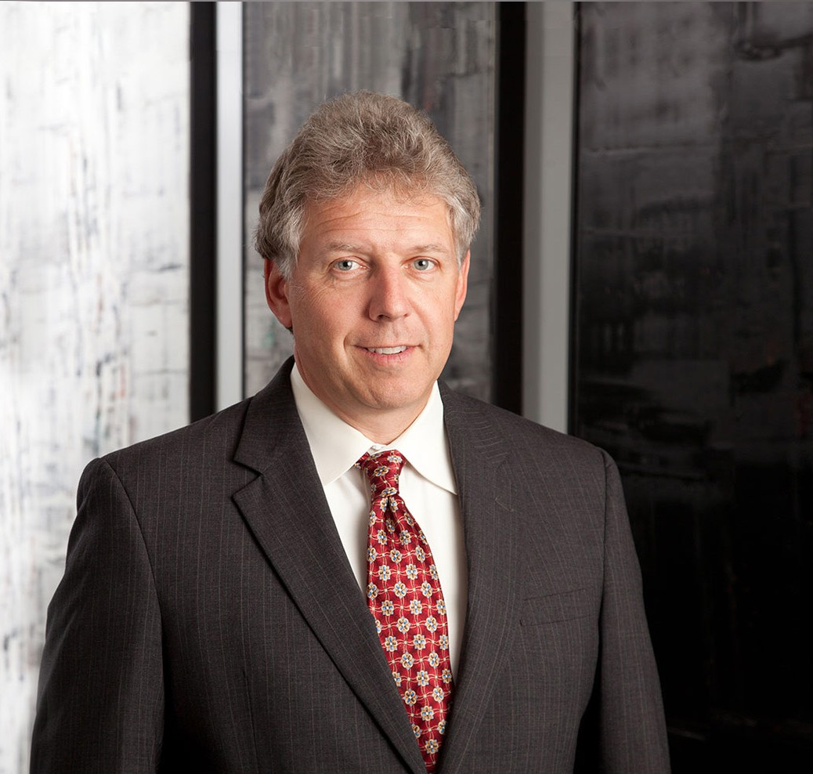

SEAN M. SABO

Of Counsel

[Real Estate](https://www.fennemorelaw.com/services/real-estate/)

[Phoenix](https://www.fennemorelaw.com/contact-us/phoenix/)

P: 602.916.5438 F: 602.916.5638

[ssabo@fennemorelaw.com](mailto:ssabo@fennemorelaw.com)

**SEAN M. SABO**

Sean practices in the areas of real estate law and finance.

He represents developers and homebuilders in all aspects of real estate, including acquisition,

development, financing and sale. Sean also represents lenders and borrowers in the negotiation and documentation of commercial loans for shopping centers, office complexes and other

projects. He also assists clients with real property issues related to receiverships, property management agreements and commercial leases.

Sean previously served as counsel to a developer with respect to financing associated with the construction of student housing at the University of Arizona.

Outside of the office, Sean enjoys tennis, golf, hiking and traveling.

# EDUCATION

J.D. Pepperdine University School of Law

M.B.A. University of Arizona

B.S., *magna cum laude*, Marietta College Phi Beta Kappa

# AREAS OF PRACTICE

OTHER EXPERIENCE

Commercial and Real Estate Finance Real Estate Finance and Lending Real Estate

Business & Finance

# REPRESENTATIVE CASES

Represented a property owner in its development and sale of residential lots to national homebuilders within various master planned communities.

Represented various affiliates of the Phoenix Suns in connection with the sale of $72 million in senior secured promissory notes to New York Life Insurance Company and related affiliates.

Served as co-counsel to various automotive manufacturers for Arizona-related work in connection with financing from the United States Department of the Treasury and with respect to the transfer and pledge of Arizona-located corporate and subsidiary assets attendant to Section 363 actions under the United States Bankruptcy Code.

Served as co-counsel to an independent oil refiner and various Arizona subsidiaries attendant to the issuance of secured notes and floating rate notes in a private placement offering.

Acted as lead and co-counsel to various lenders and life insurance companies with respect to real estate acquisition, construction, and permanent financing.

Served as counsel to the largest low-income housing tax credit multifamily developer in United States with respect to property acquisitions, construction, and financing of multifamily housing projects throughout Arizona.

Represented national homebuilders with respect to acquisition and development of master planned communities including the negotiation and preparation of joint development agreements with participating homebuilders.

Served as counsel to multiple borrowers with respect to financing associated with various office and retail projects throughout Arizona.

# AWARDS AND HONORS

*Best Lawyers in America®,* Real Estate Law, 2021-2025

# PROFESSIONAL AND COMMUNITY ACTIVITIES

Member, Real Property Section, State Bar of Arizona Member, Business Law Section, State Bar of Arizona Member, District of Columbia Bar Association Member, Men’s Arts Council, Phoenix Art Museum

Member, Valley Partnership for the Metropolitan Phoenix Area

# ADMISSIONS

Arizona

District of Columbia