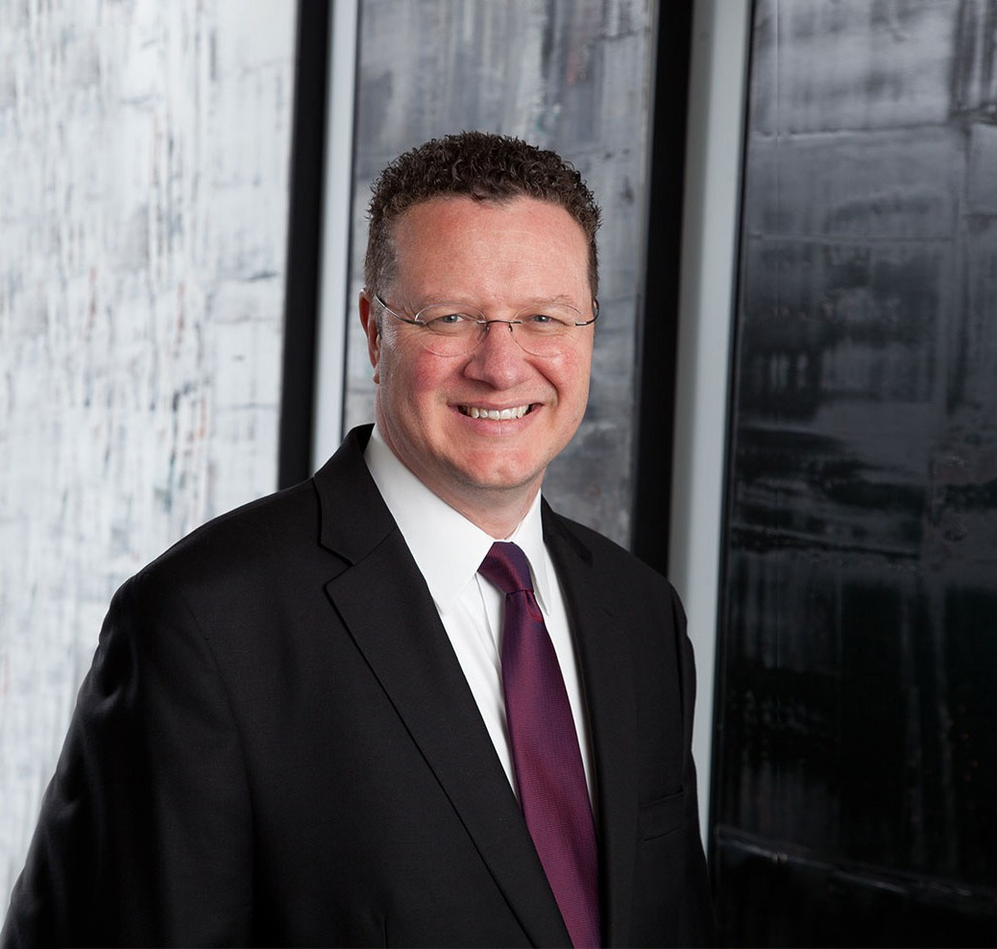

T. JAMES LEE

Director

[Trusts & Estates](https://www.fennemorelaw.com/services/trusts-estates/)

[Phoenix](https://www.fennemorelaw.com/contact-us/phoenix/)

P: 602.916.5422 F: 602.916.5622

[jlee@fennemorelaw.com](mailto:jlee@fennemorelaw.com)

“

In my practice, I most enjoy working with individuals and families in discovering thoughtful and customized solutions to the particular challenges

associated with prosperity.

”

**T. JAMES LEE**

Terry James (“Jim”) Lee advises clients in estate planning, private wealth law, tax and business law, international matters, and real estate and commercial transactions. He also counsels business founders and their families on matters of family governance, privacy, and issues of especial importance to high-profile and ultra-high net worth families and individuals.

Jim leads our *family office and private client attorneys*, a specialized group of advisors providing multidisciplinary resources and bespoke solutions for sensitive and pressing family concerns, values-based wealth transfer, and business succession. Leveraging his background in business,

economics, and accounting, he assists clients with the structuring and implementation of trusts (such as dynastic IDGTs, GRATs, DAPTs, INGs, QPRTs, CRTs, CLTs, silent/quiet trusts, and aircraft

trusts), family offices, private trust companies, family limited partnerships, LLCs, corporations, private foundations, and other sophisticated tax and investment vehicles and techniques. Coming full circle, he advises trustees and executors on their fiduciary responsibilities and tax implications in the administration and distribution of trusts and probate estates.

A testament to his abilities, Jim has a referral-only, concierge practice. He has developed a reputation for being an inventive, outside-the-box problem-solver, and for being fiercely loyal to his clients. This client-oriented approach means Jim designs estate and business plans to meet the needs of each family’s personal vision. As an example, trusts and business succession plans can be customized to provide incentives to beneficiaries and successors, such as children and grandchildren, to become productive and contributing members of society. Often known as *the family’s lawyer*, Jim develops long-term relationships that help promote continuity from generation to generation, while respecting individual thought and new perspectives.

Jim is fluent in Spanish, and many years ago, while living in a foreign country, he witnessed firsthand the impact attorneys can have helping others with their legal and familial goals and objectives. He cherishes opportunities to help people in his role as an analytical thinker, writer, and advocate.

Jim enjoys time with his family, composing music, and experiencing other cultures and

languages. For seven years he performed as a member of the Phoenix Boys Choir, entertaining and touring throughout the United States and abroad. “Because of those early eye-opening

experiences, the desire to meet and appreciate other people and their cultures and beliefs,” he says, “has never quite left me. When a guest in another country, I prefer not only to visit but also to interact with its people. They then become a part of you, and you become an ambassador of both your home country and that part of the world you have come to know. Phoenix, Arizona is my base camp.”

Married with six now-adult children, Jim once saw himself as “the roadie” and sound engineer for his kids’ mobile DJ business—a business Jim too once had back in high school. You might have found him playing at schools, weddings, and private events. His go-to song? Elvis Presley’s

“Can’t Help Falling in Love.”

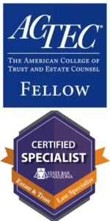

Jim is a fellow of the American College of Trust and Estate Counsel (ACTEC), a group of peer- elected trust and estate attorneys spanning the U.S. and abroad. He is also a published author, frequent lecturer to other attorneys and CPAs, and a Certified Specialist in trusts and estates through the State Bar of Arizona.

# EDUCATION

J.D., with honors Brigham Young University, J. Reuben Clark Law School B.S., Business Management Brigham Young University

Top business school graduate in entrepreneurship, business composite minor (Accounting and Economics), and minor in Spanish

*Brigham Young University Law Review,* Editorial Board, 1995-1996; Member, 1994-1996 Extern, Honorable J. Kenneth Mangum, Superior Court of Arizona, 1994

# AREAS OF PRACTICE

**OTHER EXPERIENCE**

Nonprofit and Tax-Exempt Organizations Trusts & Estates

Business & Finance Tax Law

Estate Litigation

Family Office & Private Client Attorneys Estate Planning

# AWARDS AND HONORS

*Best Lawyers in America®*, Tax Law, Trusts and Estates, Litigation – Trusts and Estates, 2010-2025

*Best Lawyers in America®*, **Lawyer of the Year**, Trusts and Estates, 2017, 2021, 2024, Tax Law, 2023

Eleanor ter Horst Distinguished Service Award, State Bar of Arizona, 2023 Recipient

*Southwest Super Lawyers®*, Estate Planning and Probate, 2008, 2010-2018, 2022-2024 Chambers HNW, Leading High Net Worth Advisors, 2016-2024

*Arizona’s Finest Lawyers*, Regular Member, admitted as of 2011

AV® Preeminent™ Peer Review Rated (the highest rating available), by Martindale Hubbell

# ARTICLES AND PRESENTATIONS

Co-Presenter, “Advanced Gifting Techniques that Encourage Philanthropy,” Arizona Charitable Gift Planners, October 2023

Program Co-Chair and Presenter, ARIZONA STATE BAR CONVENTION, “A Five-Course Meal of Estate Planning Issues, Case and Legislative Updates, Administration Practice Tips, Business and Tax Considerations, and Ethics,” Probate & Trust Law Section, June 2023

Co-Presenter, “Income Tax Exit Strategies for Privately Owned Businesses,” American Law Institute (ALI CLE), May 2023

Presenter, “Planning Techniques for Large Estates 2023,” American Law Institute (ALI CLE), April 2023

Co-Presenter, “Taxing Matters: Income Taxation of Trusts, Estates (advanced fiduciary income tax) and Inherited Retirement Accounts,” State Bar of Arizona, March 2023

Interview (podcast), “The Separate Share Rules and Their Nuances,” ACTEC, February 28, 2023

Presenter, Fiduciary Income Tax (Probate Administrator’s Guide to Fiduciary Income Tax (basic to intermediate)), State Bar of Arizona, February 2023

Co-Presenter, “When Grantor Trusts Become Non-Grantor Trusts,” Valley Estate Planners, January 2023

Co-Presenter, “Separate Share Rules,” Fall Meeting, ACTEC, San Francisco, California, 2022

Presenter, “Estate Planning for the Family Business Owner 2022,” American Law Institute (ALI CLE), October 2022

Speaker, “Estate Planning Updates: Gift, Estate, GST, and Fiduciary Income Tax,” Arizona Society of CPAs’ Annual Conference, November 2021

Co-author, “Arizona Estate Planning: Income, Estate, Gift, and GST Taxation,” *DT Publishing Company, Vols. 1 and 2 supplements,* 2020 and 2021

Presenter, “Qualified Small Business Stock,” AZCLE Entity Selection and Issues for the Estate Planner, sponsored by the State Bar of Arizona, October 13, 2020

[Contributing author, “Recent Tax Developments – 2020 April – Refresher on Benefits Under The](https://www.fennemorelaw.com/insights/newsletters/2020/recent-tax-developments-2020-april-refresher-on-benefits-under-the-cares-act) [CARES Act,” Fennemore Client Alert, May 4, 2020](https://www.fennemorelaw.com/insights/newsletters/2020/recent-tax-developments-2020-april-refresher-on-benefits-under-the-cares-act)

[Co-author, “IRS and the Arizona Department of Revenue Extend Tax Filing Deadlines to July](https://www.fennemorelaw.com/insights/newsletters/2020/irs-and-the-arizona-department-of-revenue-extend-tax-filing-deadlines-to-july-15) [15,” Fennemore Client Alert, March 26, 2020](https://www.fennemorelaw.com/insights/newsletters/2020/irs-and-the-arizona-department-of-revenue-extend-tax-filing-deadlines-to-july-15)

[Contributing author, “Recent Tax Developments – 2020 January – The SECURE Act](https://www.fennemorelaw.com/insights/newsletters/2020/recent-tax-developments-2020-january---the-secure-act) [(Individuals),” Fennemore Client Alert, January 9, 2020](https://www.fennemorelaw.com/insights/newsletters/2020/recent-tax-developments-2020-january---the-secure-act)

[Contributing author, “End of Year Tax Saving Moves – 2019,” Fennemore](https://www.fennemorelaw.com/insights/newsletters/2019/end-of-year-tax-saving-moves---2019) [Client Alert,](https://www.fennemorelaw.com/insights/newsletters/2019/end-of-year-tax-saving-moves---2019) [December 30, 2019](https://www.fennemorelaw.com/insights/newsletters/2019/end-of-year-tax-saving-moves---2019)

[Contributing a](http://clientalert.fennemorecraig.com/tax_dec2019)[uthor, “Recent Tax Developments – December 2019,” Fennemore](https://clientalert.fennemorecraig.com/tax_dec2019) [Client Alert,](http://clientalert.fennemorecraig.com/tax_dec2019) [December 23, 2019](http://clientalert.fennemorecraig.com/tax_dec2019)

Presenter, “Estate Planning for the Family Business Owner 2019,” American Law Institute (ALI CLE), October 2019

[Contributing a](http://www.fclaw.com/insights/newsletters/2019/recent-tax-developments---2019-april)[uthor, “Recent Tax Developments – 2019 April,” Fennemore](https://www.fclaw.com/insights/newsletters/2019/recent-tax-developments---2019-april) [Client Alert, April 16,](http://www.fclaw.com/insights/newsletters/2019/recent-tax-developments---2019-april) [2019](http://www.fclaw.com/insights/newsletters/2019/recent-tax-developments---2019-april)

Co-author, “Arizona Estate Planning: Income, Estate, Gift, and GST Taxation,” *DT Publishing Company, Vol. 1 supplement and new Vol. 2,* 2019

Co-author, “End-of-year Business Advice for Northern Nevada Businesses (Opinion),” *Northern Nevada Business View,* December 11, 2018

Contributing author, “Recent Tax Developments – 2018 August,” Fennemore Client Alert, August 8, 2018

[Contributing a](https://www.fennemorelaw.com/insights/newsletters/2018/recent-tax-developments---2018-july)[uthor, “Recent Tax Developments – 2018 July,” Fennemore](https://www.fclaw.com/insights/newsletters/2018/recent-tax-developments---2018-july) [Client Alert, July 2,](https://www.fennemorelaw.com/insights/newsletters/2018/recent-tax-developments---2018-july) [2018](https://www.fennemorelaw.com/insights/newsletters/2018/recent-tax-developments---2018-july)

[Interview, “The New Partnership Audit Rules and Why They Are So Important For Estate](https://actecfoundation.org/podcasts/new-partnership-audit-rules-2018/) [Planners,” ACTEC, June 12, 2018](https://actecfoundation.org/podcasts/new-partnership-audit-rules-2018/)

Speaker, “Digital Assets,” The Arizona Fiduciaries Association 2018 Spring Conference, April 20, 2018

[Co-author, “Recent Tax Developments – 2018 January,” Fennemore](https://www.fclaw.com/insights/newsletters/2018/recent-tax-developments---2018-january) [Client Alert](https://clientalert.fennemorecraig.com/secure-act)[, January 23,](https://www.fennemorelaw.com/insights/newsletters/2018/recent-tax-developments---2018-january) [2018](https://www.fennemorelaw.com/insights/newsletters/2018/recent-tax-developments---2018-january)

Speaker, “Partnership Audit Rules,” Summer Meeting, ACTEC, Chicago, Illinois, 2018

[Contributing a](http://www.fclaw.com/insights/newsletters/2017/tax-planning-checklists--2017-end-of-year)[uthor, “Tax Planning Checklists – 2017 End of Year,” Fennemore](https://www.fennemorelaw.com/insights/newsletters/2017/tax-planning-checklists--2017-end-of-year) [Client Alert,](http://www.fclaw.com/insights/newsletters/2017/tax-planning-checklists--2017-end-of-year) [October 16, 2017](http://www.fclaw.com/insights/newsletters/2017/tax-planning-checklists--2017-end-of-year)

[Contributing a](https://www.fennemorelaw.com/insights/newsletters/2017/recent-tax-developments---april-2017)[uthor, “Recent Tax Developments – 2017 April,” Fennemore](https://www.fclaw.com/insights/newsletters/2017/recent-tax-developments---april-2017) [Client Alert, April 12,](https://www.fennemorelaw.com/insights/newsletters/2017/recent-tax-developments---april-2017) [2017](https://www.fennemorelaw.com/insights/newsletters/2017/recent-tax-developments---april-2017)

Speaker, 2017 Women’s Financial Forum, Arizona Bank and Trust, 2017

Speaker, “Hot Topics in Contemporary Estate Planning (including Ron Aucutt),” sponsored by the State Bar of Arizona, 2017

Speaker and Panelist, various trusts, estates, and tax seminars, National Video Broadcasts, NBI, 2016-present

Contributing author, “Tax Planning Checklists – 2016 End of Year,” Fennemore Client Alert, November 4, 2016

[Contributing a](https://www.fennemorelaw.com/insights/newsletters/2016/recent-tax-developments---october-2016)[uthor, “Recent Tax Developments – October 2016,” Fennemore](https://www.fclaw.com/insights/newsletters/2016/recent-tax-developments---october-2016) [Client Alert,](https://www.fennemorelaw.com/insights/newsletters/2016/recent-tax-developments---october-2016) [October 26, 2016](https://www.fennemorelaw.com/insights/newsletters/2016/recent-tax-developments---october-2016)

[Contributing a](http://www.fclaw.com/insights/newsletters/2016/valuation-discounts-going-going-)[uthor, “Valuation Discounts: Going, Going,…” Fennemore](https://www.fennemorelaw.com/insights/newsletters/2016/valuation-discounts-going-going-) [Client Alert,](http://www.fclaw.com/insights/newsletters/2016/valuation-discounts-going-going-) [September 19, 2016](http://www.fclaw.com/insights/newsletters/2016/valuation-discounts-going-going-)

Speaker, Moderator, and Seminar Chair, “Probate and Estate Law, and Elder and Mental Health Care Law: A Multi-Disciplinary Approach (Practical Estate Planning and Administration; Estate Planning with Corporations, LLCs, and Partnerships; Elder and Special Needs Planning for the Modest and the Affluent; and Digital Assets),” CLE by the Sea, Coronado, California, sponsored by the State Bar of Arizona, July 2016

Speaker, “Partnership Tax Allocations, and Implications of the Repeal of TEFRA,” Business Planning Committee, Summer Meeting, ACTEC, Boston, Massachusetts, 2016

Speaker, “Section 642(c) Charitable Deduction and Tracing,” Fiduciary Income Tax Committee, Annual Meeting, ACTEC, Las Vegas, Nevada, 2016

Co-author, “Best Practices for Structuring Trusts and Estates,” *Thomson Reuters (Aspatore),* 2016 edition

Co-author, “Recent Tax Developments – January 2016,” Fennemore Client Alert, January 14, 2016

Contributing author, “Surface Transportation and Veterans Health Care Choice Improvement Act of 2015,” Fennemore Client Alert, August 12, 2015

Contributing author, “2015 Second Quarter Tax Developments,” Fennemore Client Alert, July 20, 2015

Contributing author, “Tax Developments For First Quarter 2015,” April 29, 2015

Contributing author, “Families of Those With Disabilities: New ‘Able Accounts’,” Fennemore Client Alert, April 1, 2015

Contributing author, “Tax Developments in February 2015,” Fennemore Client Alert, March 1, 2015

Contributing author, “Tax Developments in 2015,” Fennemore Client Alert, January 12, 2015

Co-author, “Arizona Estate Planning: Income, Estate, Gift, and GST Taxation,” *DT Publishing Company, Vol. 1,* 2015 supplement

Speaker, “Sophisticated Estate Planning: GRATs, Sales to Grantor Trusts, CRTs, CLTs, Asset Allocations, Fiscal Year Planning, and DNI,” Valley Estate Planners, 2015

Contributing author, “Tax Developments in 2014,” Fennemore Client Alert, December 15, 2014

Contributing author, “Tax, Business and Estate Planning,” Fennemore Client Alert, December 15, 2014

Speaker, “Estate Planning for the Novice,” sponsored by KJZZ/K-BACH Radio, 2014

Co-author, “Arizona Estate Planning: Income, Estate, Gift, and GST Taxation,” *DT Publishing Company, Vol. 1,* 2014 supplement

Speaker and Seminar Chair, “Advanced Estate Planning and Trust/Probate Administration,” CLE by the Sea, Coronado, California, sponsored by the State Bar of Arizona, 2014

Seminar Chair and Moderator, “Effect of U.S. v. Windsor on DOMA in Estate Planning, Update on T&E Litigation and Legislation (Federal and Arizona), Resolving Probate and Trust Disputes Without Protracted Litigation, and the Continuing Evolution of the Arizona Probate Rules and Procedures,” sponsored by the State Bar of Arizona, 2014

Seminar Co-Chair and Moderator, “Unraveling Estate Planning Issues after Windsor (DOMA) and Other Advanced Planning Topics,” State Bar of Arizona, Probate & Trust Law Section, 2013

Speaker, “Understanding Consequences of Transfers of Title in Unfamiliar Jurisdictions*,”* Western Region Meeting, ACTEC, Half Moon Bay (San Francisco), California, 2013

Speaker, “Wealth Transfer Tax Legislation, Estate Planning Techniques, and Current

Developments,” CLE by the Sea, Coronado, California, sponsored by the State Bar of Arizona, 2013

Co-author, “Arizona Estate Planning: Income, Estate, Gift, and GST Taxation,” *DT Publishing Company, Vol. 1,* 2012

Seminar Co-Chair, “Arizona Probate Practice in 2012 – ¡Cuidado!”, Probate & Trust Law Section, Arizona State Bar Convention, 2012

Speaker, “The Good, Bad and the Ugly in Decanting in Arizona,” Arizona Community Foundation, Professional Advisory Board, 2012

Speaker, “Unexpected Complexity of Marital Deductions,” National Teleconference, Lorman Education Services, 2012

Speaker, “Decanting (What now, pourover “trusts”?),” East Valley Estate Planning Council, 2012

Seminar Chair and Moderator, “Advanced Probate and Trust,” State Bar of Arizona, Probate and Trust Law Section, 2011

Author, “Decant or Not Decant (in Arizona)?,” *Probate and Trust Law Newsletter,* State Bar of Arizona, 2011

Author, “Marital Deduction Formula and GST Tax Severance Planning — Income Tax

Consequences,” *Estate Planning,* Thomson Reuters (Warren, Gorham & Lamont), New York, Nov. 2010

Speaker, “Recent Developments and Hot Topics: Apportionment of Estate Taxes and Administrative Expenses,” sponsored by the Jewish Community Foundation of Southern Arizona, 2010

Speaker, “Decant or Not Decant? That Is the Question,” Arizona State Bar Convention, 2010

Speaker, “Important and Hot Estate Planning and Related Tax Planning Topics,” State Bar of Arizona, Probate and Trust Law Section, 2009

Speaker, “Steeping Marital Deduction Bliss in Your GS Tea (Advanced Formula Planning),” Tucson Tax Study Group, 2009

Speaker, “Advanced Generation-Skipping Transfer Tax and Marital Deduction Planning,” National Teleconference, NBI, 2009

Speaker, “Drafting for the Arizona Trust Code,” Maricopa County Bar Association, 2009 Speaker, “GSTT and Marital Deduction Formula Planning,” VEP, 2009

Speaker, “New Trust Code and Probate Rules Take Effect: Are you Ready?” State Bar of Arizona, Elder Law and Mental Health Section, 2009

Speaker, “Arizona Trust Code,” Maricopa County Bar Association, 2008

Speaker, “Trust and Estate Distributions: Income Tax Implications and Planning Alternatives,” State Bar of Arizona, Taxation Section, 2008

Speaker, “Trust and Estate Income Taxation,” Tucson Tax Study Group, 2007

Speaker, “Income Taxation in Estate Planning,” Valley Estate Planners, 2007

Speaker, “Estate Planning and Subchapter J Issues,” East Valley Estate Planning Council, 2006 and various commercially sponsored lectures

# PROFESSIONAL AND COMMUNITY ACTIVITIES

Member, American Bar Association Member, State Bar of Arizona Member, Utah State Bar

Member and Past Chair, Executive Council, Probate and Trust Law Section, State Bar of Arizona

Member, Professional Advisory Board and Gift Acceptance Committee, Arizona Community Foundation

Trustee, Phoenix Boys Choir

Volunteer, in affiliation with local chapters of House of Refuge and Habitat for Humanity Fellow, The American College of Trust and Estate Counsel, ACTEC

Member, Fiduciary Income Tax Committee, Business Planning Committee, ACTEC Inaugural Member, TGen Ambassadors, Translational Genomics Research Institute Member, Committee on Estate and Gift Taxes, Taxation Section, American Bar Association Past Chair and Member, Estate and Trust Advisory Commission, State Bar of Arizona

Past Chair, Professional Education Series Planning Committee, Arizona Community Foundation Past Officer, Board of Directors, Ballet Arizona

Past Chair of the Planned Giving Committee, Past Executive Committee Member, Arthritis Foundation, Greater Southwest Chapter

Past Council Officer, Past Executive Board Member, Boy Scouts of America, Grand Canyon Council

Past Member, Professional Advisory Committee, Jewish Community Foundation Past President, Past Board Member, Valley Estate Planners

Past President, Past Board Member, East Valley Estate Planning Council

# ADMISSIONS

Arizona Utah

U.S. District Court, District of Arizona

Trust and Estate Specialist (Board Certified, State Bar of Arizona)