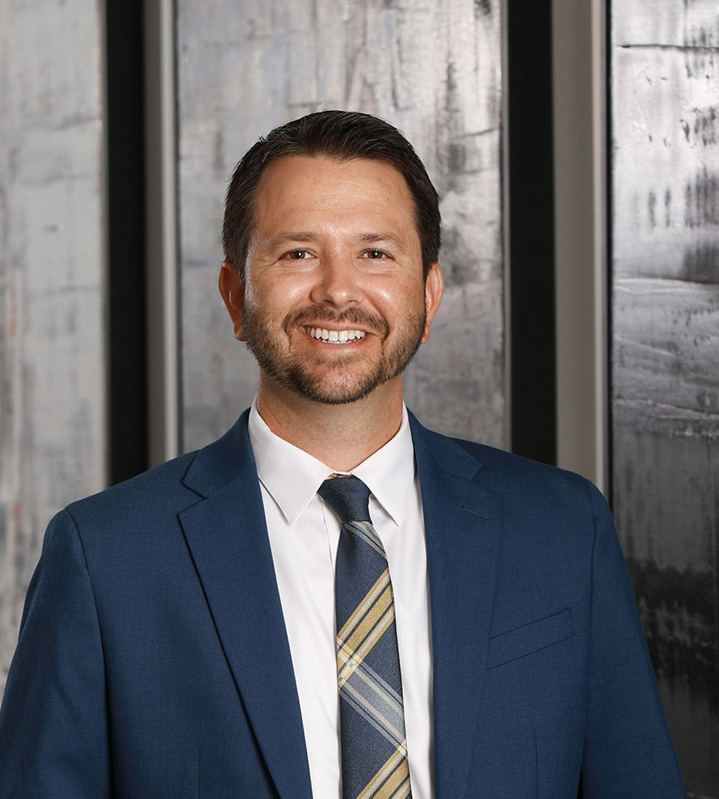

TRAVIS A. PACHECO

Pronouns: he/him

Director

[Employment & Labor](https://www.fennemorelaw.com/services/employment-and-labor-relations/)

[Phoenix](https://www.fennemorelaw.com/contact-us/phoenix/)

P: 602.916.5736 F: 602.916.5936

[tpacheco@fennemorelaw.com](mailto:tpacheco@fennemorelaw.com)

**TRAVIS A. PACHECO**

Travis practices in the area of employment and labor. He has litigated cases involving enforcement of restrictive covenant agreements, including noncompete agreements, and

employee wage and hour claims. He has also successfully defended employers against charges of employment discrimination, harassment, and wrongful termination claims filed with state and federal agencies, including the EEOC and the Arizona Attorney General’s Civil Rights Division.

Travis assists employers and HR personnel by navigating them through the broad spectrum of federal and state employment laws to ensure compliance, drafting employment handbook policies, and by drafting and enforcing various employment agreements.

As a ninth-generation Arizonan, Travis was drawn to our firm’s 130-year-plus history in Arizona. He comes from a hard-working farming family in the Tucson area who first settled in Tubac in the

1770’s. Fluent in Spanish, he enjoys working with diverse clients and businesses. Travis is the firm’s Chief Diversity Officer strongly believing that prioritizing diversity among organizations makes such entities stronger, fosters new ideas and progress, and allows others to understand each other better and to appreciate differences. For many years, Travis has also worked closely with community and student-based nonprofit organizations, such as the Be A Leader Foundation.

In his free time, Travis enjoys spending time with his wife and kids, and coaching little league baseball. He has a passion for world travel, Major League Baseball, and music in which he is classically-trained in piano.

# EDUCATION

J.D., University of Arizona, James E. Rogers College of Law B.A., *magna cum laude*, Arizona State University

# AREAS OF PRACTICE

Employment & Labor

# AWARDS AND HONORS

*Best Lawyers in America®,* Litigation – Labor and Employment, 2023-2025

*Southwest Super Lawyers Rising Stars®,* 2013-2020

Dean’s Recognition Award, University of Arizona, James E. Rogers College of Law, 2008

# ARTICLES AND PRESENTATIONS

Presenter, “Recent Updates in Employment Law,” Fennemore L&E Fall Seminar, September 2023.

Co-Presenter, “Protecting Your Business and Limiting Risk of Employment Lawsuits”, Arizona Builders Alliance, employment law seminar, May 2023

Presenter, “Getting it Right – Classifying Workers as Employees or Independent Contractors”, Arizona Department of Transportation’s Disadvantage Business Enterprise virtual conference, December 2022

Interview, “FACT FINDERS: Under vaccine mandates, why isn’t proof of natural immunity accepted?,” KOLD News 13 Phoenix, October 20, 2021

Podcast, “Diversity Equity and Inclusion at Fennemore,” Fenn.Talks Podcast, August 5, 2021

Quoted, “Why Executives Should Weigh The Pros And Cons Before Paying Workers To Get Covid Shots,” *Forbes*, May 28, 2021

Interview, “Can employers require employees to take the COVID-19 vaccine?” Fox 10 Phoenix, December 6, 2020

Presenter, “HR and Personnel Considerations for Reopening and Returning to Work”, Arizona Commerce Authority, Webinar, Small Business Bootcamp and Resource Collective, May 18, 2020

Presenter, “New Emergency Paid Leave Laws, Furloughs And Other Employment Issues Related to COVID-19”, Chandler Innovations Incubator, Webinar, Small Business Town Hall, April 2020

Quoted, “Sick-leave law helps workers amid coronavirus but puts onus on small businesses,”

*Arizona Daily Star*, *Tucson.com,* March 28, 2020

Presenter, “Employment Law Update and Trending Workplace Issues for 2020,” Arizona Hispanic Chamber of Commerce, Business Bootcamp series, March 2020

Co-Presenter, “Highlights in Employment Law in 2019 and What’s To Come in 2020,” Employment Law Section of the State Bar of Arizona, December 2019

[Co-author, “COVID-19: Health Plan Coverage For Furloughed Employees,” Fennemore Client](https://www.fennemorelaw.com/insights/newsletters/2020/covid-19-health-plan-coverage-for-furloughed-employees) [Alert, March 26, 2020](https://www.fennemorelaw.com/insights/newsletters/2020/covid-19-health-plan-coverage-for-furloughed-employees)

[Co-author, “Understanding the Emergency Family Medical Leave Expansion Act and](https://www.fennemorelaw.com/insights/newsletters/2020/understanding-the-emergency-family-medical-leave-expansion-act-and-emergency-paid-sick-leave-in-the-families-first-coronavirus-response-act) [Emergency Paid Sick Leave in the Families First Coronavirus Response Act,” Fennemore Client](https://www.fennemorelaw.com/insights/newsletters/2020/understanding-the-emergency-family-medical-leave-expansion-act-and-emergency-paid-sick-leave-in-the-families-first-coronavirus-response-act) [Alert, March 20, 2020](https://www.fennemorelaw.com/insights/newsletters/2020/understanding-the-emergency-family-medical-leave-expansion-act-and-emergency-paid-sick-leave-in-the-families-first-coronavirus-response-act)

[Co-author, “Frequently Asked Questions About the Coronavirus in the Employment Setting,”](https://www.fennemorelaw.com/insights/newsletters/2020/frequently-asked-questions-about-the-coronavirus-in-the-employment-setting) [Fennemore Client Alert, March 17, 2020](https://www.fennemorelaw.com/insights/newsletters/2020/frequently-asked-questions-about-the-coronavirus-in-the-employment-setting)

[Author, “Attention Employers With 100 or More Employees: Deadline Quickly Approaching to](https://www.fennemorelaw.com/insights/newsletters/2019/attention-employers-with-100-or-more-employees) [Submit Employee Pay Data to the EEOC,” Fennemore Client Alert, August 19, 2019](https://www.fennemorelaw.com/insights/newsletters/2019/attention-employers-with-100-or-more-employees)

Author, “How Employers Should Handle Requests for Workplace Accommodations,” *Arizona Business Magazine*, November 2018

Co-presenter, “One year After the Arizona Paid Sick Leave Law: What Have We Learned?” Business Section of the State Bar of Arizona, October 2018

Author, “How to Protect Your Business from Employee’s Social Media Posts,” *Arizona Business Magazine*, September 2018

# PROFESSIONAL AND COMMUNITY ACTIVITIES

Member, Board of Directors, Be A Leader Foundation Fennemore’s Chief Diversity Officer, January 2023-Present

Chair, Fennemore Craig Diversity and Inclusion Council, 2020-December 2022 Member, Sandra Day O’Connor Inn of Court, 2012-present

Member, Past Board Member, Los Abogados Hispanic Bar Association, 2009-present Volunteer Mentor, The Be A Leader Foundation, 2009-present

# ADMISSIONS

Arizona

U.S. District Court, District of Arizona

# LANGUAGES

Spanish, Fluent