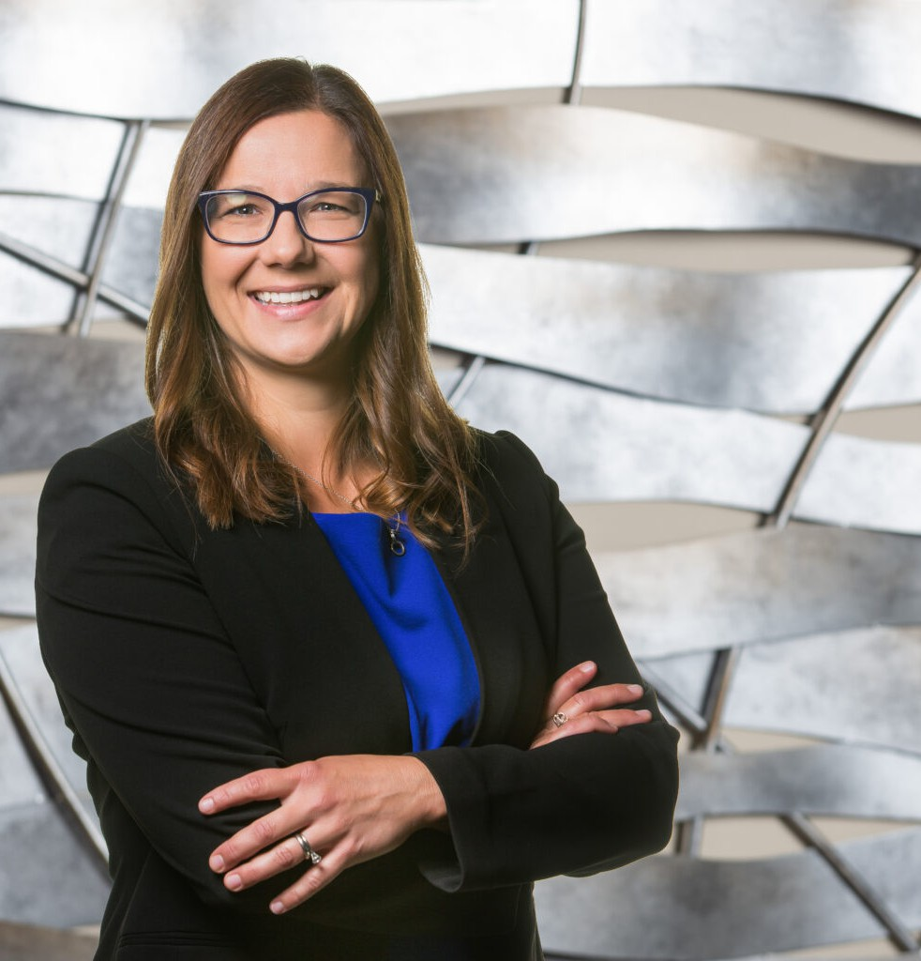

ALICE M. DOSTÁLOVÁ- BUSICK

Of Counsel

[Trusts & Estates](https://www.fennemorelaw.com/services/trusts-estates/)

[Fresno](https://www.fennemorelaw.com/contact-us/fresno/)

P: 559.432.4500

F: 559.432.4590

[adostalovabusick@fennemorelaw.com](mailto:adostalovabusick@fennemorelaw.com)

“

Stay strong, live life.

Brady Busick

**ALICE M. DOSTÁLOVÁ-BUSICK**

”

Alice Dostálová-Busick is an Of Counsel attorney who works in our Trusts & Estates practice group out of our Fresno office. Her work focuses on basic and advanced estate planning, wealth

management, trust administration, business succession and probate. Alice assists her clients to create estate plans that bring them peace of mind by developing, implementing and funding personalized plans suited for that client’s particular goals and wishes. Alice creates both basic and advanced estate plans. Alice also administers basic and complex estates, including trust administration and probate.

Alice earned her Bachelor of Science in Foreign Service from Georgetown University. She attended law school at the University of San Diego School of Law. After law school, Alice initially worked as a litigator focusing on the mortgage banking industry. She later worked on a trust administration litigation case which sparked a passion for creating plans for families that would bring peace of mind to them and their children. Since that time Alice has worked exclusively in the area of creation, planning, implementation and administration of estate plans. To this day, her clients are drawn to her because she includes her clients in the creation process ensuring their needs and wishes are addressed, and explaining the plan to clients so they understand

what the plan says and how it works.

Married with three boys and two stepdaughters, there is never a dull moment in her home. Alice’s life outside of work is family-centric with numerous outdoor activities, including skiing in the winter, and summers at the lake.

# EDUCATION

J.D., University of San Diego School of Law

B.S. in Foreign Service, Georgetown University. *Study Abroad Program,* Karlova Universita, Czech Republic

# AREAS OF PRACTICE

Trusts & Estates Estate Planning

# PROFESSIONAL AND COMMUNITY ACTIVITIES

Member, Wealth Counsel, Fresno Estate Planning Council, Fresno County Bar Member, Probate Section, Fresno County Bar

Member, Board of Directors, Buchanan and Alta Sierra Foundation Director on the Board of Directors for the Central California Ski Team

# ARTICLES AND PRESENTATIONS

[Featuring, “A conversation on motherhood as an attorney and how change can lead to](https://www.fennemorelaw.com/now-i-can-continue-to-nurture-both-my-career-and-my-family/) [better results,” Fennemore Blog, May 18, 2023](https://www.fennemorelaw.com/now-i-can-continue-to-nurture-both-my-career-and-my-family/)

# ADMISSIONS

California

Ninth Circuit Court of Appeals

U.S. District Court for the Eastern District of California

U.S. District Court for the Northern District of California

# LANGUAGES

Czech – Fluent Italian – Fluent Slovakian – Fluent Spanish – Fluent