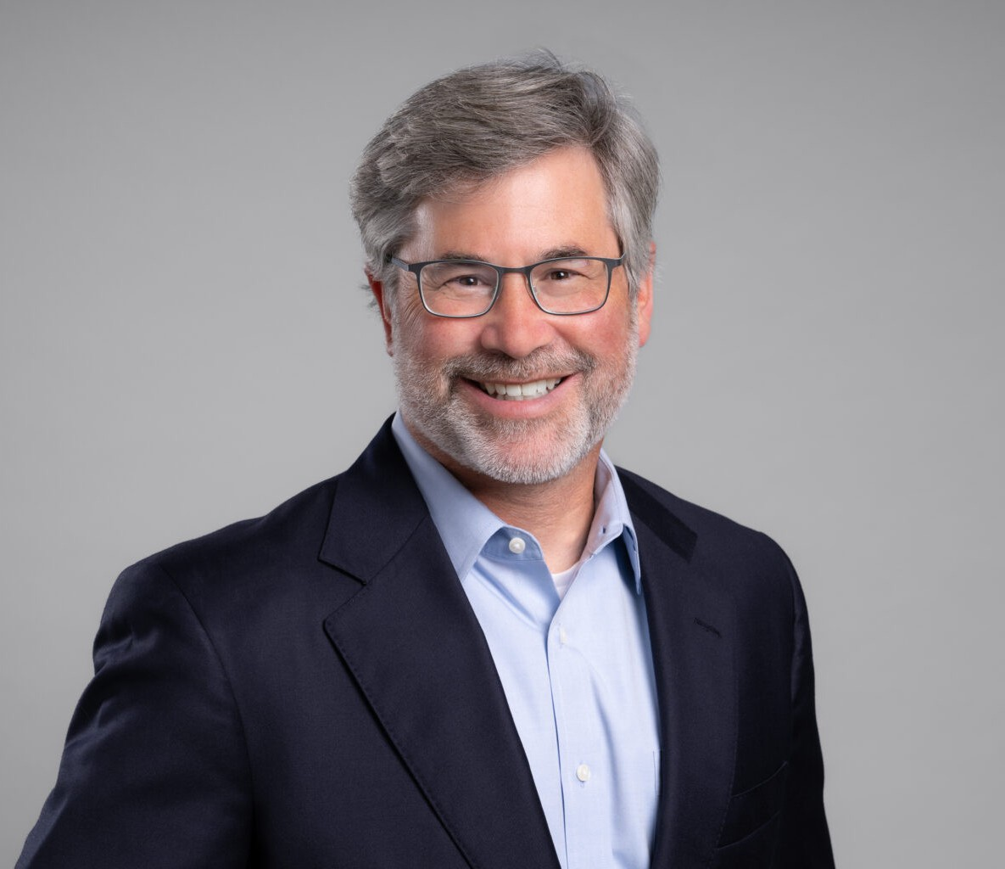

DANIEL B. MYERS

Director

[Real Estate](https://www.fennemorelaw.com/services/real-estate/)

[Oakland](https://www.fennemorelaw.com/contact-us/oakland/)

P: 510.834.6600

F: 510.834.1928

[dmyers@fennemorelaw.com](mailto:dmyers@fennemorelaw.com)

# DANIEL B. MYERS

Dan Myers serves as Vice-Chair of Fennemore’s Real Estate practice group, bringing more than 25 years of experience representing clients in all aspects of complex commercial real estate

transactions. Dan drafts and negotiates transactional documents, including leases, purchase and sale agreements and loan documents. Dan also assists clients in resolving real estate

disputes, and counsels clients on due diligence and land use issues. He has experience drafting green lease provisions and advising clients on the most effective strategies for maximizing real estate holdings and disposing of surplus properties.

In addition to his real estate practice, Dan counsels companies on advertising and promotional matters, representing clients in the fitness, food and retail industries. He reviews advertisements and promotional materials and advises clients on compliance with state and federal advertising, pricing, disclosure, substantiation and sweepstakes laws and regulations.

Dan has presented on real estate and advertising issues at the California State Bar’s Annual Meeting, the Real Property Law Section Retreat, the ICSC Law Conference and the National Retail Tenants Association’s Annual Conference. Dan previously served on the Executive Committee of the Real Property Law Section of the State Bar of California.

He is the co-author of several chapters in *Retail Leasing: Drafting and Negotiating the*

*Lease* and *Office Leasing: Drafting and Negotiating the Lease* published by CEB (Continuing Education of the Bar). In addition to his legal practice, Dan teaches as an adjunct professor at UC Law San Francisco (UC Hastings).

# EDUCATION

J.D., Santa Clara University, School of Law, *summa cum laude*

B.A., University of California, Berkeley, with distinction

# AREAS OF PRACTICE

**OTHER EXPERIENCE**

Advertising

Craft Brewing Real Estate

Food & Beverage Land Use Advanced Energy

# REPRESENTATIVE MATTERS

## Real Estate

Represents regional real estate developer/operator in purchase and sale and leasing transactions for office and mixed-use buildings in Oakland.

Represents national health and fitness center chain in lease transactions throughout California.

Represented biotech and life sciences companies in leasing transactions for lab and office space in Emeryville, San Mateo, Burlingame and South San Francisco.

Represents regional restaurant chain in the acquisition and development of single and multi- tenant retail properties.

Represented multi-state parking garage operator in sale of property for development of high- rise residential building, with right to repurchase office and parking lot commercial condominium units in project.

Represented regional hardware and garden company in leases for new locations and assisted the company in renegotiating leases during bankruptcy proceedings.

Represented financial services firms leasing class-A office buildings in Oakland and San Francisco.

Represented national pet food and food manufacturing company in office and industrial lease transactions across the country and sale of industrial, warehouse and manufacturing facilities.

Represented craft-brewer in negotiating lease for 90,000 square foot industrial building for a brewery, restaurant and offices.

Represented developer in negotiating construction, loan, intercreditor and lease agreements for acquisition, financing, construction and leasing of mixed-use center, including

condominiums, restaurants and parking garage.

## Advertising

Represents fitness and other companies reviewing and providing advice on pricing, advertising and disclosure requirements and best practices.

Assists companies with design and implementation of sweepstakes and promotional activities.

# ARTICLES AND PRESENTATIONS

Featuring, “Fennemore attorney Daniel Myers on Bay Area commercial real estate transactions and trends”, San Francisco Business Times, August 1, 2024

Featuring, “Fennemore attorney Daniel Myers on CRE trends, advice for tenants and landlords”, San Francisco Business Times, May 1, 2023

[Interview, “Twitter vs. Landlord Lawsuit Could Take Years To Resolve,” The Registry, January 23,](https://news.theregistrysf.com/twitter-vs-landlord-lawsuit-could-take-years-to-resolve/) [2023](https://news.theregistrysf.com/twitter-vs-landlord-lawsuit-could-take-years-to-resolve/)

Speaker, “Restaurant Leasing”, National Retail Tenants Association, September 2022 Moderator, “Going Dark”, National Retail Tenants Association, September 2022

Author, “Two Years In: Trends Are Emerging in Commercial Office Leasing,” *Daily Journal,* May 2022

Panelist, “East Bay Developer Forum,” The Registry, May 2022

Roundtable Moderator, “Assignment and Subletting: Trends, Issues and Best Practices,” ICSC Law Conference, November 2021

Speaker, “Estoppels & SNDAs: Just Got One, What Do I Do Now?,” National Retail Tenants Association, February 2021

Author, “Surviving the Retail Apocalypse – Are you Prepared?,” *Retail IT Insights*, June 2020

Speaker, “Commercial Sale Transactions,” Continuing Education of the Bar (CEB) Webinar, October 2019

Speaker, “Commercial Leasing Transactions,” Continuing Education of the Bar (CEB) Webinar, October 2019

Speaker, “CRE Legal Update,” CCIM Institute Northern California Chapter, September 2019

Author, “Office Leasing: Drafting and Negotiating the Lease,” *California Continuing Education of the Bar*, “Chapter 45: Green Leasing,” and update editor

Author, “Retail Leasing: Drafting and Negotiating the Lease,” *California Continuing Education of the Bar*, “Chapters 22 (Signage), 41 (Estoppel Certificates) and 44 (Subordination, Nondisturbance and Attornment),” and update editor

Guest Lecturer, “Key Legal Issues in Advertising,” San Jose State University and California State University East Bay, 2005-2020

# PROFESSIONAL AND COMMUNITY ACTIVITIES

Member, California Lawyers Association, Real Property Law Section Member, International Council of Shopping Centers (ICSC) Member, National Real Estate Tenants Association (NRTA)

Member, Real Estate Section, Alameda County Bar Association

Former Member and Executive Committee member, ProVisors, Oakland 1, and Real Estate Affinity Group

Former Member, Executive Committee, Real Property Law Section, State Bar of California, 2013-2016

Former Member, Niles (Fremont) Rotary, 2005-2013

# ADMISSIONS

California