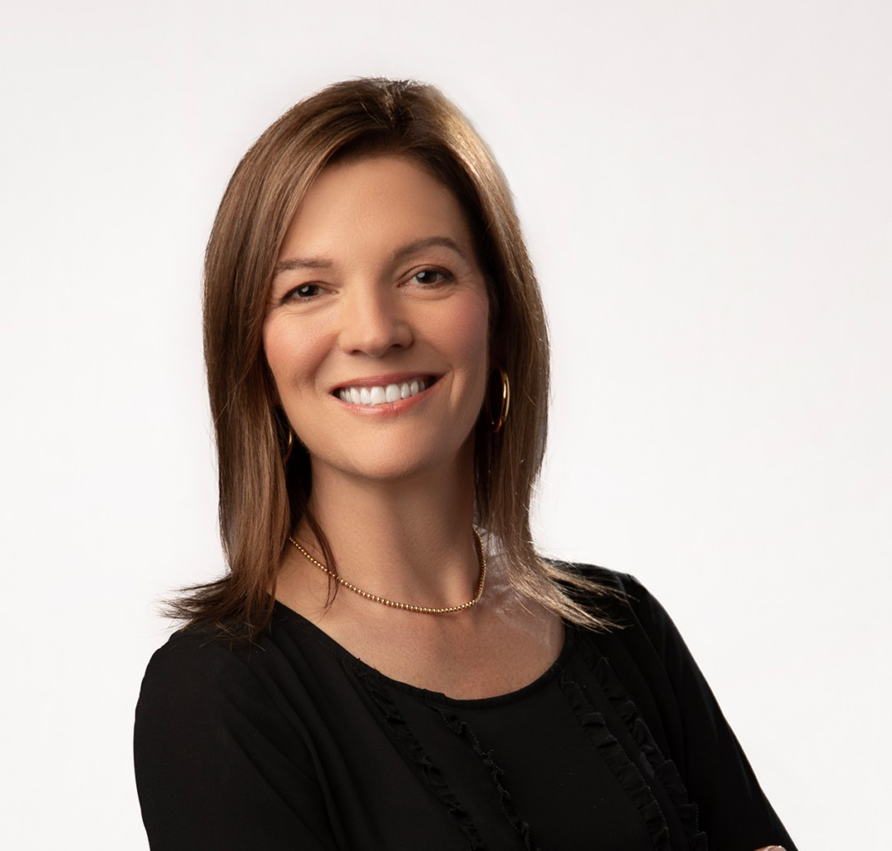

ELIZABETH K. CAMPAGNE

Of Counsel

[Trusts & Estates](https://www.fennemorelaw.com/services/trusts-estates/)

[Fresno](https://www.fennemorelaw.com/contact-us/fresno/)

P: 559.446.3258

F: 559.432.4590

[ecampagne@fennemorelaw.com](mailto:ecampagne@fennemorelaw.com)

# ELIZABETH K. CAMPAGNE

Elizabeth K. Campagne is an Of Counsel attorney in our Trusts & Estates practice group who works out of our Fresno office. She is well known by her clients through both the professionalism and meticulousness she brings to her work in estate planning and trust administration.

She offers families individualized counseling, ensuring their estate plans, from wills and living trusts, to powers of attorney and advance health care directives truly reflect their aspirations. Her comprehensive approach to trust and estate administration provides clients with thorough processes that safeguard their legacy for future generations.

# EDUCATION

J.D., Santa Clara University, School of Law B.A., University of California, Berkeley

# AREAS OF PRACTICE

Trusts & Estates Estate Planning

# AWARDS AND HONORS

Witkin Award for Academic Excellence & CALI Excellence For The Future Award for Estate Planning & Taxation at Santa Clara University School of Law

# PROFESSIONAL AND COMMUNITY AFFILIATIONS

Member, State Bar of California

Member, Trusts and Estates Section, The California Lawyers Association Member, Fresno County Bar Association

# ADMISSIONS

California