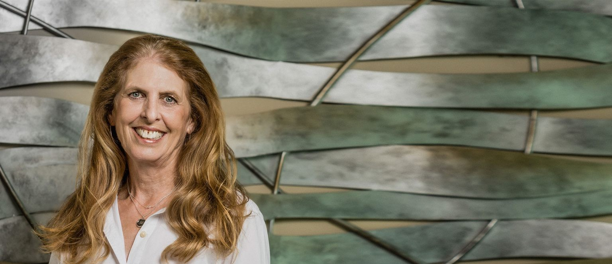

GINA T. MOSS

Paralegal

[Business & Finance](https://www.fennemorelaw.com/services/business-and-finance/)

[Fresno](https://www.fennemorelaw.com/contact-us/fresno/)

P: 559.432.4500 F: 559.432.4590

[gmoss@fennemorelaw.com](mailto:gmoss@fennemorelaw.com)

“

I've learned that people will forget what you said, people will forget what you did, but people will never forget how you made them feel.

- American Poet Maya Angelou

”

**GINA T. MOSS**

Gina Moss is a paralegal in our business and finance and real estate practice groups where her duties include entity formations, dissolutions, mergers and conversions, entity transactions, real property transfers, including searches and document analysis, and other transactional

responsibilities. These tasks included addressing project challenges and reviewing specific details, communicating with clients and attorneys regarding troubleshooting issues and

maintaining project efficiency, assisting with grammar/spelling and other writing skills, analyzing the chronology of events and the subsequent documentation of same, and researching state and other governing agency procedures and compliance requirements. She graduated with a BA in Liberal Studies from Fresno State, and is a member of the Fresno County Legal Professionals Association.

Initially beginning her career to become a special education teacher, Gina detoured and started at a law firm in 1980 as a receptionist, librarian, and court filing clerk. She found the work extremely interesting and enjoyed learning about the various types of law and decided to continue on that path. She ultimately became a legal secretary, and then became certified as a paralegal with her years of experience and her BA. She stresses the importance of “learning by doing” and how that was the best education she had in becoming a paralegal. Gina enjoys providing assistance to staff and new attorneys in a variety of ways, especially reviewing

important project details with them that are crucial in bringing it to completion. Teaching others is very motivating and gratifying for her.

Away from work, you’ll find Gina hanging out with friends and family, cooking and gardening. She also enjoys running, bike riding, swimming, reading, and savoring some of Central California’s finest wines.

# EDUCATION

B.A., Liberal Studies, California State University, Fresno

# AREAS OF PRACTICE

Business & Finance Real Estate

# PROFESSIONAL AND COMMUNITY ACTIVITIES

Member, Fresno County Legal Professionals Association

# ADMISSIONS

*\*Not licensed to the practice of law*