ROBIN L. THORNTON

Director

[Business Litigation](https://www.fennemorelaw.com/services/business-litigation/)

# ROBIN L. “THORNTON

[Oakland](https://www.fennemorelaw.com/contact-us/oakland/)

P: 510.622.7674 F: 510.834.1928

[rthornton@fennemorelaw.com](mailto:rthornton@fennemorelaw.com)

Life is better when you’re laughing. ”

Robin Thornton chairs the Eminent Domain Practice Group at Fennemore. With extensive experience in general civil litigation, she represents public and private entities, businesses, and

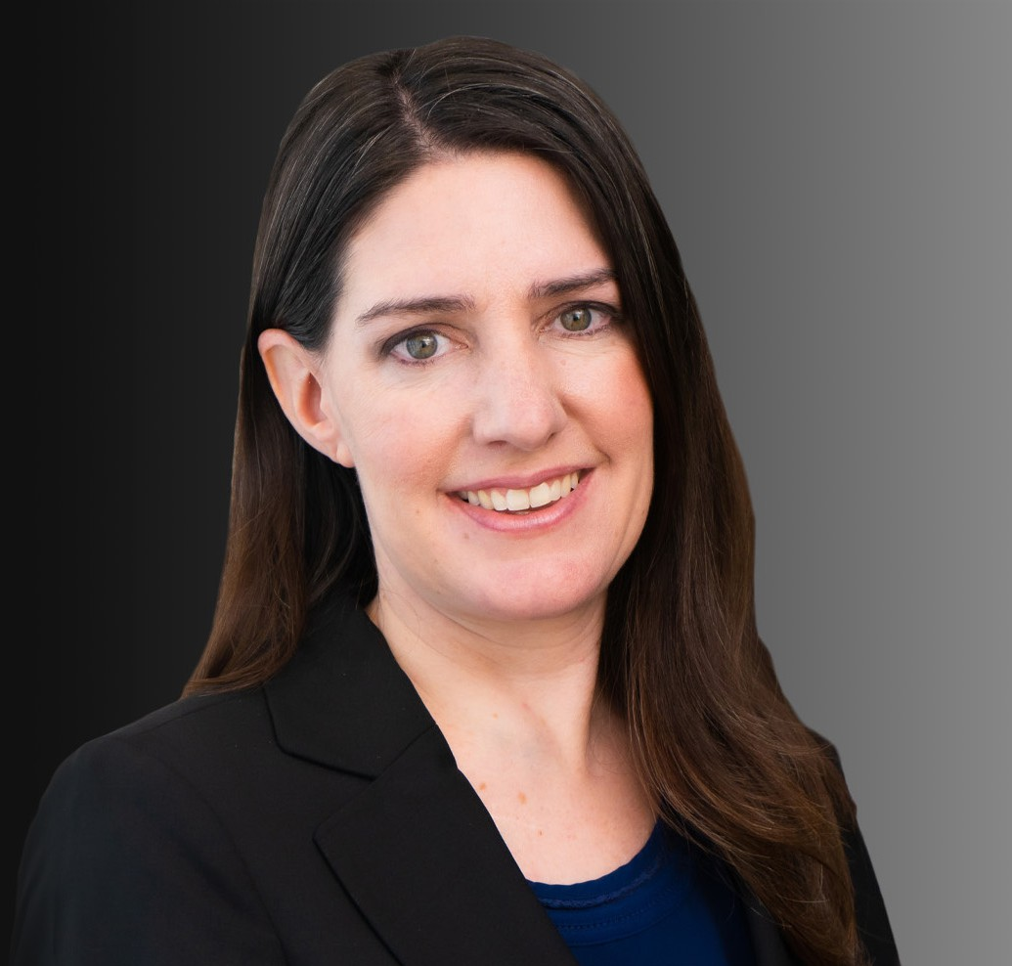

individuals, guiding them through every stage of the legal process—from strategic advisory work to hearings, trials, and appeals. She brings a results-driven approach to valuation-based real property litigation, including eminent domain and assessment appeals.

Robin’s passion for the law began in the fifth grade during a mock trial exercise, a moment that inspired her lifelong dedication to justice. She strives to pay it forward by serving as a court tour docent and moot court volunteer, introducing young students to the legal system and career opportunities in law.

A recognized advocate and industry thought leader, Robin frequently speaks on key legal

topics, collaborating with top professionals and experts to navigate the complexities of property- based litigation. She is committed to delivering innovative solutions and strategic insights, ensuring her clients are well-prepared for the unique challenges their cases may present.

# EDUCATION

J.D., Golden Gate University School of Law B.A., University of California, Berkeley

# AREAS OF PRACTICE

OTHER EXPERIENCE

* Real Estate Litigation
* Insurance
* Public Agency
* Transportation Agencies Business Litigation

Eminent Domain Land Use

Tax Law

Employment & Labor

# REPRESENTATIVE CASES

**Appellate Decisions**

*Navigators Specialty Ins. Co. v. Moorefield Construction, Inc.*, (2016) 6 Cal. App. 5th 1258 (insurance)

*Western States Petroleum Association, v. Board of Equalization*, (2013) 57 Cal. 4th 401 (property tax)

*Mann v. Said*, (2019) 2019 Cal. App. Unpub. LEXIS 6641 [Unpublished] (contract dispute)

*Solano Transportation Authority v. Scherner*, (2020) First Appellate District Case No. A159764 [Petition for Writ Summarily Denied after Preliminary Opposition Filing] (Eminent domain)

*Solano Transportation Authority v. Anderson*, (2020) 2021 WL 1203017 [Unpublished] (Eminent domain)

# AWARDS AND HONORS

Past President, IRWA Chapter Two Sophie Yore Award, IRWA Chapter Two

San Francisco Business Times Bizwomen Mentoring Monday, Mentor, 2023 Professional of the Year, IRWA Chapter Two, 2022-2023 Term

Most Influential Women in Bay Area Business Honoree, San Francisco Business Times, 2022 Legal Visionary in the Business of Law, L.A. Times, 2021

Rising Star, Eminent Domain, *Northern California Super Lawyers*®, 2013-2020

Top Women Attorneys in Northern California, San Francisco Magazine, 2013-2020

# ARTICLES AND PRESENTATIONS

Speaker, Eminent Domain – Annual Legal Update – International Right of Way Association, Chapter Two Luncheon; International Right of Way Association, Chapter 42 Luncheon, 2021- 2025

Speaker, The Uphill Battle: Overcoming Negative Perceptions of Eminent Domain at Trial, IRWA Conference – Long Beach, CA, 2024

Speaker, Conservation Easements in California, IRWA Conference – Long Beach, CA, 2024 Speaker, Larger Parcel, Appraisal Institute – Northern California, 2024

Speaker, Race in Right-of-Way, IRWA Education Conference – Denver, CO, 2023

Speaker, Cases of Consequence: Highlights of Authorities for Testifying Appraisers, Appraisal Institute Spring Conference, 2023

Moderator / Organizer, IRWA Region 1, Spring Forum, 2023

Speaker, “Eminent Domain – Annual Legal Update – International Right of Way Association”, Chapter Two Luncheon; International Right of Way Association, Chapter 42 Luncheon, 2021- 2025

Featured, “Bizwomen Mentoring Monday,” San Francisco Business Times, February 2023

Featured, “Influential Women 2022: Robin Thornton of Fennemore Wendel,” San Francisco Business Times, October 13, 2022

Speaker, Most Injurious Use: Ways to Use It, Abuse It, and What the Courts Are Saying About It, CLE Eminent Domain Conference, San Francisco, 2022

Presenter, “What’s Mine May be Yours: An Introduction to Real Property Transfers,” Wendel Rosen Webinar, 2021

Speaker, “An Introduction to Easements,” County Counsels’ Association of California, 2021

Speaker, “The Sanchez/Stamps Hearsay Rule: Saving Expert Opinions Based on Out-of-Court Statements of Others,” Appraisal Institute, Northern California Chapter, 2021

Speaker, “Into the Unknown: Condemnation in the COVID-Era,” International Right of Way Association, Chapter Two Luncheon, 2020

Speaker, “Precondemnation Damages: Hidden Dangers in Project Planning,” International Right of Way Association, Chapter Two Luncheon, 2019

Speaker, “Property Dedications: Rough Proportionality in the Age of Trump,” CLE Eminent Domain Conference, San Francisco, 2018

Speaker, “Potential Impacts from Temporary Construction Easement Acquisitions,” International Right of Way Association, Annual Conference, Anchorage Alaska, 2017

Speaker, “Precondemnation Offers / Appraisals: Right‐of‐Way / Legal Strategies for Successful Project Delivery,” International Right of Way Association, Chapter Two Luncheon, 2017

Speaker, “Front End Issues and the Right‐of‐Way Process: An Introduction to Precondemnation Appraisal and a Case Study on Identification of Early Issues,” Appraisal Institute Fall Litigation Conference, San Francisco, 2017

# PROFESSIONAL AND COMMUNITY ACTIVITIES

Member, Alameda County Bar Association and Contra Costa County Bar Association Treasurer and Inns of Court, International Right of Way Association (IRWA)

Executive Board, International Right of Way Association (IRWA), Chapter Two, 2020-2023 Inns of Court (past member)

# ADMISSIONS

California

U.S. District Court, Northern District of California

U.S. District Court, Southern District of California