STEVEN D. MCGEE

Director

[Business Litigation](https://www.fennemorelaw.com/services/business-litigation/)

# STEVEN D“. MCGEE

[Fresno](https://www.fennemorelaw.com/contact-us/fresno/)

P: 559.432.4500 F: 559.432.4590

[smcgee@fennemorelaw.com](mailto:smcgee@fennemorelaw.com)

Listen, learn, solve the problem. Always act with integrity. ”

Steven McGee is a business trial lawyer and the managing partner of our Fresno office. His practice includes a wide range of commercial and real estate matters, with substantial emphasis on construction, real estate issues and business litigation. His clients include business

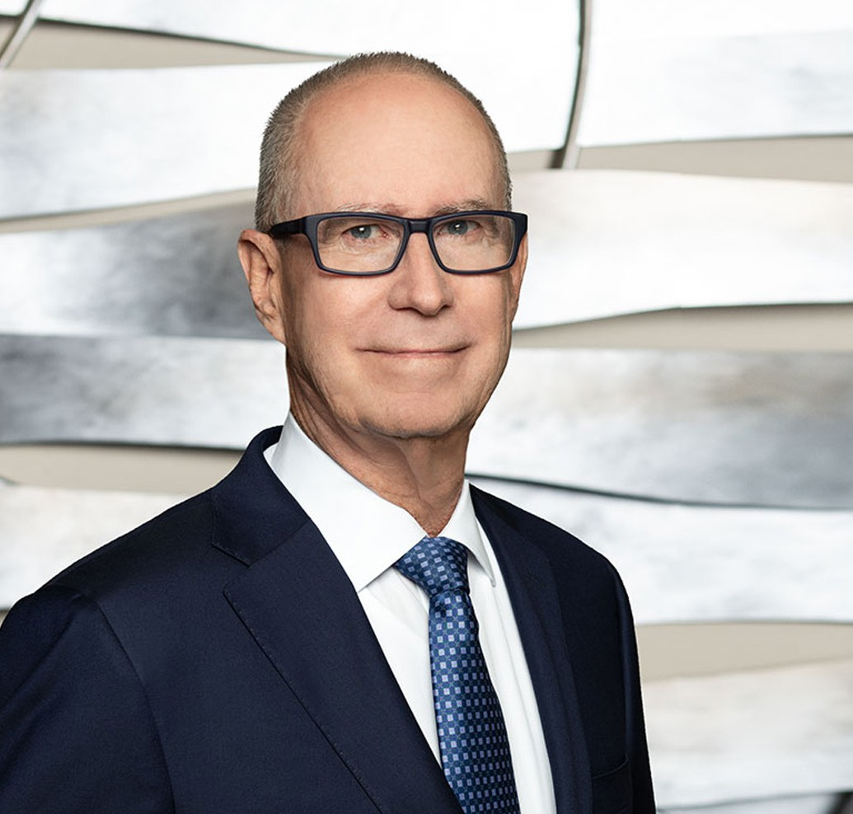

entities, contractors, design professionals, real estate developers, and agribusiness firms. Steven has over 40 years of trial experience in state and federal courts, as well as commercial and judicial arbitration proceedings. He is an American Arbitration Association arbitrator, serving on its construction industry and commercial arbitration panels.

Steven practiced law at Dowling Aaron in Fresno before it merged with Fennemore in 2020. He believes clients trust him to look out for their best interests, and he takes great satisfaction in helping clients achieve successful resolution of pending disputes.

Steven has been invited to be a speaker at a number of Lorman and NBI seminars where he has presented with local judges on trial practice and trial techniques, and has been a featured speaker on topics including construction related remedies and mechanics lien laws. He is an “AV” rated attorney by Martindale-Hubble and was selected for inclusion in the Northern California *Super Lawyers®* list (2006 through present), and a *Super Lawyers®* Top 100 Attorney in Northern California from 2008 through 2019.

Steven is married with five adult children, and he enjoys spending time with extended family, traveling, and is an avid San Francisco Giants fan. He supports a number of local charities

including the Central California Food Bank, Fresno Mission, and the National Alliance on Mental Illness.

# EDUCATION

J.D., University of San Diego School of Law

B.S., Business Administration, California State University, Fresno

# AREAS OF PRACTICE

**OTHER EXPERIENCE**

Alternative Dispute Resolution Construction Law and Litigation Business Litigation

Construction Law Real Estate

# AWARDS AND HONORS

*Northern California Super Lawyers®,* 2006-2024

*Super Lawyers®,* Top 100 in Northern California, 2008-2019

AV® Preeminent™ Peer Review Rated (the highest rating available), by Martindale-Hubbell

# PROFESSIONAL AND COMMUNITY ACTIVITIES

Panelist, American Arbitration Association-Construction Industry and Commercial Arbitration Member, American Bar Association- Construction Industry Forum

Association of Business Trial Lawyers (ABTL), San Joaquin Valley Chapter-Board Member and Past President

Member, Legal Advisory Committee to the Associated General Contractors of California Member, Federal Bar Association

Member, State Bar of California

# ADMISSIONS

California

U.S. District Court, Central District of California

U.S. District Court, Eastern District of California

U.S. District Court, Northern District of California

U.S. District Court, Southern District of California

U.S. Court of Appeals, Ninth Circuit

U.S. Supreme Court