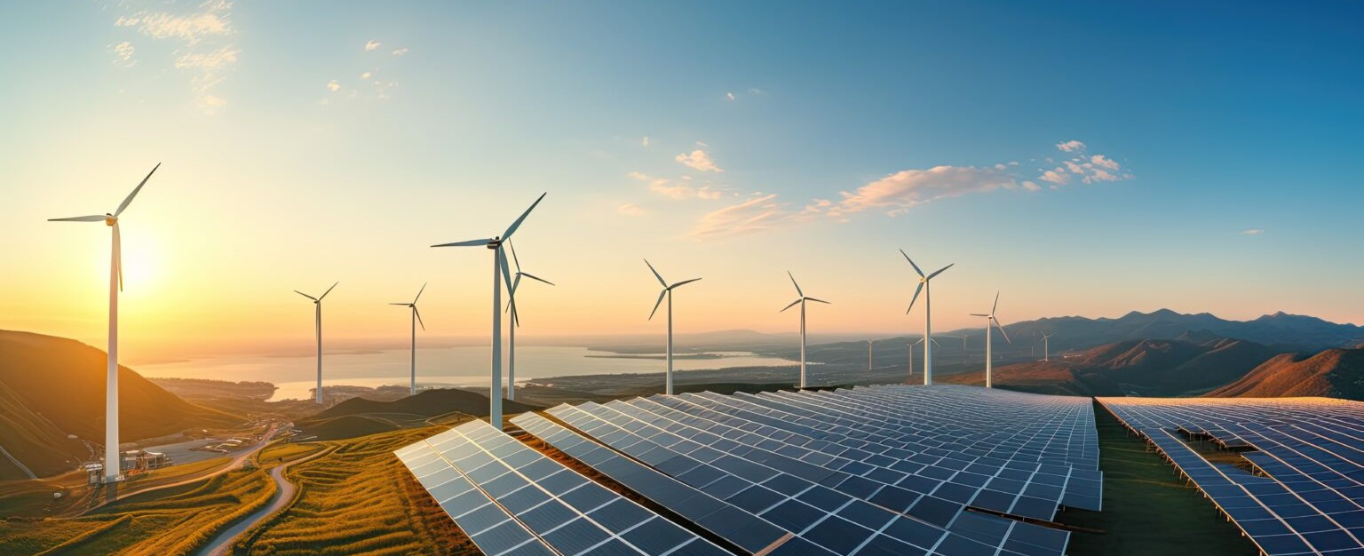

Fennemore’s Advanced Energy team provides full-service representation for renewable and next- generation energy producers, developers, and manufacturers. We counsel on facilities and business development, assist in corporate and finance matters, advise on development and construction issues, and assist with risk management and regulatory compliance strategies.

Our attorneys provide full-service representation to alternative,

renewable, and next-generation energy producers, developers, and manufacturers.

**Advanced Energy**

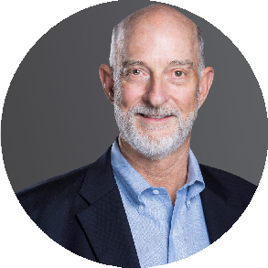[ADVANCED](https://www.fennemorelaw.com/services/advanced-energy/) [ENERGY](https://www.fennemorelaw.com/services/advanced-energy/)

[BUSINESS &](https://www.fennemorelaw.com/services/business-and-finance/) [FINANCE](https://www.fennemorelaw.com/services/business-and-finance/)

**LEADERSHIP**

[ADVANCED](https://www.fennemorelaw.com/services/advanced-energy/) [ENERGY](https://www.fennemorelaw.com/services/advanced-energy/)

[BUSINESS &](https://www.fennemorelaw.com/services/business-and-finance/) [FINANCE](https://www.fennemorelaw.com/services/business-and-finance/)

****[**Edward D. "Ted"**](https://www.fennemorelaw.com/people/attorneys/edward-d-ted-white/)[**White**](https://www.fennemorelaw.com/people/attorneys/edward-d-ted-white/)

Co-Chair

[**Denver**](https://www.fennemorelaw.com/contact-us/#denver-2)

PH 303.813.3896

FX 303.291.3201

[twhite@fennemorela](mailto:twhite@fennemorelaw.com) [w.com](mailto:twhite@fennemorelaw.com)

[**Zaki Robbins**](https://www.fennemorelaw.com/people/attorneys/zaki-robbins/)

Co-Chair

[**Denver**](https://www.fennemorelaw.com/contact-us/#denver-2)

PH 303.813.3857

FX 303.291.3201

[zrobbins@fennemorel](mailto:zrobbins@fennemorelaw.com) [aw.com](mailto:zrobbins@fennemorelaw.com)

**ABOUT**

Understanding how the industry operates, we bring skills from a broad range of disciplines to advance our clients in this evolving arena. Our team is involved in more than just the legal issues. For example, one of our partners, Ted White, is on the board of directors of a research and consulting company (a “think-and-do tank”) that collaborates with and advises on global,

national, and local advanced energy projects and distributed resources. As a team, we work with leading industry groups to create structures that commercialize innovative technologies and distribution models.

Our approach includes a focus on community buy-in and education, with local governmental and public support as keys to successful project development. Our team has successfully turned strong local concern into support for advancing the project.

**EXPERIENCE**

# Our experience includes:

Power purchase, virtual power purchase, and structure agreements Transmission and interconnection agreements

Project development agreements

Engineering, procurement, and construction agreements

Site selection, land use and real estate, including regulatory assessment Easements, rights-of-way, and eminent domain

Project acquisition and financing

FERC, state commissions, and other administrative agency proceedings (rulemakings and adjudications)

Joint venture formation and structure Technology transfer and licensing Litigation

Judicial review of agency actions

Seeking federal, state, and local energy and economic incentives

**TRACK RECORD**

# Our track record includes:

Negotiated power purchase agreements, virtual power purchase agreements, LGIPs, LGIAs, government purchase contracts and EPC agreements.

Acted as outside general counsel for a technology company that developed a patented high-throughput manufacturing measurement system that evaluates the residual and handling stresses and defects in photovoltaic (PV) silicon wafers.

Delivered primary legal counsel for day-to-day operations of an international clean energy company with solar, hydroelectric, wind, carbon trading and consulting divisions; assistance included public offering and sale.

Provided merger and acquisition services for advanced energy production facilities. Represented a private equity fund that invests in energy technology companies.

Served as project counsel to development, finance and construction arm of advance generation facility in Honduras, combining solar, battery storage and advanced reciprocating generation.

Advised nonprofit on creation of technology accelerator for startups developing solutions to combat climate change.

Worked with venture capital fund on over $30 million in early stage technology investments focused on sustainable manufacturing.

Provided comprehensive representation to a large geothermal company in both the litigation and transactional arenas.

Represented a public energy technology company in developing and implementing a long- term strategic financial plan, including public and private financing asset divestiture, a sale to

an overseas fund, and complex restructuring of debt and equity securities.

Lead counsel in connection with the creation of a global non-profit organization focused on accelerating blockchain technology development across the energy sector.

Representation of renewable energy developers in Federal Energy Regulatory Commission

(FERC) proceedings, and with Large Generator Interconnection Procedures (LGIP) and Large Generator Interconnection Agreement (LGIA) issues.

Lead counsel for the development, construction, and operation of utility scale wind and solar developments in multiple states, including Colorado, Texas, and Wyoming.

Represented venture capital fund in $2 million investment in startup developing solutions to combat climate change.