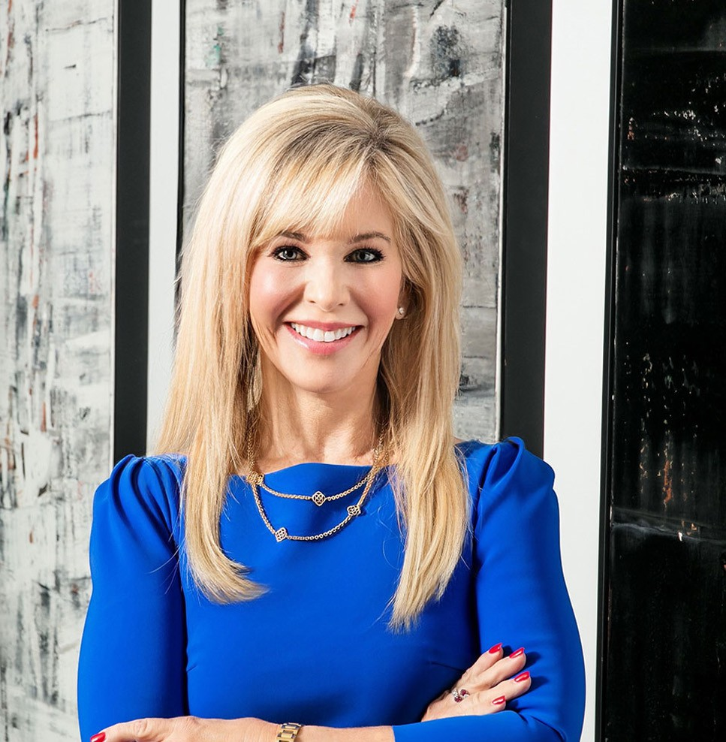

ALEXIS J. GLASCOCK

Pronouns: she/her

Director

[Business & Finance](https://www.fennemorelaw.com/services/business-and-finance/)

[Phoenix](https://www.fennemorelaw.com/contact-us/phoenix/)

P: 602.916.5488 F: 602.916.5688

[aglascock@fennemorelaw.com](mailto:aglascock@fennemorelaw.com)

“

Keep your mind on your objective, and persist until you succeed. Study, think, plan and advocate.

-W. Clement Stone

”

**ALEXIS J. GLASCOCK**

Alexis Glascock is chair of our Government Relations and Regulatory practice group, where she focuses on assisting businesses and associations to achieve their goals by advocating for or opposing changes to laws at the Legislature, agency, county and municipal level. Alexis has worked in both private practice and in senior staff positions in state government. She has served both as counsel to the President of the Arizona Senate and Assistant to the General Counsel of the Legislative Council. She effectively drafted and ensured the passage of complex legislation and was instrumental in halting or modifying legislation contrary to the interest of the majority

caucus.

While at the Legislative Council, Alexis co-authored a motion to protect the legislative privilege of legislative documents related to the national tobacco litigation, second chaired the hearing on the motion, and reviewed over 3,000 legal opinions to create a searchable data system and summary of these opinions. Additionally, Alexis garnered experience at the federal level during her tenure with the majority leadership of the Joint Economic Committee of the United States Congress. In that role, she selected witnesses to testify before the Committee on numerous

economic issues and published a three volume series on the economic impact of women in the labor market. She also assisted with the annual Economic Report of the Joint Economic

Committee.

Alexis has lobbied for clients including the [American Heart Association](https://www.heart.org/en/affiliates/arizona/phoenix), the Arthritis Foundation, the Arizona Association of Health Care Plans, the Arizona Cardinals, the Arizona Uniform Laws

Commission, and the [Greater Phoenix Economic Council](https://www.gpec.org/). She also has successfully assisted with the passage of bills in industries ranging from trucking to trampolines.

Away from work, Alexis spends time with her family, whether it’s watching her children play

sports, participating in family sporting activities or simply enjoying weekends together watching movies. She also enjoys playing tennis, skiing, biking and hiking, and has completed six half-

marathons.

# EDUCATION

J.D., University of Virginia School of Law

M.A., Harvard University Graduate School of Arts and Sciences

Masters Thesis: Technology Transfer to China, A Look at the Societal, Political, and Economic Aspects that Drive Success.

B.A., Double Major in Economics and in Chinese Studies, Wellesley College

# AREAS OF PRACTICE

Business & Finance

Government Relations & Regulatory Health Care

# REPRESENTATIVE CASES

Represents the Arizona Psychiatric Society and the Arizona Otolaryngology Association Represents the American Heart Association at the Arizona Legislature

Represents the Arthritis Foundation regarding health care and other issues at the Arizona Legislature

Represents the Uniform Laws Commission at the Arizona Legislature Represents Polaris Industries, Inc.

Represents the Community Associations Institute

Represents the West Valley Chambers of Commerce Alliance

# AWARDS AND HONORS

“Best Lobbyist of the Capitol” 2023 Honoree, *Arizona Capitol Times*

“2022 Leader of the Year Award” Political Lawyer, *Arizona Capitol Times*

“Best of the Capitol” 2022 Honoree – Best Capitol/Political Lawyer, *Arizona Capitol Times*

“2021 Athena Award Honoree”, Greater Phoenix Chamber of Commerce

Ranking Arizona Businesses, Law Firms: Government Relations Number 1 in State, AZ Big Media, 2021

*Best Lawyers in America®,* Administrative/Regulatory Law, Government Relations Practice, 2020-2025

Honoree, 2020 Women Achievers of Arizona, *Arizona Capitol Times*

Heart of a Hero Award, American Heart Association, 2018

# ARTICLES AND PRESENTATIONS

Author, “T[rending in 2025: Current Federal and State Laws Have Set Arizona Up for Technology](https://inbusinessphx.com/economy-trends/trending-in-2025-forecasting-strengths-and-challenges-in-our-key-economic-sectors) [and Housing Growth](https://inbusinessphx.com/economy-trends/trending-in-2025-forecasting-strengths-and-challenges-in-our-key-economic-sectors),” Greater Phoenix InBusiness Magazine, January 8, 2025

Author, “Arizona’s technology and housing sectors are positioned for growth in 2025, hopefully,” Town of Paradise Valley Independent, January 2, 2025

Author, “[Arizona’s technology and housing sectors are positioned for growth in 2025,](https://www.yourvalley.net/stories/arizonas-technology-and-housing-sectors-are-positioned-for-growth-in-2025-hopefully%2C555004) [hopefully](https://www.yourvalley.net/stories/arizonas-technology-and-housing-sectors-are-positioned-for-growth-in-2025-hopefully%2C555004),” Daily Independent, January 2, 2025

Presenter, “Legislative Panel,” Southwest Valley Chamber of Commerce, October 2024

Author, “Public Policy: New Arizona laws that mean business,” Glendale Chamber Voice of Business, Fall 2024

Interview, “[Key highlights from the Arizona Legislative Session](https://azpbs.org/horizon/2024/06/arizona-legislative-session-highlights/),” Arizona PBS, June 26, 2024

Author, “Public Policy: Forum Discusses Water Conservation and the Future of Water in Arizona,” The Voice of Business Glendale Chamber, Spring 2024

Author, “Arizona Again Ranks Among the Top Swing States for the 2024 National Elections,” The Voice of Business Glendale Chamber, Winter 2024

Presenter, “Water Forum,” Glendale Chamber Of Commerce, January 26, 2024

Author, “Legislation Furthers Economic Development in the State,” The Voice of Business, Fall 2023

Presenter, “National Trends in State Health Care Legislation,” SCG’s Legal 2023 Annual Meeting, September 21, 2023

Author, “Protecting children from their opportunistic social influencer parents,” Arizona Capitol Times, September 19, 2023

Presenter, “Child Influencer Compensation,” Fox 10, August 25, 2023

Author, “Protecting children from their opportunistic social influencer parents,” Arizona Digital Free Press, 2023

[Author, “Tax credits and incentives for Arizona businesses from Inflation Reduction Act,” AZ Big](https://azbigmedia.com/business/tax-credits-and-incentives-for-arizona-businesses-from-inflation-reduction-act/) [Media, April 6, 2023](https://azbigmedia.com/business/tax-credits-and-incentives-for-arizona-businesses-from-inflation-reduction-act/)

[Author, “A roadmap to credits and incentives from the Inflation Reduction Act,” Phoenix](https://www.bizjournals.com/phoenix/news/2023/04/03/tax-credits-from-inflation-reduction-act.html) [Business Journal, April 3, 2023](https://www.bizjournals.com/phoenix/news/2023/04/03/tax-credits-from-inflation-reduction-act.html)

Featuring, “Celebrating women who tell our stories – CAI’s female legislative advocates,” Community Associations Institute, March 9, 2023

[Featured, “Congratulations to our 2022 ‘Leaders of the Year,’” Arizona Capitol Times, August](https://azcapitoltimes.com/leaders-of-the-year/) [27, 2022](https://azcapitoltimes.com/leaders-of-the-year/)

[Interview, “Legislative Session, Solar Energy, and Cristela Alonzo,” Arizona PBS, July 7, 2022](https://azpbs.org/horizon/2022/07/legislative-session-solar-energy-and-cristela-alonzo/)

[Author, “Here’s how Arizona businesses can win federal infrastructure funds,” AZ Big Media,](https://azbigmedia.com/business/heres-how-arizona-businesses-can-win-federal-infrastructure-funds/) [August 2, 2022](https://azbigmedia.com/business/heres-how-arizona-businesses-can-win-federal-infrastructure-funds/)

[Interview, “Legislative Update,” AZ PBS, July 7, 2022](https://protect-us.mimecast.com/s/drJ9C82XWzsYxDM2hnJC2Y?domain=azpbs.org)

[Author, “How to Cash in on Infrastructure Dollars Coming to Arizona,” AZ Big Media, June 6,](https://azbigmedia.com/business/how-businesses-can-cash-in-on-infrastructure-dollars-coming-to-arizona/) [2022](https://azbigmedia.com/business/how-businesses-can-cash-in-on-infrastructure-dollars-coming-to-arizona/)

[Author, “How Businesses Can Cash In On Infrastructure Dollars Coming to Arizona,” AZ Big](https://azbigmedia.com/business/how-businesses-can-cash-in-on-infrastructure-dollars-coming-to-arizona/) [Media, April 6, 2022](https://azbigmedia.com/business/how-businesses-can-cash-in-on-infrastructure-dollars-coming-to-arizona/)

[Author, “Federal Infrastructure Funds are Flowing to Arizona: How Local Businesses Tap In,”](https://www.bizjournals.com/phoenix/news/2022/04/01/federal-infrastructure-funds-are-flowing.html) [Phoenix Business Journal, April 1, 2022](https://www.bizjournals.com/phoenix/news/2022/04/01/federal-infrastructure-funds-are-flowing.html)

Speaker, “2021 Arizona Legislative Session,” WeServ Arizona Legislative Session Overview Meeting, November 3, 2021

Speaker, “Arizona Rules of Professional Conduct for Government Relations Attorneys,” State Bar of Arizona, September 28, 2021

Speaker, “The Impact of COVID-19 on Government Relations,” SCGLegal’s 2021 Annual Meeting in San Francisco, September 24, 2021

Speaker, “Recently Passed Arizona Law to Limit COVID-10 Liability Claims Against Businesses and Other Entities,” Association of Corporate Counsel, Arizona Chapter, September 2, 2021

Interview, “Chat with the President,” Southwest Valley of Chamber Commerce, August 19, 2021

[Interview, “Relationships built on trust and years of working together,” Fennemore Blog, August](https://www.fennemorelaw.com/relationships-built-on-trust-and-years-of-working-together/) [5, 2021](https://www.fennemorelaw.com/relationships-built-on-trust-and-years-of-working-together/)

Interview, “4 New Arizona Laws That May Impact You,” 12 News NMC, July 7, 2021

[Author, “My View: Measure to Stop Arizona Forced Condo Conversion to be Included in Final](https://www.bizjournals.com/phoenix/news/2021/06/28/condo-conversion-measure-arizona-state-budget.html) [Budget,”](https://www.bizjournals.com/phoenix/news/2021/06/28/condo-conversion-measure-arizona-state-budget.html) [*Phoenix Business Journal*, June 29, 2021](https://www.bizjournals.com/phoenix/news/2021/06/28/condo-conversion-measure-arizona-state-budget.html)

Speaker, “Protect Your Business, Charter School or Healthcare Entity from COVID-19 Claims by Customers or Employees,” Association of General Counsel, Fennemore Webinar, June 2, 2021

[Author, “New Sports Betting Law Means Increased Revenue for State, Tribes,”](https://azcapitoltimes.com/news/2021/04/23/new-sports-betting-law-means-increased-revenue-for-state-tribes/) [*Arizona Capitol*](https://azcapitoltimes.com/news/2021/04/23/new-sports-betting-law-means-increased-revenue-for-state-tribes/)[*Times*, April 23, 2021](https://azcapitoltimes.com/news/2021/04/23/new-sports-betting-law-means-increased-revenue-for-state-tribes/)

[Author, “Their Take: Proposed Modification of State’s Unemployment Insurance,”](https://inbusinessphx.com/government-compliance/their-take-proposed-modification-of-states-unemployment-insurance#.YHiuhOhKgUG) [*InBusiness*,](https://inbusinessphx.com/government-compliance/their-take-proposed-modification-of-states-unemployment-insurance#.YHiuhOhKgUG) [April 12, 2021](https://inbusinessphx.com/government-compliance/their-take-proposed-modification-of-states-unemployment-insurance#.YHiuhOhKgUG)

Quoted, “Legal Implications of Utah’s Proposed Prenatal Expenses Law,” Fox 10 Arizona, April 8, 2021

Quoted, “Here’s how bill protects businesses from COVID-19-related lawsuits,” *AZ Big Media*, March 31, 2021

[Author, “COVID-19 Business Restrictions Update: Don’t Let it Surprise You,” Fennemore Client](https://www.fennemorelaw.com/insights/newsletters/2021/covid-19-business-restrictions-update-don-t-let-it-surprise-you) [Alert, March 10, 2021](https://www.fennemorelaw.com/insights/newsletters/2021/covid-19-business-restrictions-update-don-t-let-it-surprise-you)

Speaker, “Lobbying—What to Expect and Registration Process,” State Bar of Arizona, January 14, 2021

Interview, “SCGGlobalSpin USA 2020 Presidential Election Executive Branch Discussion Part 1,” SCGGlobalSpin, October 6, 2020

Presenter, “Legislative Session and Legislation to Limit Liability for Businesses Should an Employee or Customer Bring a Claim That They Contracted COVID-19 on the Business Premises,” Community Associations Institute, June 2, 2020

Presenter, “Update: 2020 Legislative Session,” Scottsdale Chamber of Commerce, May 26, 2020

Quoted, “Business Briefcase,” *Peoria Times*, May 21, 2020

[Co-author, “Get up to 100% Forgivable Loan from the SBA,”](http://inbusinessphx.com/in-business/get-up-to-100-forgivable-loan-from-the-sba#.XodQk8hKhhG) [*InBusiness*, April 1, 2020](http://inbusinessphx.com/in-business/get-up-to-100-forgivable-loan-from-the-sba#.XodQk8hKhhG) [Author, “Chamber Alliance Promotes West Valley Business Interest to State Legislators,”](https://issuu.com/raxxdirect/docs/living_mag_lg_fall19-lores/28)

[*Glendale Living,*](https://issuu.com/raxxdirect/docs/living_mag_lg_fall19-lores/28)[November 21, 2019](https://issuu.com/raxxdirect/docs/living_mag_lg_fall19-lores/28)

Speaker, “Best Practices for Lobbyists to Develop Legislation Work with Legislative Council,” State Bar of Arizona: A Funny Thing Happened on the Way to the Capitol, June 21, 2018

[Interview, “Arizona Lawmakers Pass New Laws on Photo RADAR, Physician Credentialing,](https://azpbs.org/horizon/2018/05/arizona-lawmakers-pass-new-laws-on-photo-radar-physician-credentialing-sober-living-facilities-and-more/) [Sober Living Facilities and More,” Arizona PBS, May 16, 2018](https://azpbs.org/horizon/2018/05/arizona-lawmakers-pass-new-laws-on-photo-radar-physician-credentialing-sober-living-facilities-and-more/)

Author, “New Law Protect Those With Disabilities, Businesses,” *Arizona Attorney,* December 2017

Speaker, “Arizona Americans with Disabilities Act and Fair Housing,” West Valley Realtor’s Association, WeMarr, November 2017

Co-author, “Be Aware of Changes to Phoenix’s Rules for Lobbyists,” *The Arizona Republic*, October 25, 2017

Author, “Review of City of Phoenix Lobbying Ordinance Requirements,” Fennemore Client Alert, October 25, 2017

Speaker, “What Your Business Needs to Know About Changing ADA Compliance Law,” Fennemore Seminar, June 14, 2017

Speaker, 2017 Arizona Bankers Association Annual Convention and Meeting, June 9, 2017

Speaker, “Federal and State Legislation to Address Litigation Regarding the Americans with Disabilities Act,” Greater Phoenix Chamber of Commerce, June 2017

Speaker, “Overview of Legislation at the Federal and State Level to Protect Businesses from Litigation Arising Under the American with Disabilities Act,” 2017 Arizona Bankers Association Annual Convention and Meeting, June 2017

Speaker, “WHO, WHAT, WHERE, WHEN: The Future of ADA Litigation and Legislation” Fennemore Labor and Employment Seminar, May 4, 2017

Speaker, “ADA Compliance,” AZ Bankers Association April Seminar, April 18, 2017 [Speaker, “New Laws Impacting Business,” Arizona PBS, June 6, 2016](https://azpbs.org/horizon/2016/06/new-laws-impacting-business/)

# PROFESSIONAL AND COMMUNITY ACTIVITIES

Member, Sandra Day O’Connor Ladies of the Court Committee at the O’Connor House, Sandra Day O’Connor Institute for American Democracy

Member, Foundation Board of Trustees, Barrow Neurological Institute Member, Board of Directors, Arizona Chamber of Commerce and Industry Member, Board of Directors, Harvard Club of Phoenix

Member, Desert Foundation Auxiliary

Member, American Heart Association Heart Ball

Member, Nominating Committee, Phoenix Country Day School Parent’s Association Gala Chairman, Phoenix Symphony, 2008

Benefit Chairman, Crisis Nursery, 2004

# ADMISSIONS

Arizona

Washington, D.C.

U.S. District Court District of Arizona

U.S. Court of Appeals Ninth Circuit