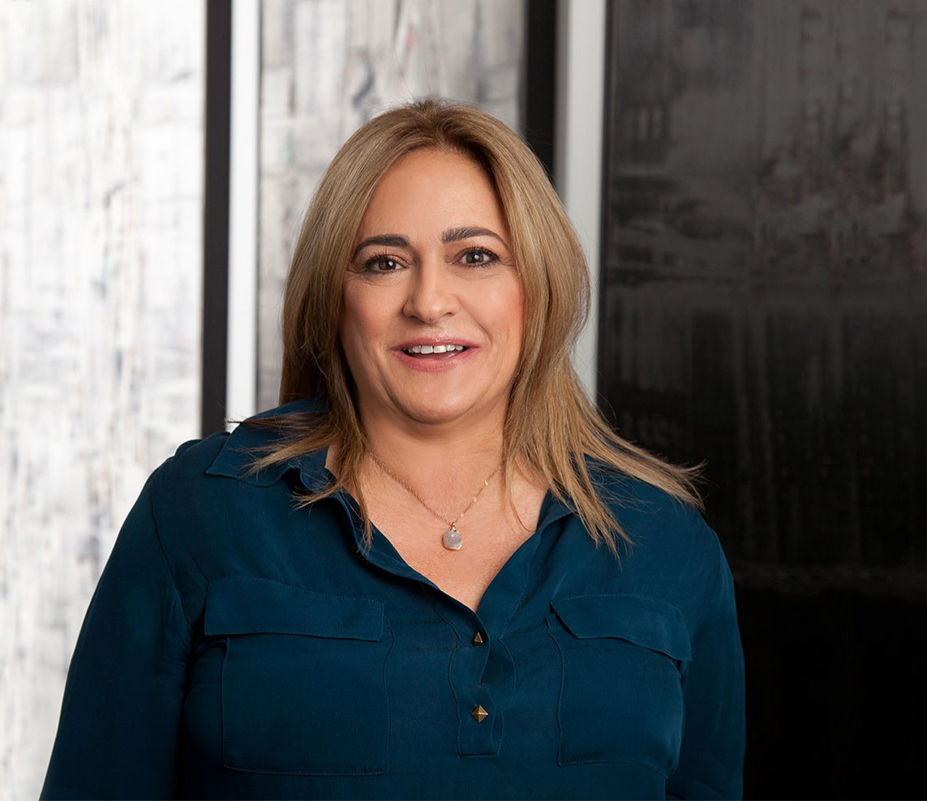

BRUNA E. PEDRINI

Director

[Employment & Labor](https://www.fennemorelaw.com/services/employment-and-labor-relations/)

[Phoenix](https://www.fennemorelaw.com/contact-us/phoenix/)

P: 602.916.5487

F: 602.916.5687

[bpedrini@fennemorelaw.com](mailto:bpedrini@fennemorelaw.com)

**BRUNA E. PEDRINI**

Bruna focuses her practice on education law and employment law, with a particular emphasis on compliance, administrative investigations, accessibility and anti-discrimination issues. She brings extensive, high-level experience advising educational institutions and employers, including K-12 public charter schools, colleges, universities, and corporate clients, on compliance with federal, state, and local laws such as the ADA, Title IX, Title VI, and Title VII and Fair Housing laws.

Bruna represents educational institutions in a wide range of matters, including student and

employment law matters involving discrimination and retaliation complaints, sexual misconduct investigations, policy development and implementation, and compliance reviews. She also

advises employers on workplace accessibility, anti-discrimination policies, and diversity initiatives, ensuring compliance with laws governing fair treatment in hiring, promotion, and workplace

practices.

In addition, Bruna conducts training for executives, managers, and employees on anti- discrimination and accessibility laws, as well as workplace diversity and inclusion strategies.

Bruna is skilled in Alternative Dispute Resolution (ADR) methods, including mediation and

arbitration, helping clients resolve conflicts efficiently while minimizing costs and preserving relationships. Her innovative problem-solving approach helps employers and educational institutions create inclusive environments and address areas for improvement.

Previously, Bruna served as Chief Counsel of the Civil Rights and Conflict Resolution Section for the Arizona Attorney General’s Office and was a Visiting Professor at the Sandra Day O’Connor College of Law.

# EDUCATION

J.D. University of Minnesota Law School

M.A. University of California, Los Angeles

B.A. University of Iowa

Associate Editor, *Minnesota Law Review,* 1984-1987

# AREAS OF PRACTICE

Employment & Labor Real Estate

# AWARDS AND HONORS

AV® Preeminent™ Peer Review Rated (the highest rating available), by Martindale-Hubbell

*Best Lawyers in America®,* Labor Law – Management, 2025

# ARTICLES AND PRESENTATIONS

Co-Author, “[Update: U.S. Department of Education Final TITLE IX Regulations Effective August 1](https://www.fennemorelaw.com/update-u-s-department-of-education-final-title-ix-regulations-effective-august-1-increase-scope-against-sex-discrimination/) [Increase Scope Against Sex Discrimination](https://www.fennemorelaw.com/update-u-s-department-of-education-final-title-ix-regulations-effective-august-1-increase-scope-against-sex-discrimination/),” Fennemore Blog, September 11, 2024

Co-Author, “[Update: U.S. Department of Education Final TITLE IX Regulations Effective August 1](https://www.fennemorelaw.com/update-u-s-department-of-education-final-title-ix-regulations-effective-august-1-increase-scope-against-sex-discrimination-key-facts-about-title-ix-training/) [Increase Scope Against Sex Discrimination, Key Facts About TITLE IX Training](https://www.fennemorelaw.com/update-u-s-department-of-education-final-title-ix-regulations-effective-august-1-increase-scope-against-sex-discrimination-key-facts-about-title-ix-training/),” Fennemore Blog, September 11, 2024

[Featuring, “Thursday Thoughts,” Fennemore Blog, October 5, 2023](https://www.fennemorelaw.com/i-liken-that-work-to-standing-in-a-batters-box-and-taking-the-pitches-as-they-come/)

Co-Author, “Businesses using AI in hiring could be on the hook for discrimination as EEOC cracks down,” inBusiness, October 1, 2023

Featuring, “9th U.S. Circuit ruling: AZ students can be disciplined for certain off-campus, social media posts,” Arizona Capitol Times, KJZZ and AZ Central, January 13, 2023

Quoted, “Self-Checkouts Often Inaccessible to Disabled Shoppers,” The Food Institute, December 14, 2022

Quoted, “Are Coronavirus Mask Exemption Cards Real? Experts Weigh In,” *Best Life,* June 25, 2020

[Co-author, “COVID-19: Health Plan Coverage For Furloughed Employees,” Fennemore Client](https://www.fennemorelaw.com/insights/newsletters/2020/covid-19-health-plan-coverage-for-furloughed-employees) [Alert, March 26, 2020](https://www.fennemorelaw.com/insights/newsletters/2020/covid-19-health-plan-coverage-for-furloughed-employees)

[Co-author, “Understanding the Emergency Family Medical Leave Expansion Act and](https://www.fennemorelaw.com/insights/newsletters/2020/understanding-the-emergency-family-medical-leave-expansion-act-and-emergency-paid-sick-leave-in-the-families-first-coronavirus-response-act) [Emergency Paid Sick Leave in the Families First Coronavirus Response Act,” Fennemore Client](https://www.fennemorelaw.com/insights/newsletters/2020/understanding-the-emergency-family-medical-leave-expansion-act-and-emergency-paid-sick-leave-in-the-families-first-coronavirus-response-act) [Alert, March 20, 2020](https://www.fennemorelaw.com/insights/newsletters/2020/understanding-the-emergency-family-medical-leave-expansion-act-and-emergency-paid-sick-leave-in-the-families-first-coronavirus-response-act)

Speaker, “Implicit Bias Training,” National Association of Charter School Lawyers, April 2019

Speaker, “Welcome to ADA Compliance: Serving Your Guests and the Animals That Serve Them,” AAHOA Convention, April 2019

Speaker, “Service Animals: The Who, What, When, Where, Why and How,” Asian American Hotel Association Webinar, June 26, 2018

Speaker, “Arizona Americans with Disabilities Act and Fair Housing,” West Valley Realtor’s Association, WeMarr, November 2017

Speaker, “What Your Business Needs to Know About Changing ADA Compliance Law,” Fennemore, June 14, 2017

Speaker, “WHO, WHAT, WHERE, WHEN: The Future of ADA Litigation and Legislation” Fennemore Labor and Employment Seminar, May 4, 2017

Speaker, “ADA Compliance,” AZ Bankers Association April Seminar, April 18, 2017

Panelist, “ADA Title III Accessibility Litigation – A Panel Discussion,” ADA Title III Accessibility Litigation Webinar, January 2017

[Author, “Fair Housing and Domestic Violent Alert: Nuisance Laws, Eviction Policies and](https://www.fennemorelaw.com/insights/newsletters/2016/fair-housing-and-domestic-violence-nuisance-laws-eviction-policies-and-emergency-services-calls) [Emergency Services Calls Policies May Be Discriminatory,” Fennemore Client Alert, November](https://www.fennemorelaw.com/insights/newsletters/2016/fair-housing-and-domestic-violence-nuisance-laws-eviction-policies-and-emergency-services-calls) [16, 2016](https://www.fennemorelaw.com/insights/newsletters/2016/fair-housing-and-domestic-violence-nuisance-laws-eviction-policies-and-emergency-services-calls)

[Author, “Fair Housing Issues For Group Homes and State and Local land Use Laws,” Fennemore](https://www.fennemorelaw.com/insights/newsletters/2016/fair-housing-issues-for-group-homes-and-state-and-local-land-use-laws) [Client Alert, November 15, 2016](https://www.fennemorelaw.com/insights/newsletters/2016/fair-housing-issues-for-group-homes-and-state-and-local-land-use-laws)

[Author, “Fight Over the Enforcement of the ADA and AZDA Continues to Heat Up,”](https://www.fennemorelaw.com/insights/newsletters/2016/fight-over-enforcement-of-the-ada-and-azda-continues-to-heat-up) [Fennemore Client Alert, October 5, 2016](https://www.fennemorelaw.com/insights/newsletters/2016/fight-over-enforcement-of-the-ada-and-azda-continues-to-heat-up)

Panelist, “ADA Lawsuits and Their Impact on the CRE Industry,” BOMA Greater Phoenix and NAIOP, October 2016

Speaker, “Empower to Evaluate,” ADA Compliance Seminar, September 29, 2016

# PROFESSIONAL AND COMMUNITY ACTIVITIES

Member, State Bar of Arizona Member, American Bar Association

Member, Maricopa County Bar Association Member, Association for Conflict Resolution Member, Arizona Dispute Resolution Association

Member, Maricopa Alternative Dispute Resolution Association

Conducted gang mediations and coordinated “Not in Our State” anti-harassment and anti- discrimination program

# ADMISSIONS

Arizona

U.S. District Court District of Arizona

# LANGUAGE

Italian (Fluent)