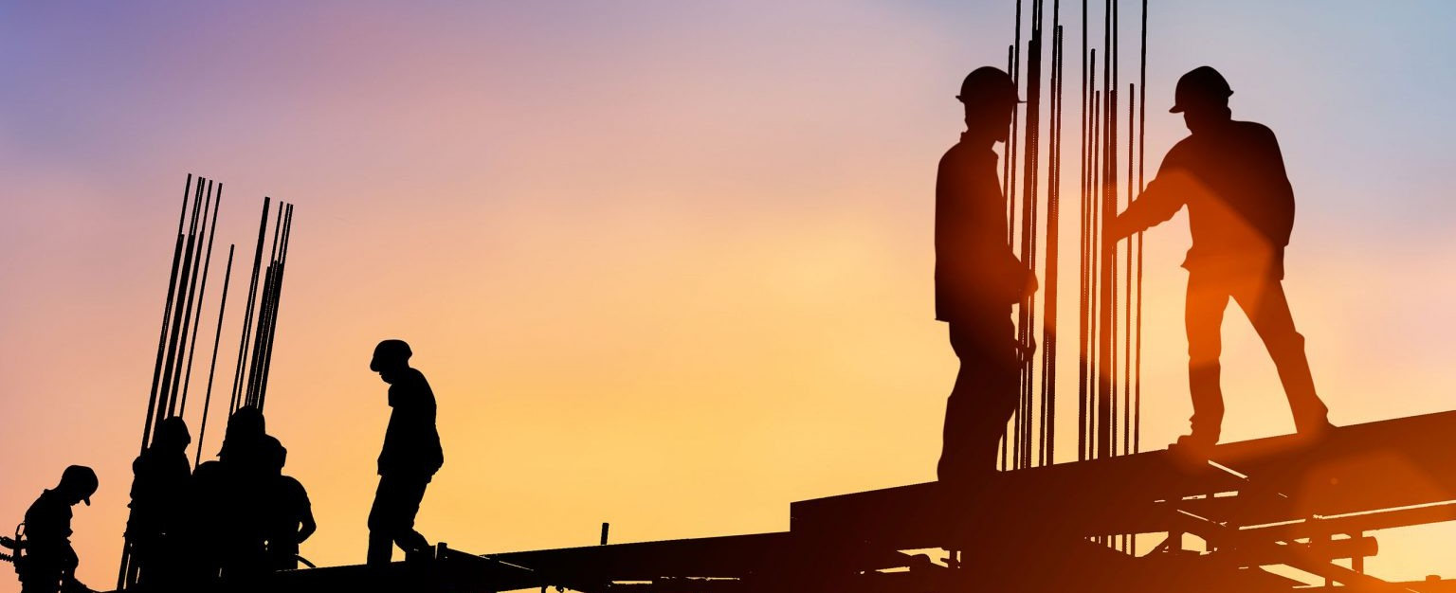

Our clients include general contractors, owners, developers, subcontractors, design professionals and material suppliers. Our attorneys from litigation, real estate, business and finance law, environmental law, employment law, government relations, and other areas of the law work together in our construction legal practice to assist clients with projects ranging from resorts, office, multifamily, retail, mining, hospital, and energy projects to casinos, sports stadiums, bridges, roads and toll roads, dams, and highways.

Our construction attorneys have substantial experience with the diverse and often complex aspects of the construction business.

**Construction Law**

**LEADERSHIP**

[CONSTRUCTION](https://www.fennemorelaw.com/services/construction-law/) [LAW](https://www.fennemorelaw.com/services/construction-law/)

[BUSINESS](https://www.fennemorelaw.com/services/business-litigation/) [LITIGATION](https://www.fennemorelaw.com/services/business-litigation/)

[**Kevin J. Bonner**](https://www.fennemorelaw.com/people/attorneys/kevin-j-bonner/)

Chair

[**Phoenix**](https://www.fennemorelaw.com/contact-us/#phoenix)

PH 602.916.5379

FX 602.916.5579

[kbonner@fennemorel](mailto:kbonner@fennemorelaw.com) [aw.com](mailto:kbonner@fennemorelaw.com)

# OUR TEAM IS BEHIND SUSTAINABLE GROWTH IN THE NEW AMERICAN WEST

We understand the intricacies surrounding all aspects of building developments, whether the project is a small or major project. Our attorneys represent owners, developers, contractors,

subcontractors, design professionals and material suppliers in assisting them in a variety of issues that arise related to the construction process.

We assist our clients through the construction process from the beginning to the end of a project and beyond. We assist in evaluating and drafting RFPs, drafting and negotiating complex agreements and work with clients during and after construction as issues and disputes arise. Our construction attorneys are have extensive experience with construction claims involving

contractors, architects, engineers, land surveyors, and real estate professionals.

# CONSTRUCTION DEFECTS & DISPUTES

Recognizing that delay, uncertainty and expenses are a part of the litigation process, our attorneys carefully assess our client’s dispute at the outset to determine if it can be resolved more effectively and efficiently through litigation alternatives such as mediation or arbitration — both common practices in the construction industry. This avenue often achieves better results, saves substantial resources and provides a more timely resolution of construction disputes.

Our construction attorneys are experienced in mediation, arbitration and litigation of construction-related disputes as well as mass actions, class actions and construction-related

appeals. In addition to defending claims brought against general contractors and developers, our construction attorneys have significant experience pursuing claims on behalf of owners and developers and prosecuting reimbursement claims against subcontractors, vendors, and other responsible third parties. In conjunction with our experience in defending defect claims and prosecuting reimbursement claims, we frequently pursue insurance carriers on coverage claims arising from alleged faulty workmanship. Finally, our construction litigators often are involved in legal work that accompanies construction defect litigation, such as property evaluations,

contract issues and public report matters. Construction litigation encompasses federal and state actions throughout the Mountain West, as well as administrative proceedings before state registrars or state contractor boards and other state agencies.

# CONSTRUCTION TRANSACTIONS

Our construction attorneys provide comprehensive document review and revisions, with adjustments necessary to implement the client’s desires and requirements’ timely completion, compliance with contract documents, lien and stop notice prevention/mitigation, payment procedures, lender requirements, statutory payment limitations, privilege taxation, insurance and indemnification, allocation of uninsured risks, and dispute resolution mechanisms. Our construction legal services also include assistance with strategic planning; selecting appropriate project delivery systems; contract negotiation and regulatory compliance; permitting; bid

processes; and employment issues related to construction. Our construction attorneys routinely provide seminars and training on effective construction administration as well as on recent law changes impacting construction projects, such as those relating to liens and stop notices,

prompt payment obligations, environmental matters, and construction-related employment requirements.

# GOVERNMENT PROCUREMENT CLAIMS

Our construction litigators represent clients in bid protest matters before the comptroller general of the General Accountability Office and state agencies. We also represent general contractors against city, county, state and federal governments. In addition, we prosecute claims against federal agencies before the various boards of contract appeals and claims courts.

# INFRASTRUCTURE PROJECTS

We represent numerous prime contractors working on civil projects throughout the Mountain West. Construction law services include providing counsel to clients concerning procurement issues, bid protests, joint venture agreements, public/private partnerships, contracts, financing

transactions, employment, and litigation of all types relating to civil projects, including bridges, dams, roads, highways, toll roads, and other large projects.