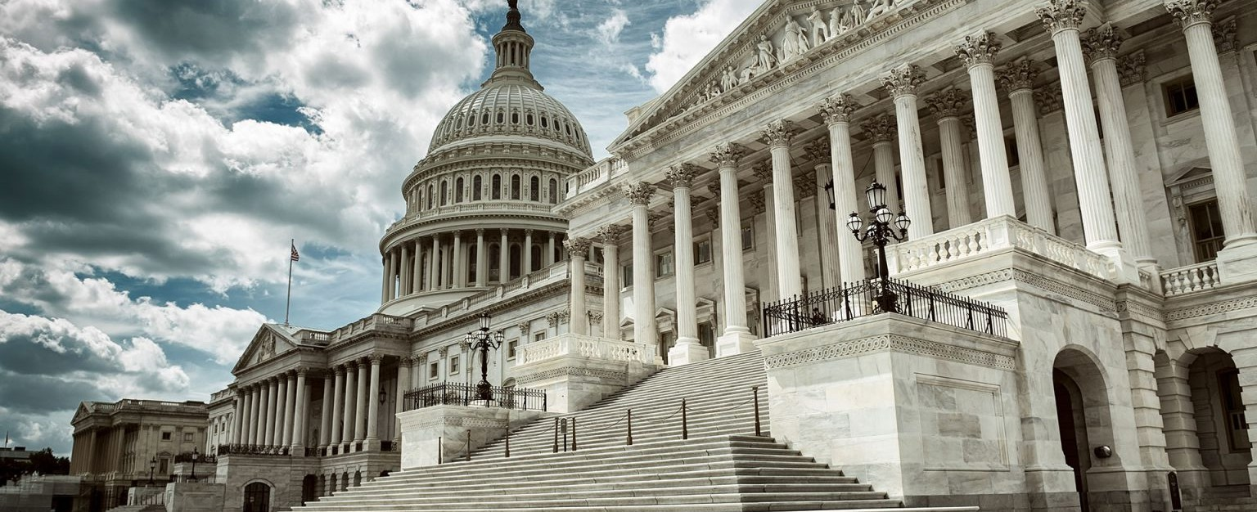

Government Relations and Regulatory

Our regulatory attorneys have helped develop and define laws shaping our region for more than a century. We serve clients at all levels of state, county and municipal government as well as numerous federal

agencies.

Today, an effective government affairs legal practice must also possess strategic planning and tactical implementation skills. Our regulatory attorneys help clients determine what outcomes are in their best interest and then build and implement a plan to achieve those outcomes. Our goal is to find and deliver the best solutions for our client. We are a member of the State Capital Law Firm Group, an organization comprised of top government relations legal professionals in all 50 states, selected on a one law firm per state basis.

**LEADERSHIP**

[GOVERNMENT](https://www.fennemorelaw.com/services/government-relations-and-regulatory-law/) [RELATIONS &](https://www.fennemorelaw.com/services/government-relations-and-regulatory-law/) [REGULATORY](https://www.fennemorelaw.com/services/government-relations-and-regulatory-law/)

[BUSINESS &](https://www.fennemorelaw.com/services/business-and-finance/) [FINANCE](https://www.fennemorelaw.com/services/business-and-finance/)

[**Alexis J.**](https://www.fennemorelaw.com/people/attorneys/alexis-j-glascock/)[**Glascock**](https://www.fennemorelaw.com/people/attorneys/alexis-j-glascock/)

Chair

[**Phoenix**](https://www.fennemorelaw.com/contact-us/#phoenix)

PH 602.916.5488

FX 602.916.5688

[aglascock@fennemor](mailto:aglascock@fennemorelaw.com) [elaw.com](mailto:aglascock@fennemorelaw.com)

# APPEALS

Our appellate attorneys regularly appear before the U.S. Courts of Appeals for the Ninth Circuit, Tenth Circuit and the U.S. Tax Court; the Supreme Court and Court of Appeals of Arizona; the Supreme Court and Court of Appeals of Nevada; and the Supreme Court and Court of Appeals of Colorado. We also participate in appeals before the U.S. Supreme Court and the U.S. Court of Appeals for the District of Columbia Circuit, Fourth Circuit, Fifth Circuit, Eighth Circuit and Eleventh Circuit.

Our appellate legal services cover civil, administrative and regulatory law, with emphasis in the following areas:

**Constitutional and Public Law –** challenges to the validity under the United States and state constitutions of statutes and ordinances, state, local and municipal regulations and other government actions.

**Bankruptcy Law and Creditors’ Rights** – appeals to the U.S. District Court and the Ninth Circuit Bankruptcy Appellate Panel.

**Eminent Domain Law** – appeals to district and higher courts in connection with direct condemnations, inverse condemnations, regulatory takings, and claims for pre-

condemnation damages in the context of public projects, including pipelines, high voltage transmission lines, roads and freeways, buildings and redevelopment projects.

**Tax Law** – challenges to state and local ad valorem real property taxation, state and local sales, use and income taxation and federal income taxation.

Real Property Law – actions to enforce mortgages, deeds of trust and restrictive covenants; and suits concerning title to minerals on private and public land.

**Natural Resources, Environmental and Water Law** – challenges to the U.S. Environmental Protection Agency’s adoption of rules and orders, and appeals from orders of the Arizona Department of Water Resources and Arizona Department of Environmental Quality.

**Public Utility Law** – appeals from orders of the public utility commissions of Arizona and

Nevada setting rates for and governing provision of service by public utilities; and appeals arising from suits and administrative proceedings involving the competing rights of

corporations, governmental bodies and other entities to provide utility service.

**Tort Law** – appeals in cases involving product liability claims, medical negligence claims and business torts, such as antitrust, lender liability and insurance coverage claims.

**Commercial Litigation** – appeals arising from claims of violations of securities laws, laws governing trade secrets and unfair competition, as well as disputes arising from every aspect of corporate and business transactions.

**Labor and Employment** – appeals primarily on behalf of employers from orders of the National Labor Relations Board and in cases involving breach of contract, wrongful discharge and discrimination claims.

One of our appellate attorneys formerly served as a judge on the Arizona Court of Appeals and previously was solicitor general, chief counsel of the tax section, and chair of the Arizona attorney general’s open meeting law enforcement team. The practice chair, Tim Berg, is past president of the American Academy of Appellate Lawyers. Our attorneys have served and currently serve on the appellate handbook committee of the State Bar of Arizona and are responsible for the chapters of the handbook relating to attorneys’ fees on appeal. We also serve on the advisory committee of Division One of the Arizona Court of Appeals.

# AVIATION LAW

Our aviation aerospace attorneys are highly experienced in aviation law, driverless car regulations and aerospace engineering legal needs.

Our attorneys have diverse legal knowledge and experience in the areas of airport and airline representation, government affairs, administrative laws, insurance, intellectual property, real

estate, corporate governance and finance, and federal and state regulation and contracting.

We represent many segments of the aviation industry, including air carriers, airport and aviation related matters, airline use and lease agreements, public purchasing, public works, and federal law relating to airport issues. Our attorneys have also worked with the Federal Aviation

Administration (FAA) and the U.S. Department of Transportation (DOT) and assist clients with federal aviation regulations and laws.

In addition, our intellectual property group has specific technical experience in the fields of aerospace engineering, autonomous vehicle and control system design, geospatial positioning systems, and wireless communications technologies.

Our aviation attorneys also have experience with international trade associations including membership on the Legal Steering Committee of Airports Council International.

With related academic credentials, such as a degree in aerospace engineering, the insights we derive from our diverse practice enable us to achieve our clients’ goals more efficiently and

effectively.

# INDIAN LAW

Our interaction with the American Indian tribes of the Southwest covers a wide range of practice areas related to business and development both on and off Indian lands.

As one of the Southwest’s oldest and largest law firms, our experience with business intersecting tribal lands extends to the early 1900s. Then, as it is now, federal law, tribal governments, state

law, the U.S. Bureau of Indian Affairs, and the U.S. Department of Interior frequently intersect on transactions or litigation involving tribes and entities doing business on Indian lands as well as with tribal governments.

## REPRESENTATION

Representation of client interests in the area of Indian law often draws upon the diverse and substantial specialized resources within our law firm, ranging from government relations to

taxation. This includes drawing upon knowledge of the challenges of commercial transactions in Indian Country, which Tim Berg helped address through a new national model of secured transactions law for America’s tribes. Released in 2005, the Model Tribal Secured Transactions Act was drafted by a committee of the National Conference of Commissioners on Uniform State

Laws, chaired by Tim. The model act provides a secured transactions law for American Indian tribes modeled after the Uniform Commercial Code Article 9, which is the basis for commercial transactions across the country and is designed to assist the country’s tribes, tribal entities and members to secure financing for commercial ventures.

## COMMERCIAL TRANSACTIONS

Our commercial transactional experience on Indian lands includes such diverse matters as site selection and contracts for a proposed sports stadium; fuel contracts; construction and design contracts; the sale of real property involving tribal assets; and businesses sold to tribal entities.

## REAL ESTATE DEVELOPMENT

There is a growing trend toward increased commercial development on Indian lands, particularly near urban centers. Our Indian law attorneys represent commercial development and industrial interests, as well as retail businesses with existing or planned projects on Indian

lands. Real estate legal services include master ground leases, intergovernmental agreements, commercial leases, CC&Rs, and development agreements for both large- and small-scale

projects.

## LITIGATION

The litigation experience held by our Indian law attorneys includes property and possessory interest tax, construction defects, commercial finance, product liability, professional services, and jurisdiction and trespass disputes that involve either tribal lands or interests. Our attorneys represent clients on a variety of commercial disputes, as well as tort claims, including personal injury, professional disputes and product liability matters.

## TAX LAW

Conducting business on Indian lands often entails complex taxation questions, such as taxation of leasehold interests. Our [tax attorneys](https://www.fennemorelaw.com/services/practices/tax) are experienced in property and possessory interest taxation on Indian lands for a wide range of businesses, such as energy companies, natural resource-based projects, utility infrastructure, and commercial ventures.

# INSURANCE LAW & REGULATION

Our insurance law and regulation attorneys have represented numerous insurance companies in connection with licensure and regulation. We have experience in matters pertaining to:

The formation of insurance companies

Obtaining Certificates of Authority for indemnity insurers and health maintenance organizations

Communicating and responding to the departments of insurance in Nevada, Arizona and Colorado

Representing insurance companies in mergers and acquisitions Representing insurance companies at regulatory and disciplinary hearings Structuring insurance company relationships with healthcare providers Writing plans of operation for medical professional liability companies

Advising insurance companies regarding policy provisions and regulatory requirements Forming and obtaining licensure for third party administrators

Forming, obtaining licensure for and advising captive insurance companies, risk retention groups, mutual and reciprocal insurers

Our insurance law attorneys also advise self-insured employers and trusts on regulatory matters and contract negotiations.

# LIQUOR LICENSING

Our liquor licensing attorneys regularly assist clients with:

Representation before local licensing authorities in Nevada Preparation of all required documentation

Coordinate submission of all required materials in complex licensing matters

# PLANNING, ZONING & LAND USE

Our land use attorneys take major development projects from inception to approval of all required land use permits and entitlements. We also assist clients in obtaining traditional land use approvals and facilitate coordination with all departments of local government to address all unique matters.

# POLITICAL & ELECTION LAW

Our government relations attorneys regularly assist clients with the following:

Representation of candidates, political parties, PACs, donors, and other persons with an interest in the legal aspects of the political process

Campaign finance compliance, campaign counsel services, recounts and election contests, and other election-related litigation or administrative action

Representation of proponents and opponents of ballot initiatives and referenda Creating initial draft and research in support of ballot measures

Defending or attacking such measures in court

# PUBLIC POLICY & LOBBYING

We have a bipartisan team of government relations attorneys directly advocates to legislative and executive branch officials obtaining support for legislative and regulatory objectives on behalf of our clients. We analyze and interpret legislation, provide testimony, and develop advocacy efforts, including grassroots programs and coalition development. Our regulatory attorneys work closely with clients to draft legislation and regulatory proposals, and shepherd them through the legislative process.

# REGULATORY PRACTICE

Our regulatory attorneys offer the following experience and services:

Complete regulatory practice for all manner of state and local issues

Practice before the Nevada Tax Commission to the Nevada Division of Insurance and all manners of boards and commissions

Provide advice and legal knowledge in handling regulatory issues

# STRATEGY DEVELOPMENT

Our government relations attorneys routinely assist clients with the following:

Development of goals and effective strategies in support of legislative and regulatory agendas

Arrangement of meetings with key elected officials and policy makers

Development of effective and supportive public relations and media campaigns

# TRACKING & EVALUATION OF LEGISLATION

Our government relations attorneys also monitor legislative trends and developments. They regularly offer legal analysis, and these regulatory attorneys report on legislation as it moves through hearings, committee meetings and floor debate to related clients.