**LEADERSHIP**

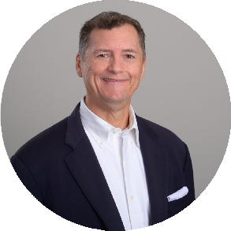[INSURANCE](https://www.fennemorelaw.com/services/insurance-coverage/) [COVERAGE](https://www.fennemorelaw.com/services/insurance-coverage/)

[BUSINESS](https://www.fennemorelaw.com/services/business-litigation/) [LITIGATION](https://www.fennemorelaw.com/services/business-litigation/)

[**Robert P. Allenby**](https://www.fennemorelaw.com/people/attorneys/robert-p-allenby/)

Director

[**San Diego**](https://www.fennemorelaw.com/contact-us/#san-diego)

PH 619.595.3209

FX 619.231.4372

[rallenby@fennemorela](mailto:rallenby@fennemorelaw.com) [w.com](mailto:rallenby@fennemorelaw.com)

[INSURANCE](https://www.fennemorelaw.com/services/insurance-coverage/) [COVERAGE](https://www.fennemorelaw.com/services/insurance-coverage/)

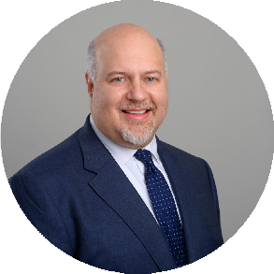[BUSINESS](https://www.fennemorelaw.com/services/business-litigation/) [LITIGATION](https://www.fennemorelaw.com/services/business-litigation/)

[**Timothy C. Earl**](https://www.fennemorelaw.com/people/attorneys/timothy-c-earl/)

Director

[**San Diego**](https://www.fennemorelaw.com/contact-us/#san-diego)

PH 619.595.3279

FX 619.231.4372

[tearl@fennemorelaw.](mailto:tearl@fennemorelaw.com) [com](mailto:tearl@fennemorelaw.com)



**Insurance Coverage**

Our insurance coverage attorneys have substantial experience with the complex and nuanced aspects of insurance coverage.

Our clients include general contractors, owners, developers, design professionals, manufacturers, medical associations, and all kinds of other businesses. Our attorneys from litigation, real estate, business and finance law, environmental law, employment law, and other areas of the law work together in our insurance coverage legal practice to assist clients with insurance disputes arising

out of construction projects, business activities, theft, natural disasters, etc.

# INSURANCE COVERAGE DISPUTES AND LITIGATION

Fennemore’s Insurance Coverage Practice Group represents the interests of policyholders in maximizing insurance coverage for litigation matters and for losses under first party policies, and represents insurance carriers in coverage disputes and litigation. We aggressively litigate insurance coverage issues on behalf of our clients – both prosecuting bad faith claims against insurers, and defending against insurer’s recovery actions against their insureds, and we will take cases to trial if necessary. Our knowledge and experience spans all major property and casualty commercial insurance lines — including first-party Property and Business Interruption and third- party Commercial General Liability — as well as many specialty coverage areas, such as Auto, Excess/Umbrella, Cyber Liability, E&O/Professional Liability, Crime, D&O, Employment Liability, and Environmental/Pollution Coverage. We also prosecute and defend bad faith actions.

Many of our insurance matters focus on the construction industry, manufacturing industry, and commercial property ownership/property management.

Our Insurance Coverage Group attorneys have recovered hundreds of millions of dollars in insurance benefits for policyholder clients

# INSURANCE POLICY PLACEMENT

We help our clients’ decisionmakers make informed business decisions by analyzing insurance policies to help them understand potential risks. Our attorneys also assist clients in negotiations with insurance underwriters and brokers to secure insurance policies that afford coverage for our clients’ particular anticipated and unanticipated risks. We partner with insurance brokers and insurance consultants where appropriate to secure coverage and address insurance risks.

# EDUCATION

Fennemore insurance coverage attorneys educate our clients and our community on developments in the insurance coverage arena. Our attorneys are sought-after speakers that regularly serve as panelists on a variety of insurance coverage issues at bar association events, conferences and seminars.