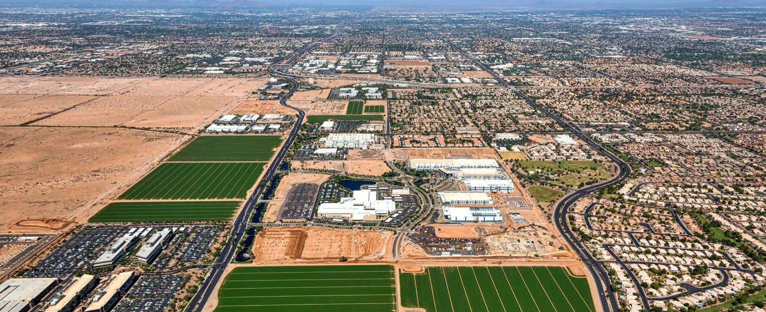

As land use issues continue to evolve and become more complex, our land use attorneys help clients find creative solutions. We advise private and public sector clients in all aspects of development and permitting, including land use litigation.

Fennemore’s land use attorneys take major development projects from inception to approval, providing counsel on all required land use permits and entitlements. We also assist clients in obtaining traditional land use approvals, and facilitate coordination with all departments of local governments to address any unique matters.

For More Than 137 Years – Helping Our Clients Realize Their Vision For Responsible Development In The American West

**Land Use**

**LEADERSHIP**

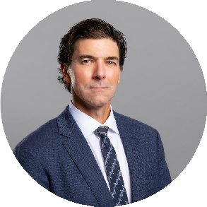[LAND USE](https://www.fennemorelaw.com/services/land-use/) [REAL ESTATE](https://www.fennemorelaw.com/services/real-estate/)

[**Todd A. Williams**](https://www.fennemorelaw.com/people/attorneys/todd-a-williams/)

Chair

[**Oakland**](https://www.fennemorelaw.com/contact-us/#oakland)

PH 510.834.6600

FX 510.834.1928

[toddwilliams@fennem](mailto:toddwilliams@fennemorelaw.com) [orelaw.com](mailto:toddwilliams@fennemorelaw.com)

[LAND USE](https://www.fennemorelaw.com/services/land-use/) [REAL ESTATE](https://www.fennemorelaw.com/services/real-estate/)

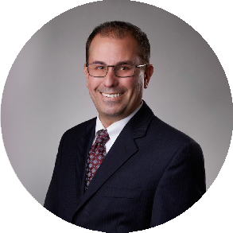[**Donovan C.**](https://www.fennemorelaw.com/people/attorneys/donovan-c-collier/)[**Collier**](https://www.fennemorelaw.com/people/attorneys/donovan-c-collier/)

Vice-Chair

[**San Bernardino**](https://www.fennemorelaw.com/contact-us/#san-bernardino)

PH 909.723.1814

FX 909.890.9877

[dcollier@fennemorela](mailto:dcollier@fennemorelaw.com) [w.com](mailto:dcollier@fennemorelaw.com)

# RESOLVING LAND USE CHALLENGES

As land use issues continue to evolve and become more complex, our land use attorneys help clients find creative solutions. From small redevelopment projects to major residential, commercial, industrial and mixed-use developments, we assist with zoning and permitting matters in cities, counties, and special districts.

Whether your project is ground-up construction or reuse of an existing site, our attorneys manage the intricate legal details so that you can focus on project development. Our team will support

you throughout every phase of the development process, from initial environmental due diligence to the acquisition of land use approvals that maximize the use of your property.

With a firm history spanning more than 137 years, our attorneys have the expertise, agency connections, and legal knowledge to handle any matter effectively and efficiently.

# PUBLIC HEARINGS AND APPROVALS

Our knowledge of local, regional and state agencies helps us minimize roadblocks. For example, in California, our attorney team includes current and former board and commission members in San Francisco Bay Area jurisdictions and regional agencies, former city planners, and advanced degree holders in related land-use fields. This experience provides unique insight for guiding clients through the complex land use process and providing representation before city councils, boards of supervisors, planning commissions, zoning boards, and commissions.

We appear at hearings on behalf of project proponents and are able to secure highly contested land use approvals in jurisdictions throughout the Golden State.

# SUPPORTING THE DEVELOPMENT TEAM

We work with client project teams to prepare documentation to obtain land use approvals, including development agreements, tentative and final subdivision maps, complex project

applications, conditions of approval, and environmental review documents. Working closely with architects, surveyors, engineers, contractors and others, we help streamline the process. Our practical experience untangling the local, state and federal regulations that govern land use applications (including CEQA, the Subdivision Map Act, density bonus and housing streamlining

legislation, wetlands, air quality, historic resource and congestion management regulations) keeps your project on track.

# PUT OUR EXPERIENCE TO WORK FOR YOU

Our land use attorneys have unparalleled experience serving commercial, industrial and residential developers; renewable energy project developers, municipalities and other

government entities; as well as brokers, lenders and borrowers. Our team works with government entities at all levels, as well as Native American communities on a broad variety of land use and zoning matters.

We advise our clients with respect to state land entitlements; amendments to city and county general plans, special plans and zoning ordinances; adoption and modification of area plans and comprehensive master plans; negotiation, drafting and approval of development

agreements, annexation and pre-annexation agreements, economic incentive agreements, the creation and application of overlay zoning districts.

Our land use attorneys also bring substantial experience in the pursuit of zoning code interpretations; approval and implementation of master-planned developments; historic

preservation districts and overlays, conservation easements, hillside overlays, and the proposal and adoption of text and ordinance amendments, formation of community facilities districts, including California geologic hazard abatement districts, and all other aspects of land use legislative and administrative processes.

We work with clients seeking to purchase, lease and entitle lands managed by state and federal governments for purposes of residential and commercial development. Our attorneys work with clients to acquire easements and rights of way over state trust lands for purposes of streets and access roads as well as municipal and utility infrastructure.

Additionally, our land use attorneys have a substantial background in analyzing and arguing state land issues regulated by the Federal Enabling Act, State constitutions and statutes. Our attorneys routinely interface on land use, land exchange and property acquisition with

representative agencies, including the U.S. Bureau of Land Management, the U.S. Forest Service, and state and county departments of transportation, water resources, natural resources, mining and mineral resources, flood control districts and others.

Our land use attorneys have extensive experience representing Clients in obtaining incidental take authorization under the Federal Endangered Species Act and incidental take permits and streambed alteration permits from the California Department of Fish and Wildlife.

# BROAD EXPERIENCE WITH ALL TYPES OF DEVELOPMENT IN CALIFORNIA

We can help you satisfy the requirements at the local, state, or federal level. We have a great depth of experience in the California Environmental Quality Act (CEQA). In addition, our attorneys are well-versed in the details of the California Planning and Zoning Law, Subdivision Map Act and Takings jurisprudence.

In addition to entitling thousands of residential units in recent years, our attorneys have had the privilege of assisting one of the largest national retailers with site acquisition and planning, government approvals, and environmental analysis for nearly every store opening in Southern and Central California. Our California lawyers also represent one of the largest freight railroad networks in the country and have assisted on the approval of logistics centers throughout the

state. Other representative matters include the approval of millions of square feet of office space, biotech facilities and hotel projects.

# LITIGATION AND DISPUTE RESOLUTION

Our attorneys are resolution-oriented, using their experience to find creative solutions to complex issues. As needed, we help clients defend their rights through litigation and alternative dispute

resolution, including negotiation, mediation, and arbitration. We have successfully represented clients in matters involving CEQA, the Subdivision Map Act, exactions and development fees, building moratoria, and similar issues.

# FENNEMORE REGULARLY REPRESENTS DEVELOPERS OF:

Retail and shopping centers

Manufacturing, warehouses, distribution centers, and logistics centers Residential projects, including multi-family, single-family and senior housing Mining projects

Schools and educational institutions

Automotive uses, such as truck facilities and auto dealerships Office buildings

Military base reuse

Biotech and life science facilities

Entertainment and performing arts centers Public-Private Partnership Projects Hospitals and medical facilities

Vineyard and winery development Cemeteries

Geologic Hazardous Abatement Districts