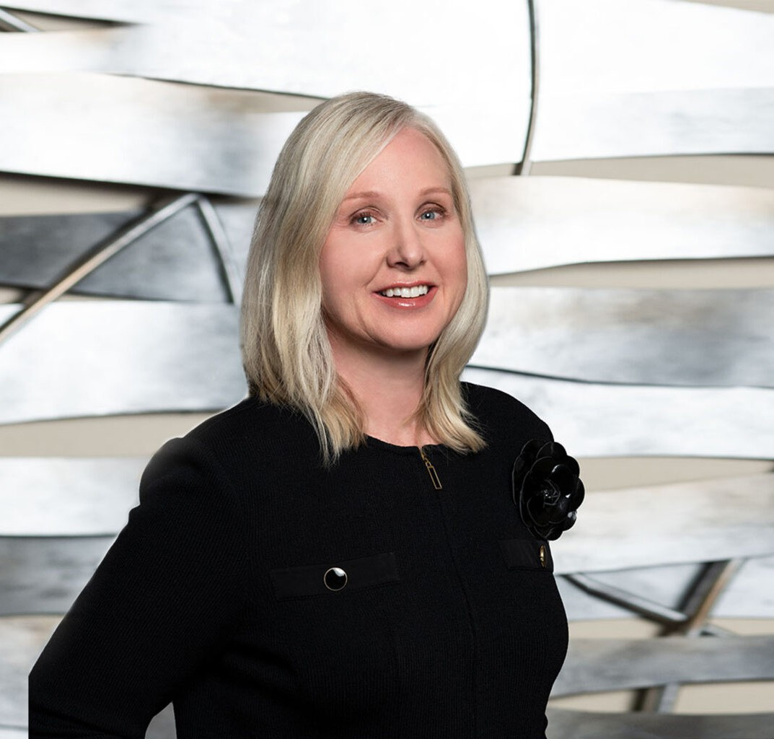

LEIGH W. BURNSIDE

Director

[Trusts & Estates](https://www.fennemorelaw.com/services/trusts-estates/)

[Fresno](https://www.fennemorelaw.com/contact-us/fresno/)

P: 559.432.4500

F: 559.432.4590

[lburnside@fennemorelaw.com](mailto:lburnside@fennemorelaw.com)

“

If you want to conquer fear, don’t sit home and think about it. Go out and get busy.

-Dale Carnegie

”

**LEIGH W. BURNSIDE**

Leigh Burnside is the Chair of the Board of Directors of Fennemore and a member of the firm’s eight-person Management Committee. Leigh regularly counsels fiduciaries in their administration of trusts and estates. She defends them in court actions brought by beneficiaries, assists them in the preparation and defense of accountings, and represents them in actions against third parties to recover assets belonging to the disputed trust, estate or conservatorship. Leigh also represents beneficiaries and heirs in disputes with personal representatives and trustees. Such matters include will and trust contests, disputes over the distribution of assets, and disputes over whether the fiduciary acted properly in performing his or her duties.

Leigh became an attorney because she wanted to advocate for clients in the courtroom and be challenged every day. Her clients turn to her because of her focus on practical solutions to complex problems – and she has no fear of taking cases to trial. Leigh appreciates and thoroughly enjoys courtroom advocacy, and she takes great pride in presenting her client’s case in a way that is compelling and resonates with the judge, jury or decision-maker.

Leigh’s practice also includes conservatorship, contested and uncontested. She assists clients in determining whether a conservatorship is warranted, represents them in court proceedings to

appoint a conservator, and also advises court-appointed conservators in their role as fiduciaries. As an extension of these services, Leigh has handled numerous trust and estate appeals, several of which resulted in published opinions finding in favor of her client.

Outside of the office, Leigh loves spending time with her family, traveling, exercising, and

reading. She was selected as one of only six *Super Lawyers® Rising Stars* in Northern California for her work in Estate and Trust Litigation in 2012. She has also been named as one of Northern

California’s *Super Lawyers®* representing the top 5 percent of practicing attorneys in Northern California, every year since 2013. *Super Lawyers®* named Leigh one of the “Top 50 Women Attorneys” of Northern California in 2016, 2018-2019. And most recently, *Super Lawyers®* named her to the list of the Top 100 Attorneys in Northern California in 2018 and 2019.

# EDUCATION

J.D., Santa Clara University School of Law

B.A., English and French Literatures, Stanford University

# AREAS OF PRACTICE

**OTHER EXPERIENCE**

Conservatorships

Trust and Estate Administration Trusts & Estates

Estate Planning Estate Litigation

# AWARDS AND HONORS

*Northern California Super Lawyers®,* 2013-2024

*Super Lawyers®,* Top 50 Women Attorneys in Northern California, 2016, 2018-2019

*Super Lawyers®,* Top 100 Attorneys in Northern California, 2018-2019

*Super Lawyers®* Rising Stars, Estate and Trust Litigation, 2012

AV® Preeminent™ Peer Review Rated (the highest rating available), by Martindale-Hubbell

# ARTICLES AND PRESENTATIONS

[Interview, “Honesty, Commitment & Lots of Laughter: Fennemore Dowling Aaron’s Leigh](https://www.fennemorelaw.com/insights/blogs/2021/honesty-commitment-lots-of-laughter-fennemore-dowling-aaron-s-leigh-burnside) [Burnside,” Fennemore Blog, March 11, 2021](https://www.fennemorelaw.com/insights/blogs/2021/honesty-commitment-lots-of-laughter-fennemore-dowling-aaron-s-leigh-burnside)

# PROFESSIONAL AND COMMUNITY ACTIVITIES

Member, California State Bar Association, Trusts and Estates Section

Board of Governors, Association of Business Trial Lawyers; Treasurer 2008-present Board of Directors, Fresno County Bar Association, 2005-2008

Board of Directors, Past President, Fresno County Young Lawyers Association, 1999-2004; President, 2003

# ADMISSIONS

California