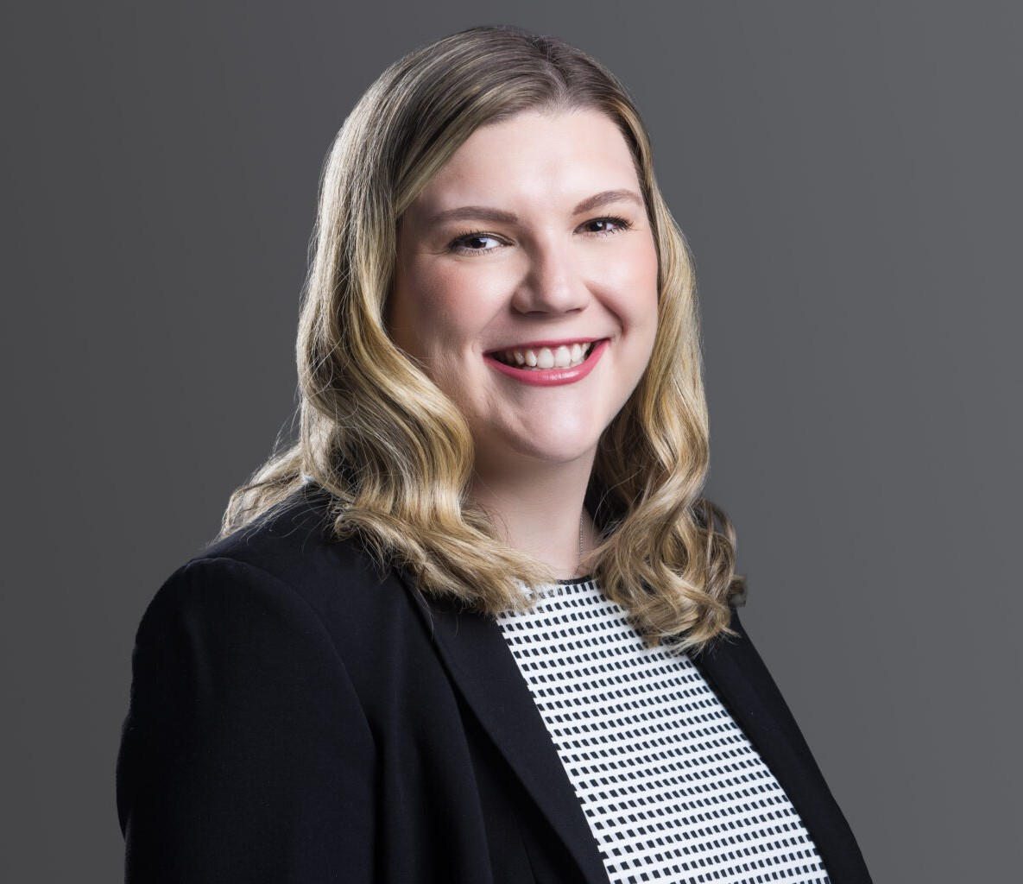

LEXIE DAVIS

Associate

[Business Litigation](https://www.fennemorelaw.com/services/business-litigation/)

[Denver](https://www.fennemorelaw.com/contact-us/denver-2/)

P: 303.764.3730 F: 303.291.3201

[ldavis@fennemorelaw.com](mailto:ldavis@fennemorelaw.com)

# LEXIE DAVIS

Lexie Davis is an attorney in the Healthcare practice group, where her work spans health care law, compliance, and liability defense. Her practice includes HIPAA compliance, physician shareholder and employment agreements, medical practice structuring and agreements, credentialing, licensing, and regulatory compliance. Lexie’s specialty in these areas has established her as a trusted outside counsel for medical practices, entities, and professionals, addressing complex legal and regulatory challenges.

Lexie’s practice also includes health care litigation and business litigation. She advocates on behalf of her clients in federal and state court during all phases of civil litigation. Over the last several years, she has litigated complex cases involving regulatory, professional malpractice, employment, and contractual issues.

While attending law school at the Sandra Day O’Connor College of Law at Arizona State

University, Lexie worked as a law clerk for the Colorado Office of the Attorney General and as an extern to the Honorable Douglas L. Rayes of the U.S. District Court for the District of Arizona. She

also served as a teaching assistant for research and writing classes, competed in moot court competitions, and was a staff writer and editor for the Arizona State Law Journal.

Lexie’s career reflects a commitment to legal excellence and a deep understanding of the intricacies of health law, making her a valued member of the legal community.

# EDUCATION

J.D., Sandra Day O’ Connor College of Law, Arizona State University B.A., Colorado State University

# AREAS OF PRACTICE

Business Litigation Health Care

# AWARDS AND HONORS

*Colorado Super Lawyers*®, Rising Stars, Health Care, 2024-2025

# PROFESSIONAL AND COMMUNITY AFFILIATIONS

Member, Colorado Bar Association: Health Law Section Member, American Health Law Association

Big Sister through Big Brothers Big Sisters of Colorado

# ADMISSIONS

Colorado

United States District Court for the District of Colorado

# LANGUAGES

Spanish – Proficient