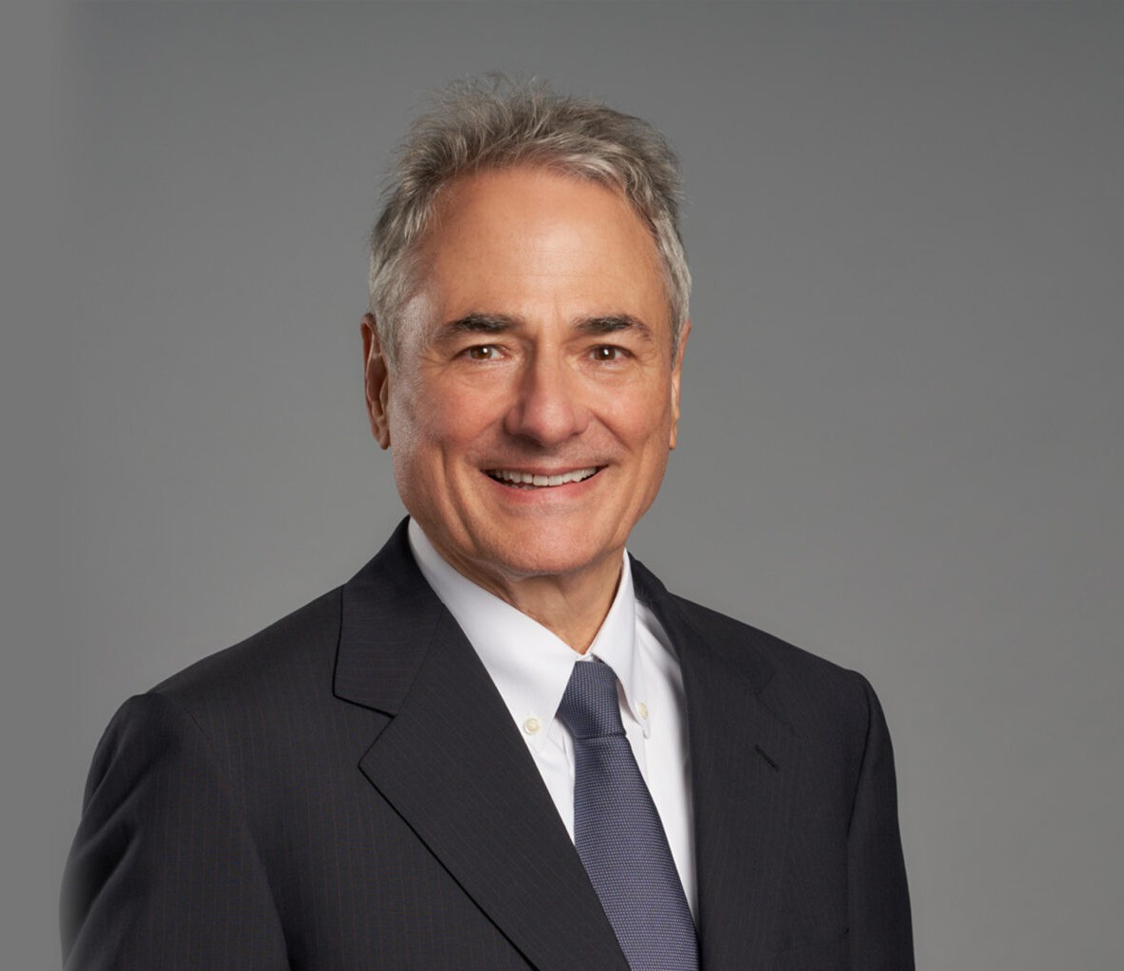

MARK S. BOSTICK

Director

[Financial Restructuring](https://www.fennemorelaw.com/services/financial-restructuring-bankruptcy-creditors-rights/)

[Oakland](https://www.fennemorelaw.com/contact-us/oakland/)

P: 510.834.6600

F: 510.834.1928

[mbostick@fennemorelaw.com](mailto:mbostick@fennemorelaw.com)

# MARK S. BOSTICK

Mark has more than 35 years of experience focused on insolvency law, representing trustees,

debtors, creditors and other interested parties in all forms of insolvency proceedings and out-of- court workouts. In 2018, he served as the Chair of the Bankruptcy Section for the Alameda County Bar Association and as Co-Chair of the Committee of Lawyer and Trustee Representatives of the United States Bankruptcy Court for the Northern District of California.

Prior to entering private practice in 1983, Mark clerked for the Honorable Robert L. Hughes, Bankruptcy Judge (Oakland) and former Chief Judge for the Bankruptcy Appellate Panel for Ninth Circuit.

# EDUCATION

J.D., University of San Francisco, School of Law B.A., University of California, Berkeley

# AREAS OF PRACTICE

OTHER EXPERIENCE

Bankruptcy

Financial Restructuring Business & Finance

# REPRESENTATIVE CASES

*In re Golden*, 789 F.2d 698 (9th Cir. 1986) holding that a bankruptcy trustee may recover un- reinvested homestead sale proceeds despite the lack of objection to the debtor’s exemption claim.

*In re Serrato*, 214 B.R. 219 (Bankr. N.D. Cal. 1997) finding that an unsecured debt of $1 existing on date of transfer is sufficient to avoid fraudulent transfer under 11 U.S. C. §544(b).

# AWARDS AND HONORS

*Northern California Super Lawyers*®, 2006-2021

AV® Preeminent™ Peer Review Rated by Martindale Hubbell

# ARTICLES AND PRESENTATIONS

Author, “California Mechanics Liens and Related Construction Remedies,” CEB, 2019-2021 Author, “Syllabus for Bankruptcy for Litigators 101(A)”, Alameda County Bar Association, 2017 Presenter, “Bankruptcy 101A for Litigators,” Alameda County Bar Association and Contra

Costa County Bar Association, March 1, 2017

Editor, “California Mortgage in Deed of Trust Practice, Bankruptcy Section,” CEB, 2007-2016

Author, “How to Avoid Needlessly Exposing a Client’s Assets to Creditors in an Estate Plan or Trust,” Wendel Rosen LLP, October 2015

Author, “Startup Entrepreneurs Should Plan for Success But Prepare for Failure: Do You Have a Plan B?” Wendel Rosen LLP, September 2015

Presenter, “How Trusts and Estates Attorneys Can Avoid Exposing Clients’ Assets to Creditors in Estate Plans,” East Bay Trusts and Estates Lawyers, April 8, 2015

# PROFESSIONAL AND COMMUNITY ACTIVITIES

Member, Committee, Bankruptcy Court for the Northern District of California Member, California Bankruptcy Forum

Member, San Francisco County Bar Association Member, National Association of Bankruptcy Trustees Member, American Bankruptcy Institute

# ADMISSIONS

California