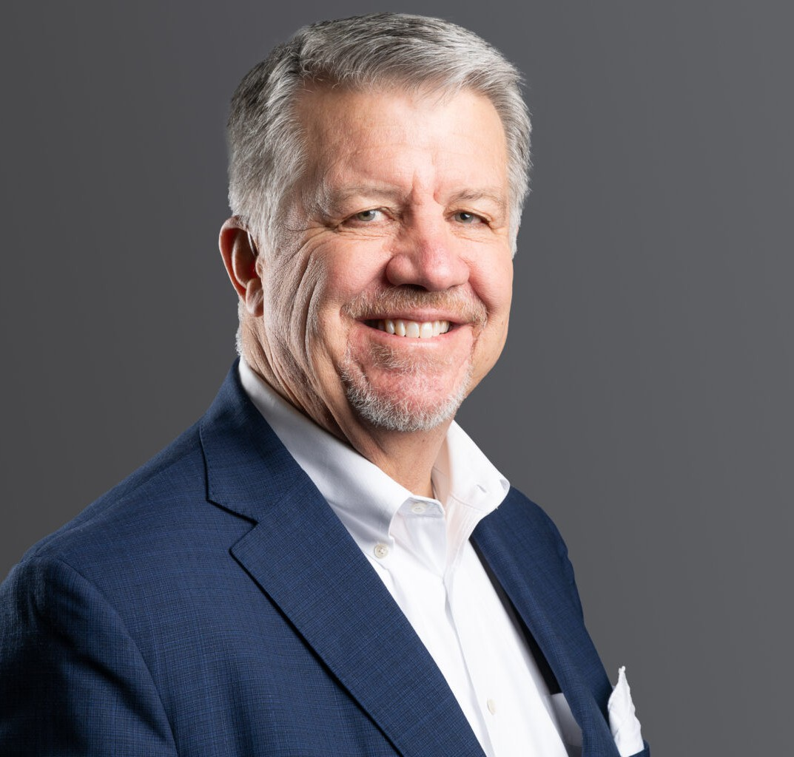

PAUL R. FRANKE, III

Director

[Business Litigation](https://www.fennemorelaw.com/services/business-litigation/)

[Denver](https://www.fennemorelaw.com/contact-us/denver-2/)

P: 303.813.3820

F: 303.291.3201

[pfranke@fennemorelaw.com](mailto:pfranke@fennemorelaw.com)

# PAUL R. FRANKE, III

Paul R. Franke III has over 30 years of experience helping clients navigate complex financial challenges with practical, effective solutions. As a trial attorney specializing in financial litigation, he advises businesses on issues involving banking, real estate, corporate financing, and capital structures.

Paul is known for his creative problem-solving and focus on preserving value, successfully representing corporations, financial institutions, and insurers in high-stakes disputes, including breaches of contract, loan covenant issues, and corporate buy-sell disagreements. Whether addressing intricate contractual provisions or advocating for clients in disputes with the federal government, Paul’s approach ensures business continuity while safeguarding client interests.

His leadership as national counsel for a Fortune 100 company highlights his ability to manage high-stakes litigation on a national scale. He has a proven track record of crafting strategies that minimize disruptions and drive favorable outcomes for his clients. His skill level extends to working with traditional and non-traditional lenders, as well as handling unique claims arising from legislative changes or evolving regulatory landscapes. Paul’s ability to navigate these complex matters has earned him the trust of a diverse range of clients, from multinational corporations to niche financial institutions.

On the international stage, Paul has tackled complex corporate finance and asset procurement matters across Europe, Asia, Africa, the Middle East, and the Americas. From 2021 to 2023, he served as President of Ally Law, a global network of prestigious law firms, further demonstrating his ability to lead and resolve multifaceted legal challenges. In every case, Paul’s goal is the

same: to provide clients with actionable, practical solutions that allow them to move forward with confidence.

# EDUCATION

J.D., Willamette University

Associate Editor, *Willamette University Law Review*

B.A., University of New Mexico

# AREAS OF PRACTICE

Business Litigation

# AWARDS AND HONORS

*Best Lawyers in America®,* Lawyer of the Year, Banking and Finance Law, 2025 America’s Top 100 Bet-the-Company Litigators, 2019

Benchmark Litigation Local Litigation Star, General Commercial Litigation and Real Estate Litigation, 2021-2024

Best Lawyers®, Commercial Litigation, 2021-2025 Best Lawyers®, Litigation – Real Estate, 2022-2025

Best Lawyers®, Banking and Finance Law, 2024 and 2025 Colorado Super Lawyers®, Business Litigation, 2018-2025 Litigation Counsel of America, Fellow

Martindale-Hubbell Rating, AV® Preeminent™ (highest)

Martindale-Hubbell Rating, AV® Preeminent™ (highest) – Judicial Edition

# ARTICLES AND PRESENTATIONS

Author, “Stuck in the COVID-19 Backlog? Arbitration May Be Your Best Alternative,” ColoradoBiz, October 2020

Co-author, “Moye White Attorneys Assist in Supreme Court Case,” Firm Blog, July 2020 Moderator, “Getting Coloradoans Back to Work,” FIrm Webinar, May 2020

Panelist, “Collaborative Technology,” Ally Law Annual General Meeting, March 2019 Panelist, “Ally Law Best Practices,” Ally Law Annual General Meeting, March 2019

Moderator, “The Role of Outside Counsel in Risk Management,” Ally Law Annual General Meeting, May 2018

Keynote Host, “Global and Economic Considerations with Tony Blinken,” Ally Law Annual General Meeting, May 2017

Panelist, “Growing Your Firm Through Small Practice Acquisitions,” Ally Law (formerly International Alliance of Law Firms) Annual General Meeting, May 2014

Presenter, “The New Proposed RESPA Rules,” Colorado Mortgage Lenders Association, September 2002

Presenter, “Managing Defaults in Security Pools,” International Asset Securitization and Other Financing Tools, Salzburg, Austria, October 1999

# PROFESSIONAL AND COMMUNITY AFFILIATIONS

President, 2021-2023, Ally Law Colorado Bar Association

Board of Directors, Colorado Homeownership Coalition

Associate Member and General Counsel, Colorado Mortgage Lenders Association Denver Bar Association

Executive Committee, Past Chair of the Board of Trustees, Past Chair of Safety Net, Mile High United Way

Former Board of Directors, SeedCo, Inc.

# ADMISSIONS

Colorado