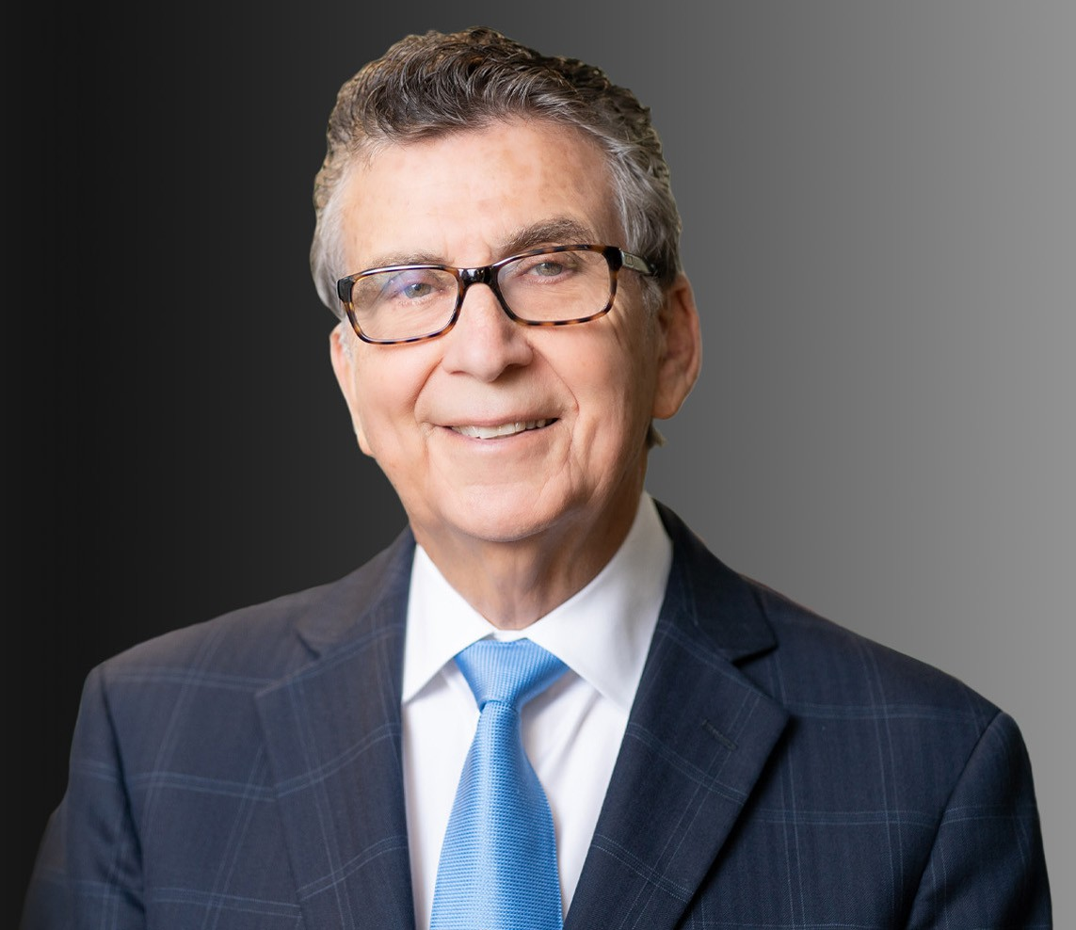

SIDNEY A. ISRAELS

Of Counsel

[Business & Finance](https://www.fennemorelaw.com/services/business-and-finance/)

[Modesto](https://www.fennemorelaw.com/contact-us/modesto/)

P: 510.834.6600

F: 510.834.1928

[sisraels@fennemorelaw.com](mailto:sisraels@fennemorelaw.com)

# SIDNEY A. ISRAELS

Sid has extensive experience in real estate, business, and regulatory matters. He represents a broad spectrum of clients, including title insurers and agents, healthcare providers, transportation logistics, food processors, lenders, agribusinesses, real estate investors, and venture capital providers.

Not only working with startups, Sid works with well-established entities in negotiating and closing complex business deals involving mergers, acquisitions, sales, share and asset purchases, shareholder separations, joint ventures, and private placements.

He represents prospective business purchasers, and he has developed special skills in working with business founders, their families, and personal professional advisors. He has a long track record of successfully working with general counsel. Sid’s involvement is usually characterized by team participation, excellent communication between participants resulting in expeditious and cost-efficient documentation.

Sid has been instrumental in developing a strong team at Fennemore to effectively represent title insurers and underwritten title insurance companies in regulatory matters. These matters include audit compliance and the obtaining of organizational permits and approvals for sales, mergers, and acquisitions of underwritten title companies.

In addition, he has a particular passion for transportation issues, bringing experience and familiarity with matters involving logistics and infrastructure financing affecting shippers, retailers, rail carriers, and land development projects.

A native of Modesto, California, Sid helped originate and maintains strong connections with Fennemore’s Modesto office. With considerable experience and knowledge of the Great Central Valley’s resources, challenges, and opportunities, Sid has been involved in several

projects, including agriculture research, food safety, farm equipment manufacturing, and public and private development partnerships.

# EDUCATION

J.D., University of California, Los Angeles – School of Law B.A., University of California, Berkeley

# AREAS OF PRACTICE

**OTHER EXPERIENCE**

Regulatory Matters involving Title Insurers and Underwritten Title Companies Business & Finance

# ARTICLES AND PRESENTATIONS

[Interview, “Think of the Law Firm as a Team,” Fennemore Blog, July 22, 2022](https://www.fennemorelaw.com/think-of-the-law-firm-as-a-team/)

# PROFESSIONAL AND COMMUNITY ACTIVITIES

Board Member, Board of Trustees, UC Merced Foundation

Former Vice Chair, Real Property Section, The State Bar of California Affiliate Member of California Land Title Association (CLTA)

# ADMISSIONS

California

U.S. District Court