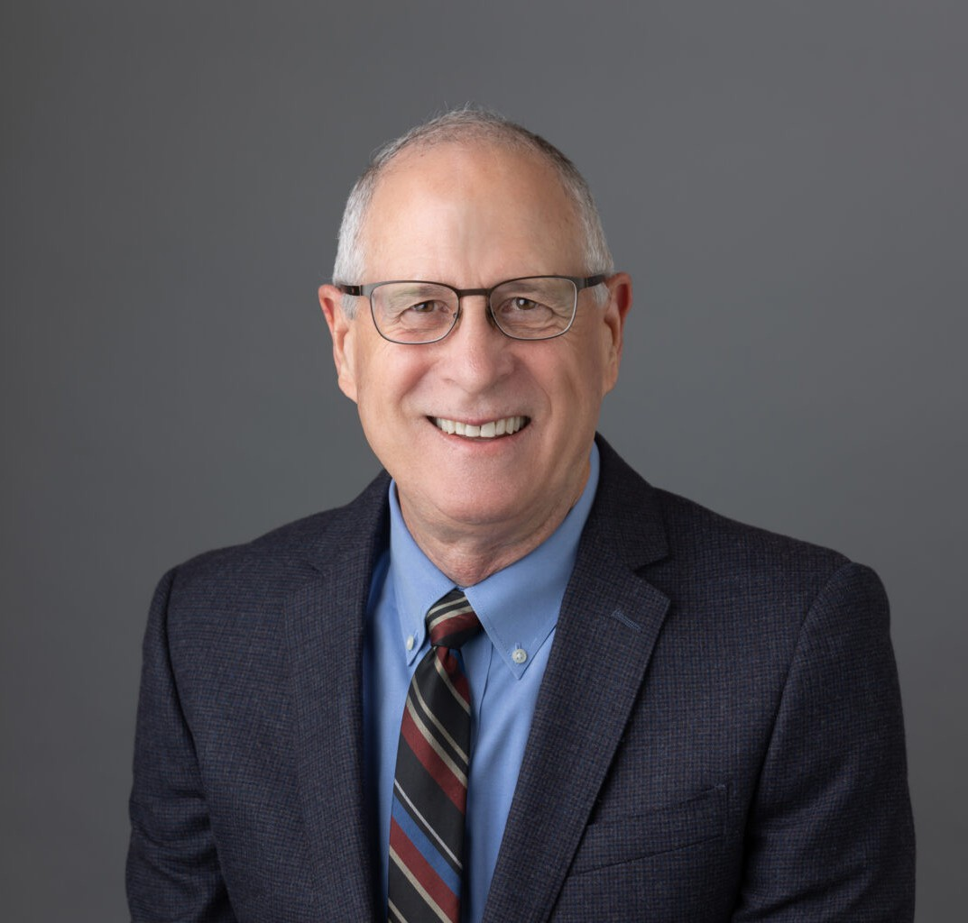

TIMOTHY S. WILLIAMS

Director

[Real Estate](https://www.fennemorelaw.com/services/real-estate/)

[Oakland](https://www.fennemorelaw.com/contact-us/oakland/)

P: 510.622.7677

[twilliams@fennemorelaw.com](mailto:twilliams@fennemorelaw.com)

# TIMOTHY S. WILLIAMS

Tim has assisted clients with their real estate transactions for over 40 years, and has extensive experience in purchase and sale transactions, leases, financing, easements, title matters, and property tax issues.

Tim has been a contributing author for several California Continuing Education of the Bar publications on topics including secured financing, ground leasing, office leasing, and retail leasing, and has been an active member of the California and Alameda County bar

associations’ real property sections.

Tim currently serves as associate general counsel to the firm, having previously served as general counsel to his prior firm.

# EDUCATION

J.D., University of California Berkeley, School of Law B.A., Stanford University

# AREAS OF PRACTICE

Real Estate

# ARTICLES AND PRESENTATIONS

Contributing Author, Ground Lease Practice, California Continuing Education of the Bar, 2024 Contributing Author, Retail Leasing, , California Continuing Education of the Bar, 2007, 2012 Contributing Author, Office Leasing, California Continuing Education of the Bar, 1996, 2012

Contributing Author, California Mortgage and Deed of Trust Practice, California Continuing Education of the Bar, 2003

Author, “Proposition 8 Spells Property Tax Relief,” Oakland Business Review, May 2008 Author, “Prop. 8 May Help Down and Out Property Owners,” The Registry, March 2008

Co-Author, “Reassessment On Change Of Ownership,” The Wendel Report, Fall 2006

Author, “California’s New Legislation Regarding Use Restrictions in Commercial Leases: Can Commercial Landlords Just Say No?” California Real Property Journal, Vol. 10, No. 3, Summer 1992

# PROFESSIONAL AND COMMUNITY ACTIVITIES

Member, Real Property Law Section, State Bar of California

Past Member, Board of Directors, Real Estate Section, Alameda County Bar Association Past Chair, Fee Arbitration Executive Committee, Alameda County Bar Association

# ADMISSIONS

California