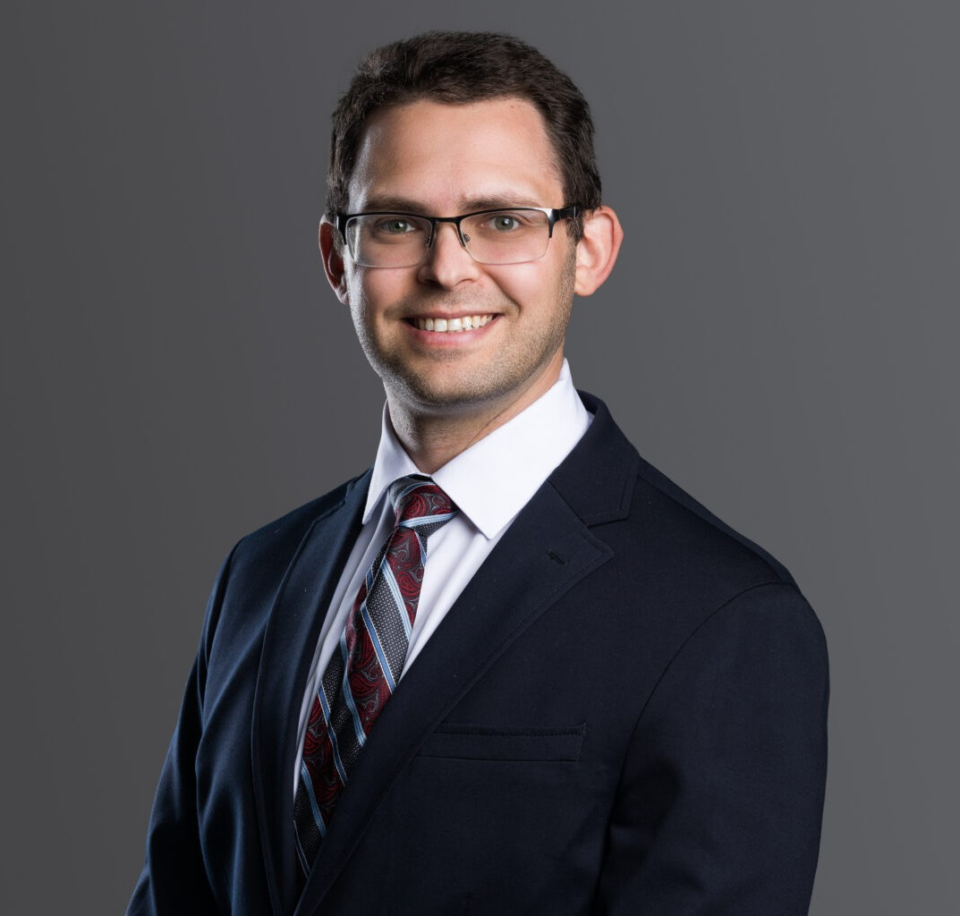

ZACHARY ROSENBERG

Associate

[Business Litigation](https://www.fennemorelaw.com/services/business-litigation/)

[Phoenix](https://www.fennemorelaw.com/contact-us/phoenix/)

P: 602.916.5315 F: 602.916.5999

[zrosenberg@fennemorelaw.com](mailto:zrosenberg@fennemorelaw.com)

# ZACHARY ROSENBERG

Litigation attorney Zach Rosenberg represents clients in business and construction controversies ranging from complex and multi-party lawsuits to simple contractor invoice disputes.

Before joining Fennemore, Zach served as a judicial clerk at the Arizona Court of Appeals for Judge Peter Swann. In law school at Arizona State University, Zach was the Executive Articles Editor for the Arizona State Law Journal, served as president of the Jewish Law Students

Association, and held leadership roles in several other student organizations.

Zach is a published author in e-discovery and leverages his fondness for computers and technology to provide efficient representation to his clients.

Outside the office, Zach spends his time with his wife and children. He enjoys hiking and traveling and is a theater and science fiction fan.

# EDUCATION

J.D., Sandra Day O’Connor College of Law, Arizona State University, 2017 B.A., Occidental College, 2011; Truman Scholarship Nominee

# AREAS OF PRACTICE

Business Litigation Construction Law

# AWARDS AND HONORS

*The Best Lawyers in America®,* “Ones to Watch” – Commercial Litigation, 2024 – 2025

# ARTICLES AND PRESENTATIONS

Co-Author, “[An ounce of prevention goes a long way to avoid wire hacking schemes: 4 tips](https://www.bizjournals.com/phoenix/news/2025/03/01/wire-hacking-schemes-prevention-businesses.html) [for businesses](https://www.bizjournals.com/phoenix/news/2025/03/01/wire-hacking-schemes-prevention-businesses.html),” Denver Business Journal, March 1, 2025

Author, “[Returning to Plato’s Cave: Metadata’s Shadows in the Courtroom](http://arizonastatelawjournal.org/wp-content/uploads/2016/07/Rosenberg_Final.pdf),” 48 Ariz. St. L.J. 439, 2016

# PROFESSIONAL AND COMMUNITY ACTIVITIES

Member, State Bar of Arizona

Clerk, Hon. Peter B. Swann, Arizona Court of Appeals, 2016-2017 Extern, Legislative Council, Arizona Legislature, 2016

Extern, Hon. Donn Kessler, Arizona Court of Appeals, 2015

Work-Life, Law and Policy Clinic (Student Attorney), Sandra Day O’Connor College of Law, Arizona State University, 2015

Extern, Hon. Sally Duncan, Maricopa County Superior Court, 2014

Legislative Assistant, Religious Action Center for Reform Judaism, Washington, D.C., 2012-2013 Staff Assistant, U.S. Senator Tom Udall (New Mexico), 2012

Intern, U.N. Security Council Counter-Terrorism Committee Executive Directorate, 2010 Staff Assistant, Office of Lt. Governor Diane Denish (New Mexico), 2007-2010

Intern and Assistant Regional Field Director, Tom Udall for Senate, 2008

# ADMISSIONS

Arizona

U.S. District Court, District of Arizona