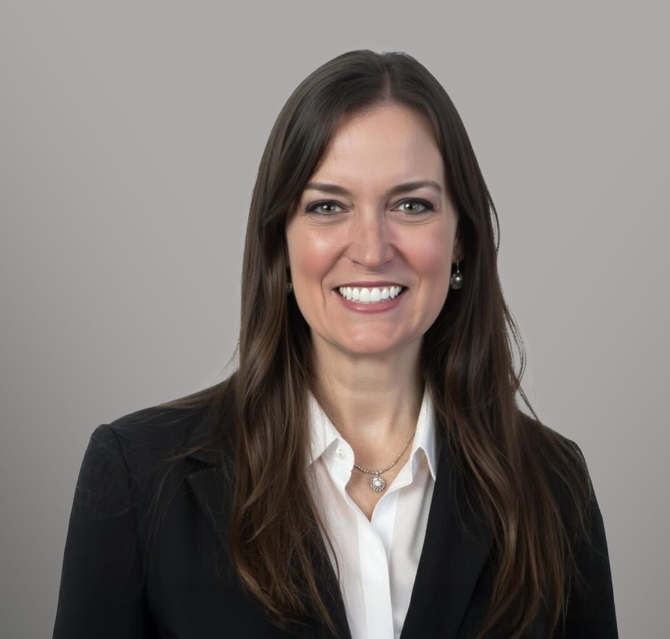

ALAINA LYNN SYLVESTER

Of Counsel

[Trusts & Estates](https://www.fennemorelaw.com/services/trusts-estates/)

[Reno](https://www.fennemorelaw.com/contact-us/reno/)

P: 775.788.2214

F: 775.786.1177

[asylvester@fennemorelaw.com](mailto:asylvester@fennemorelaw.com)

# ALAINA LYNN SYLVESTER

Alaina Sylvester is an Of Counsel attorney in Fennemore’s Trusts & Estates group. Practicing out of the firm’s Reno office, Alaina works with her clients representing them in probate matters, trust administration matters, and in the development of estate plans of varying complexity. Her work ranges from basic revocable living trusts to more advanced plans involving irrevocable structures aimed at maximizing asset protection and minimizing estate taxes. She is known for advising clients with unique asset holdings, and collaborating with a team of knowledgeable professionals to develop plans that integrate varied assets into long-term estate planning and wealth- building strategies.

Prior to joining Fennemore, Alaina honed her probate and estate planning skills as an attorney licensed in both California and Nevada focused on availing the advantages of Nevada probate and trust law to her clients. She also acted as a Trust Officer with a local trust company where she assisted clients in understanding the nuances of various trust and estate structures and ensuring compliance with trust documents and governing policies. Alaina’s well-rounded background in both legal and financial aspects of estate planning make her a trusted advisor to clients with diverse needs.

When Alaina isn’t in the office you may find her on a golf course making everyone else feel better about their golf game, hiking the beautiful Great Basin with her family, or bribing her children with cookies and chocolates down a ski slope.

# EDUCATION

LL.M. in Taxation, University of San Diego School of Law J.D., University of San Diego School of Law

B.A., University of Southern California, *cum laude*

# AREAS OF PRACTICE

Trusts & Estates Estate Planning

# AWARDS AND HONORS

Top Rank Attorney, Nevada Business Magazine, 2024

# PROFESSIONAL AND COMMUNITY AFFILIATIONS

Member, Probate Bar Association of Washoe County

# ADMISSIONS

California Nevada