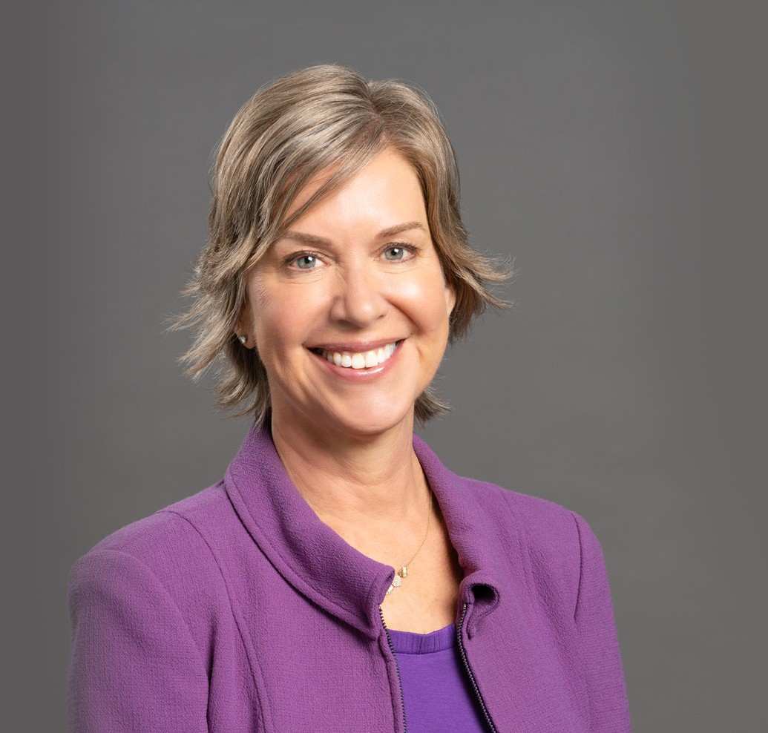

AMARA L. MORRISON

Director

[Land Use](https://www.fennemorelaw.com/services/land-use/)

[Oakland](https://www.fennemorelaw.com/contact-us/oakland/)

P: 510.834.6600 F: 510.834.1928

[amorrison@fennemorelaw.com](mailto:amorrison@fennemorelaw.com)

“

When you get the chance to sit out or dance, I hope you dance.

- Maya Angelou

**AMARA L. MORRISON**

”

Amara understands municipal law, land use, and real estate from just about every angle. With more than 25 years of experience as an assistant city attorney, she’s worked closely with mixed use, residential, commercial, industrial and hotel developers, public agencies, and individuals and community groups on everything from land use approvals and subdivisions to capital improvement projects. She has extensive experience in all aspects of land use law, including compliance with the California Environmental Quality Act (CEQA), the Permit Streamlining Act, planning and zoning law, the Subdivision Map Act and affordable housing laws, including density bonus and SB 35.

Amara is currently general counsel to various transportation agencies and Geologic Hazard Abatement Districts (GHADs). Prior to private practice, Amara served as assistant city attorney

for two Bay Area cities, where she advised officials and staff on matters including the California Public Records Act, the Ralph M. Brown Act, public finance and contracts, solid waste, risk

management and conflicts of interest, First Amendment, and redevelopment. She drafted the state’s first comprehensive no-smoking ordinance, which banned smoking in the workplace (including bars and restaurants), cigarette vending machines, and smoking in multi-family housing units, an action followed by jurisdictions around the country.

Valued by clients for her responsive, determined, pragmatic style, she was named “Woman of

Influence” by Globe Street Real Estate in 2019. Amara was also honored as one of San Francisco Business Times’ “Most Influential Women in Bay Area Business” in 2020.

Amara is proud of her lengthy service to non-profit organizations, previously as a Board Member and Secretary of Save Mount Diablo and currently as a Board Member of the Bay Planning

Coalition. She is also co-chair of the Programs Committee for the East Bay Chapter of Commercial Real Estate Women (CREW).

Amara is an avid dressage rider and hiker and proud parent of her daughter, Islay, attends Brandeis University.

# EDUCATION

J.D. and M.S.L., Vermont Law School, *magna cum laude*

B.S., University of Michigan

# AREAS OF PRACTICE

**OTHER EXPERIENCE**

Public Agency Transportation Agencies Land Use

Real Estate

Eminent Domain

Government Relations & Regulatory

# AWARDS AND HONORS

*Best Lawyers in America®,* Land Use and Zoning Law, 2025

*Northern California Super Lawyers*®, 2023

“Most Influential Women in Bay Area Business” Awards List, *San Francisco Business Times*, May 2020

Selected as a “Woman of Influence,” *GlobeSt. Real Estate Forum*, July/August 2019

AV® Preeminent™ Peer Review Rated (the highest rating available), by Martindale-Hubbell

# ARTICLES AND PRESENTATIONS

Co-Author, “[Legislative Update: California Adopts New Housing Laws](https://www.fennemorelaw.com/legislative-update-california-adopts-new-housing-laws/),” Fennemore Blog, October 16, 2024

Author, “[Fennemore attorney Amara Morrison provides update on evolving builder’s remedy](https://www.bizjournals.com/sanfrancisco/news/2024/08/01/fennemore-attorney-amara-morrison-builders-remedy.html),” San Francisco Business Times, August 1, 2024

Featured, “[Fennemore Proudly Celebrates Women’s History Month](https://www.fennemorelaw.com/fennemore-proudly-celebrates-womens-history-month/),” Fennemore Blog, March 14, 2024

Featuring, “Attorney Amara Morrison on builder’s remedy, impact of the California housing crisis on employers,” San Francisco Business Times, May 15, 2023

Speaker, “Streamlined Housing Laws and New Housing Legislation,” League of California Cities’ Planning Commissioner Academy, March 17, 2022

Speaker, “Streamlined Housing Approval with SB 35, SB 330 and New Pro-Housing Legislation,” Wendel Rosen LLP, October 20, 2021

Author, “California Supreme Court Denies Review in Berkeley Shellmound Case Paving the Way for Housing Under SB 35,” Wendel Rosen LLP, August 2021

Speaker, “Density Bonus: A Strong Development Tool Gets Stronger,” Wendel Rosen LLP, June 2, 2021

Author, “Superior Court Validates Cupertino’s Streamlined Approval of Major Affordable Housing and Office Project,” Wendel Rosen LLP, May 6, 2020

Author, “Due Process Issues Related to Remote Public Hearings,” Wendel Rosen LLP, May 2020

Speaker, “Current Topics in Planning Law – from Cannabis to the Fast Track,” American Planning Association California Chapter Northern (APACA) Webinar, November 15, 2019

Author, “Wendel Rosen Focuses on More than Just the Law,” Contra Costa Lawyer, July 2019

Speaker, “Streamlined Processing of Ministerial Projects Under SB 35,” City of Attorneys’ Spring Conference, May 2019

Speaker, “Is Your City Ready for Senate Bill 35 League of CA Cities’ Planning Commissioner Academy, March 7, 2019

Author, “California Housing Bills Impacting 2019, March 1, 2019

Speaker, “2019 Legal Updates; to Cannabis SB 35,” American Planning Association California Chapter Northern, February 23, 2019

Author, “AB 2923: BART transit-oriented housing legislation,” Daily Journal’s New Laws, January 9, 2019

Co-Author, “Slate of New Housing Bills Take Effect,” Wendel Rosen Client Update, January 3, 2018

# PROFESSIONAL AND COMMUNITY ACTIVITIES

Board Secretary, Commercial Real Estate Women (CREW) – East Bay

Co-Chair, Programs Committee, Commercial Real Estate Women (CREW) – East Bay Member, Board of Directors, Bay Planning Coalition

Chair, Government Affairs Committee, Bay Planning Coalition Member, Leadership Committee, Innovation Tri-Valley Member, Pro Visors

Immediate Past Secretary, Save Mount Diablo Member, Contra Costa Bar Association Member, Alameda County Bar Association

# ADMISSIONS

California