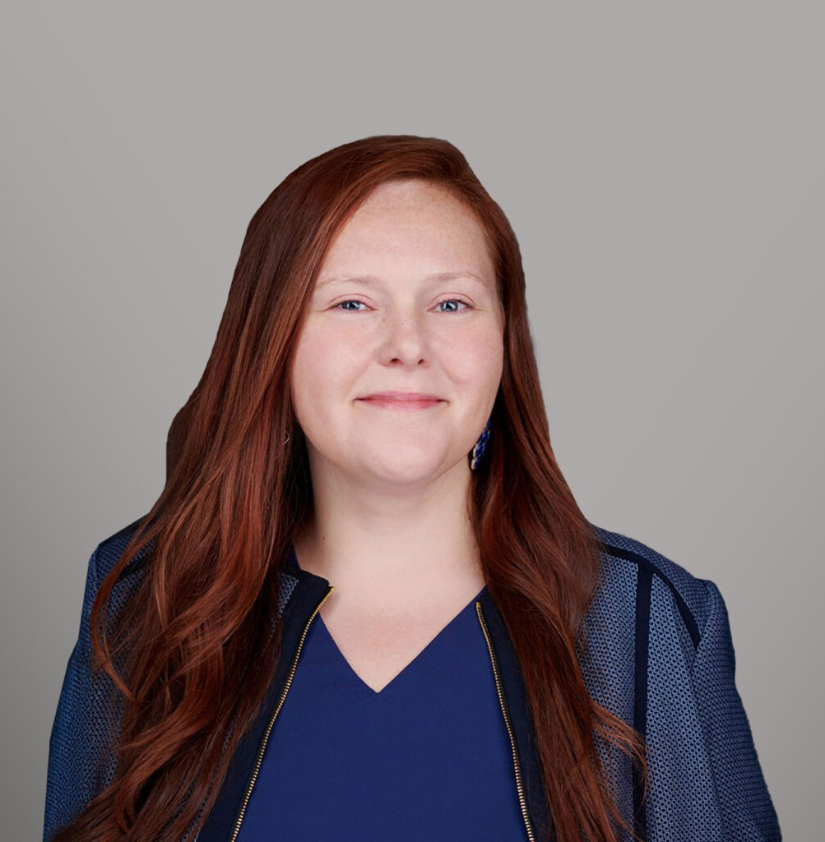

ELISE O’BRIEN

Director

[Agribusiness](https://www.fennemorelaw.com/services/agribusiness/)

[Orange County](https://www.fennemorelaw.com/contact-us/orange-county/)

P: 949.430.3417 F: 949.752.0953

[Seattle](https://www.fennemorelaw.com/contact-us/seattle/)

P: 949.430.3417 F: 949.752.0953

[eobrien@fennemorelaw.com](mailto:eobrien@fennemorelaw.com)

# ELISE O'BRIEN

Elise O’Brien is a director in our Irvine office who works in our Agribusiness and Employment Law Practice Groups. Elise has extensive experience representing employers in federal and state

court litigation involving wrongful termination, discrimination, harassment, retaliation, and wage and hour claims. She has successfully represented management in various administrative forums, including the Division of Labor Standards and Enforcement, the Civil Rights Department, the California Unemployment Insurance Appeals Board, the Equal Employment Opportunity Commission and the National Labor Relations Board.

Elise devotes a significant portion of her practice to advising employers on a broad spectrum of employment matters, including employee discipline, terminations, leaves of absence, and wage and hour issues. Elise regularly assists employers in drafting employment policies and handbooks to ensure compliance with California, Washington, and federal law.

In addition to her employment practice, Elise practices agricultural law and has over 15 years’ experience enforcing trust rights of produce sellers under the Perishable Agricultural Commodities Act (PACA) in U.S. District and Bankruptcy Courts throughout the United States, including managing complex, multi-party PACA litigation. She also represents produce companies and individuals in administrative proceedings before the PACA Branch of the U.S. Department of Agriculture.

Outside of work, Elise enjoys traveling and spending time with her husband and two young children.

Agribusiness

Employment & Labor Food & Beverage

# EDUCATION

J.D., Chapman University School of Law, *magna cum laude*

Notes Editor, Chapman Law Review Dean’s Fellow

B.S., Wright State University, *magna cum laude*

Beta Gamma Sigma

# AREAS OF PRACTICE

Agribusiness

Employment & Labor Food & Beverage

# ARTICLES AND PRESENTATIONS

Co-Author, “[A Canadian Produce Trust Law, Eh](https://mailchi.mp/fennemorelaw/fennmore-general-elections-federal-and-state-update-dont-let-it-surprise-you-15829195?e=c7a081f66a)?” Fennemore Client Alert, January 17, 2025.

Co-Author, “Unionization in the Fast Lane: NLRB’s New Rule Accelerates Union Formation,” California Lawyers Association, Business Law News, Spring 2024

Co-Author, “Two New California Non-Compete Laws Take Aim at Employers in the Golden State and Beyond,” California Lawyers Association, Business Law News, Spring 2024

Speaker, “To Arbitrate or Not to Arbitrate? That is the Question,” Western Growers Association Webinar, May 15, 2024

[Co-Author, “SCOTUS Subtly Redefines the Landscape of Workplace Religious](https://hrdailyadvisor.blr.com/2023/08/23/scotus-subtly-redefines-the-landscape-of-workplace-religious-accommodations/) [Accommodations,”](https://hrdailyadvisor.blr.com/2023/08/23/scotus-subtly-redefines-the-landscape-of-workplace-religious-accommodations/) [*HR Daily Advisor*, August 23, 2023](https://hrdailyadvisor.blr.com/2023/08/23/scotus-subtly-redefines-the-landscape-of-workplace-religious-accommodations/)

Featuring, “Pay Transparency Backlash: the Harm of Reluctant Compliance,” BioSpace, February 27, 2023

Featuring, “How Small Firms Can Trim The Burden Of Administrative Work,” Law360, November 23, 2022

[Interview, “Don’t Be Afraid To Say ‘YES’ To Opportunities That Are Outside Of Your Comfort](https://www.fennemorelaw.com/dont-be-afraid-to-say-yes-to-opportunities-that-are-outside-of-your-comfort-zone/) [Zone,” Fennemore Blog, October 21, 2022](https://www.fennemorelaw.com/dont-be-afraid-to-say-yes-to-opportunities-that-are-outside-of-your-comfort-zone/)

# PROFESSIONAL AND COMMUNITY ACTIVITIES

Member, State Bar of California Member, State Bar of Washington

Past Chair of the Agribusiness Committee, Business Law Section, California Lawyers Association

Past Vice-Chair of Programs of the Agribusiness Committee, Business Law Section, California Lawyers Association

Member, Orange County Bar Association Member, King County Bar Association

# ADMISSIONS

California Washington

U.S. District Court, Northern District of California

U.S. District Court, Eastern District of California

U.S. District Court, Central District of California

U.S. District Court, Southern District of California

U.S. District Court, Western District of Washington

U.S. District Court, Eastern District of Washington