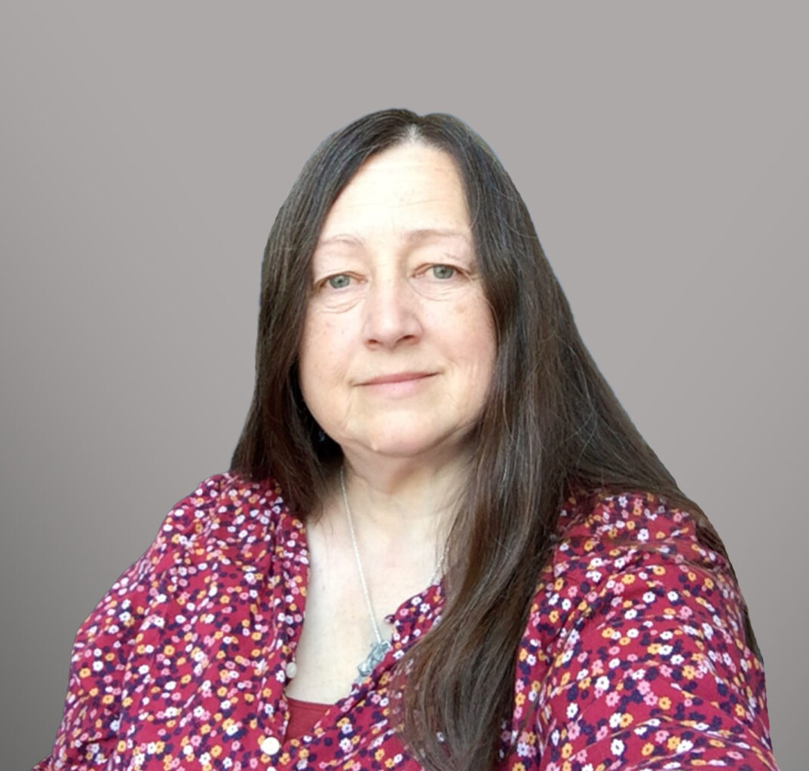

REBECCA LOGSDON

Paralegal

[Intellectual Property](https://www.fennemorelaw.com/services/intellectual-property-and-ip-litigation/)

[Oakland](https://www.fennemorelaw.com/contact-us/oakland/)

P: 510.622.7603

[rlogsdon@fennemorelaw.com](mailto:rlogsdon@fennemorelaw.com)

“

Be the change you wish to see in the world

Mahatma Gandhi

**REBECCA LOGSDON**

”

Rebecca Logsdon is an Intellectual Property paralegal where her work is focused on domestic and international trademark applications, prosecution, registration, and maintenance, as well as trademark searches and research. She is also a member of our Food and Beverage practice, and has experience in regulatory and labeling issues in the food, beverage, dietary supplement, and cosmetic fields.

She also handles filings concerning Underwritten Title Company licenses as well as other California Department of Insurance matters; and California Prop 65 issues. She has also worked on real estate issues and reviewed commercial leases. In particular, she enjoys long, complicated projects, which may take months to complete.

Initially, Rebecca intended to become an attorney (after many people telling her that’s what she should do); however, after a couple of years of law school, she decided that while she enjoyed working with attorneys, she didn’t actually want to be one. After law school, becoming a Paralegal was the natural evolution of her legal career. Rebecca takes great satisfaction in getting the Certificate of Registration (trademark) for a client, particularly if the registration process has been difficult. She also enjoys getting the huge application wrapped up and filed, as well as finding the “golden nugget” in the mountain of research (or, finding the key that makes sense of the research). She relishes knowing that her attorneys and clients appreciate her work.

Outside of work, you’ll find Rebecca caring for her dogs and training them for competition in performance events (agility, obedience, rally). She is also on the Board for a couple of dog Clubs. Rebecca also likes to cook, bake, garden, read, and enjoy the natural world.

Intellectual Property

Food & Beverage

# EDUCATION

B.A.*,* California State University, San Francisco Humboldt, *magna cum laude and Phi Beta Kappa*

# AREAS OF PRACTICE

Intellectual Property Food & Beverage

# PROFESSIONAL AND COMMUNITY ACTIVITIES

President, San Lorenzo Dog Training Club

Secretary, Shetland Sheepdog Club of Northern California

# ADMISSIONS

*\*Not licensed to the practice of law*