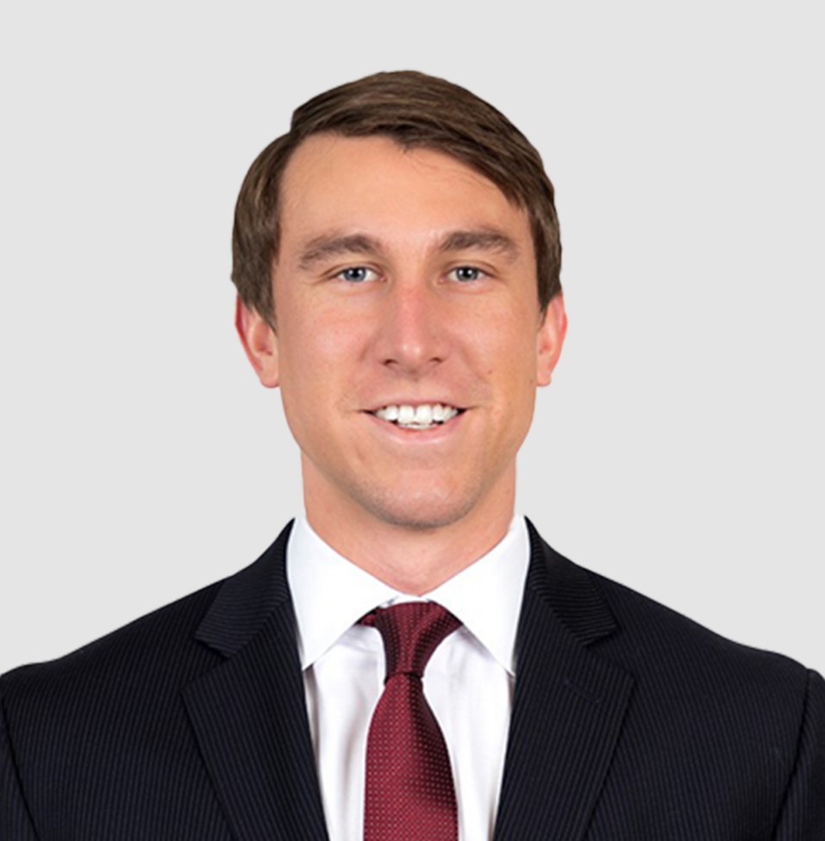

CODY C. BOURKE

Director

[Business Litigation](https://www.fennemorelaw.com/services/business-litigation/)

[Denver](https://www.fennemorelaw.com/contact-us/denver-2/)

P: 303.764.3710

F: 303.291.3201

[Basalt](https://www.fennemorelaw.com/contact-us/basalt/)

P: 970.431.9060

F: 303.291.3201

[cbourke@fennemorelaw.com](mailto:cbourke@fennemorelaw.com)

# CODY C. BOURKE

Cody has a long track record of success representing businesses in litigation matters in the courtroom and through advantageous settlements, focusing on a wide range of complex commercial litigation. He represents clients from a broad range of industries including food and beverage, real estate, construction, and oil and gas – in both state and federal courts across the United States. Cody has experience in disputes involving contracts, construction defects, mechanic’s liens, quiet title, commercial leases, oil and gas class actions, product liability, and corporate governance and shareholder issues.

Cody enjoys advising clients on implementing litigation avoidance and risk reduction strategies

to resolve issues before they need to be addressed in the courtroom. In working with clients in an outside general counsel role, it allows him to understand the client’s business needs and goals to develop a long-term relationship. He is particularly adept in negotiations with contractors and service providers to resolve disputes favorable for the client without litigation. Cody is also the Vice Office Managing Partner of Fennemore’s Denver office.

Cody also regularly represents clients in regulatory adversary proceedings, hearings and rulemakings before the Colorado Oil and Gas Conservation Commission and the Colorado Department of Public Health and Environment.

In his spare time, Cody likes to spend time with his daughter in the mountains or at her swim meets. Cody seeks out any competitive or outdoor activity, whether that be participating in

basketball and sand volleyball leagues or hiking Colorado’s Fourteeners, 58 peeks above 14,000 feet of elevation.

# EDUCATION

J.D., University of Denver, Sturm College of Law Order of St. Ives (Top 10%)

Scholastic Excellence Awards: Torts, Property

B.A., University of Nebraska-Lincoln, with distinction

# AREAS OF PRACTICE

Business Litigation Natural Resources Food & Beverage

# REPRESENTATIVE CASES

As lead counsel, successfully defended global dairy company in high value premises liability dispute by prevailing on summary judgment under theory that company was a statutory- employer immune from tort liability

Successfully argued and prevailed before the Colorado Court of Appeals that oil and gas lease automatically expired a decade prior and was not properly released by lessee and obtained an award of client’s fees and costs under lease forfeiture statute

Substantially prevailed for client in arbitration involving a dispute with post-closing adjustments made following title due diligence period

Represented operator and franchiser of national restaurants and breweries group in commercial lease disputes, construction disputes, and pre-litigation risk reduction strategies across the United States

Represent and advise private investment company specializing in oil and gas acquisitions with broad range of quiet title and ownership disputes

Defended oil and gas companies in numerous statewide class action royalty disputes in Colorado and Oklahoma

Represented trade association for the home building industry and various oil and gas companies in rulemakings before the Colorado Oil and Gas Conservation Commission related to forced pooling, flowlines and the enactment of Senate Bill 19-181

Acted as lead counsel in representation of real estate developer in lawsuits involving multimillion-dollar construction defects and delays in Colorado and Texas

Defended real estate developer against mechanic’s lien foreclosure and breach of contract claims brought by general contractors and subcontractors

Represented limited liability company and members asserting individual and derivative claims in an action against other members for breach of contract, breach of fiduciary duty, conversion and civil conspiracy

Defended oil and gas companies against claims by surface owners, including claims for alleged ground water contamination and conflicts with current and planned surface operations

Defended midstream oil and gas company in arbitration in connection with claims for breach of natural gas purchase contract

Defended manufacturer of ladders in product liability lawsuits

# AWARDS AND HONORS

*The Best Lawyers in America*®, Ones to Watch, Commercial Litigation, Real Estate Litigation, Oil and Gas Law, 2021-2025

*Colorado Super Lawyers*®, Business Litigation, 2025

*Colorado Super Lawyers*®, Rising Stars Edition, Business Litigation, 2021-2022

# ARTICLES AND PRESENTATIONS

Criminal and Enforcement Litigation,” Co-Author, ABA 2018 Edition: Recent Developments in Business & Corporate Litigation (April 2018)

“[Colorado Supreme Court Holds Privity Necessary for Homeowner to Sue Developer](https://information.swlaw.com/REACTION/2017/Newsletters/UnderConstruction/0602_UC_WEB.html),” Co- Author, Snell & Wilmer Under Construction Newsletter (June 2017)

“[The Foreign Corrupt Practices Act’s One-Year “Pilot Program” Nears the Halfway Mark](http://www.swlaw.com/blog/white-collar-defense/2016/09/09/the-foreign-corrupt-practices-acts-one-year-pilot-program-nears-the-halfway-mark/),” Co- Author, Snell & Wilmer White Collar Defense, Investigations and Compliance Blog (September 9, 2016)

“EPA Looks to Follow Colorado’s Lead on Regulating Methane Emissions in the Oil and Gas Industry,” Author, Snell & Wilmer Environmental, Natural Resources, Oil and Gas Law Blog (October 15, 2015)

# PROFESSIONAL AND COMMUNITY ACTIVITIES

Colorado Bar Association Young Lawyers Division

Denver Bar Association

Natural Resources and Energy Law Section Rhone-Brackett Inn of Court

Colorado Petroleum Association

Colorado Association of Home Builders

Metro Volunteer Lawyers (Present)

Rocky Mountain Immigrant Advocacy Network (RMIAN) Volunteer Attorney (2016-present)

University of Denver Sturm College of Law Professional Mentoring Program (2016-present)

Impact Denver Leadership Program

Denver Metro Chamber of Commerce (2019)

Colorado Poverty Law Clinic Volunteer Attorney (2016-2018)

# ADMISSIONS

Colorado

Supreme Court of Colorado

United States District Court, District of Colorado