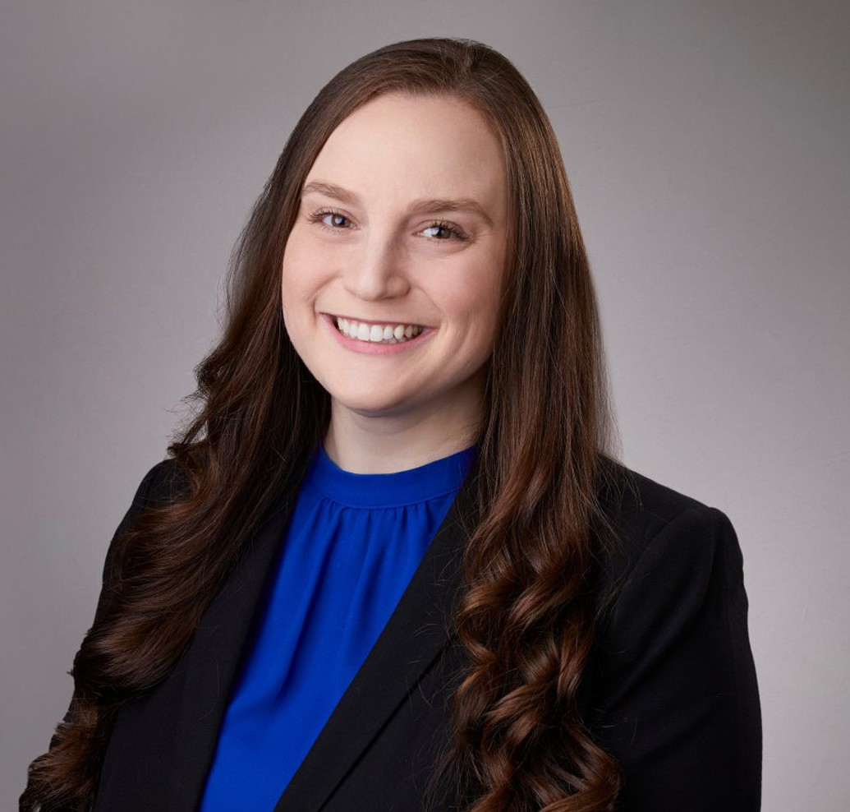

RACHEL J. GREENBERG

Associate

[Business & Finance](https://www.fennemorelaw.com/services/business-and-finance/)

[San Bernardino](https://www.fennemorelaw.com/contact-us/san-bernardino/)

P: 909.890.4499

F: 909.890.9877

[rgreenberg@fennemorelaw.com](mailto:rgreenberg@fennemorelaw.com)

“

You are braver than you believe, stronger than you seem, and smarter than

you think.

- Winnie-the-Pooh by A.A. Milne

”

# RACHEL J. GREENBERG

Rachel Greenberg is an associate attorney who works out of our San Bernardino office. Her practice focuses on the intersection of tax law and business; she helps her clients with a broad range of services related to general corporate matters, as well as tax law and planning. Rachel’s goal is to help clients align their tax and business strategies in an effort to increase their operational efficiencies. In addition, Rachel will often assist attorneys with tax questions that arise in our Real Estate and Trust & Estates groups.

Rachel received her Bachelor’s degree in Economics from the University of California, Los

Angeles. After graduating from Chapman University’s School of Law, where she was Editor-in- Chief of the Chapman Law Review and a member of the Mock Trial Board, Rachel began her career working for PricewaterhouseCoopers in their International Tax Services practice.

Outside of work, Rachel enjoys travel and spending time with her family. She is involved in several local bar associations and is a volunteer “wish granter” for Make-A-Wish Orange County and the Inland Empire.

# EDUCATION

J.D., Business Emphasis, Chapman University, Dale E. Fowler School of Law B.A., Economics, University of California, Los Angeles

# AREAS OF PRACTICE

**OTHER EXPERIENCE**

Corporate Governance Business & Finance

Real Estate Tax Law

Trusts & Estates Estate Planning

# PROFESSIONAL AND COMMUNITY ACTIVITIES

Member, Orange County Bar Association Member, UCLA Alumni Association

Alumni, Delta Delta Delta Fraternity

# ADMISSIONS

California