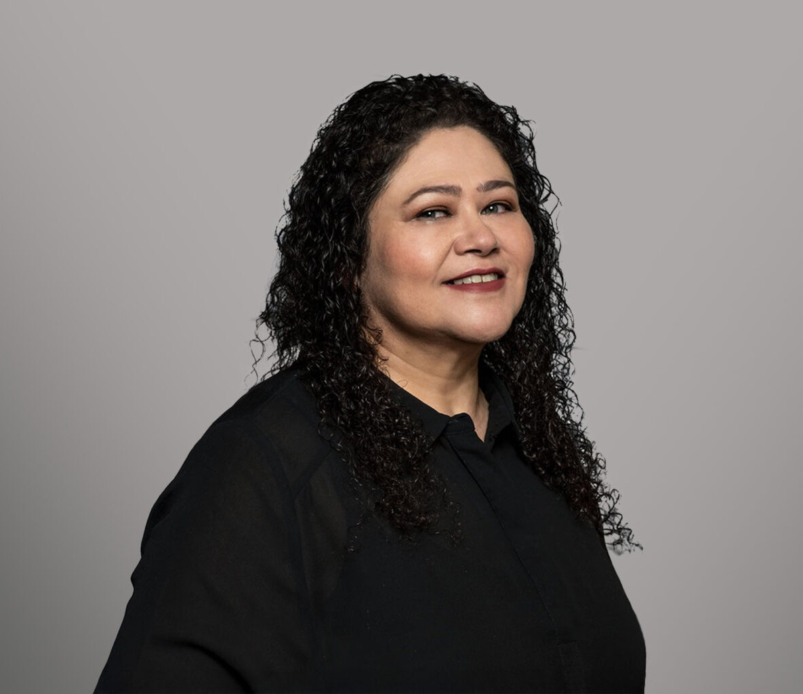

RITA S. BELL

Paralegal

[Business Litigation](https://www.fennemorelaw.com/services/business-litigation/)

[Fresno](https://www.fennemorelaw.com/contact-us/fresno/)

P: 559.432.4500 F: 559.432.4590

[rbell@fennemorelaw.com](mailto:rbell@fennemorelaw.com)

“

I've always believed you can think positive just as well as you can think negative.

James Baldwin

”

**RITA S. BELL**

Rita Bell is a paralegal in our business litigation practice group known for her reliability and experience – and for sharing a good laugh with her teammates. She attended Los Angeles Mission College.

Early in her career, Rita worked for an inspiring County Counsel who encouraged her to go back to school and seek a promotion, which led to the path she is on today as a paralegal. Rita has gained experience in labor and employment, transactional, intellectual property, and litigation areas of practice over the last 24 years. Since 2021, she has worked exclusively in business

litigation, focusing on working up the case and assisting with trial. Rita particularly enjoys the trial preparation phase, and being part of a team working toward a successful conclusion for each client. Rita is known for her initiative and strong attention to detail, even while handling several cases at a time.

To unwind, Rita is an avid reader and enjoys evening walks through her downtown Fresno neighborhood with her husband. She gives back to her local community by volunteering with non-profit community groups Fresno Filmworks, Fresno Center for Nonviolence, and Earth Day Fresno.

# EDUCATION

Los Angeles Mission College

# AREAS OF PRACTICE

Business Litigation Intellectual Property

Natural Resources

# PROFESSIONAL AND COMMUNITY ACTIVITIES

President, Fresno Center for Nonviolence Board member, Fresno Filmworks Volunteer, Earth Day Fresno

# ADMISSIONS

*\*Not licensed to the practice of law*