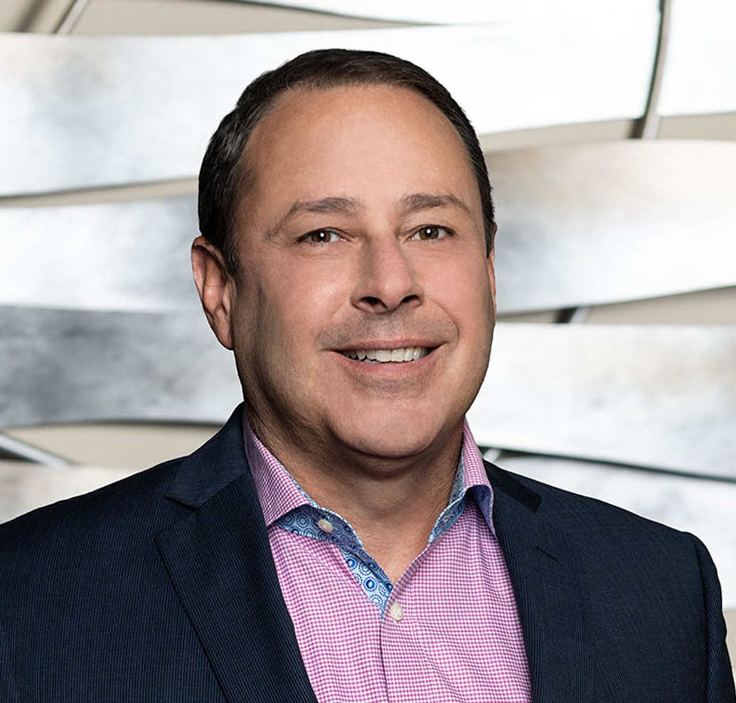

ROBERT D. TOOKOIAN

Of Counsel

[Business & Finance](https://www.fennemorelaw.com/services/business-and-finance/)

[Fresno](https://www.fennemorelaw.com/contact-us/fresno/)

P: 559.432.4500

F: 559.432.4590

[rtookoian@fennemorelaw.com](mailto:rtookoian@fennemorelaw.com)

# ROBERT D. TOOKOIAN

Rob represents a broad range of clients in general business, transactions, contracts, healthcare law, privacy compliance, and real estate transactions. His diverse and extensive legal and business background allows Rob to counsel business owners and management providing

practical, business-oriented solutions to complex legal problems. His clients include such varied industries and service groups as healthcare providers, government entities, and food processors, as well as agribusiness, technology, and health benefit companies.

Rob began practice in the San Francisco Bay Area as counsel and General Counsel to internet and “high-tech” companies. He has been in-house counsel for start-ups, early-stage, and public companies, working on complex service and licensing agreements, compliance, real property

transactions, IP, and corporate governance, among other services.

Rob has spent the last 20-plus years working with small and midsize organizations to provide

strategic guidance on growth and transactions, as well as complex litigation, compliance, and public entity defense. In his healthcare practice, Rob assists clients with formation, contract negotiation and preparation, growth strategies, employment matters, regulatory and contractual compliance, and risk mitigation. Rob regularly counsels his clients about HIPAA,

Stark, Anti-kickback, CCPA, and other compliance matters.

Rob is also the Co-Chief Privacy Officer at Fennemore. Outside of work, Rob and his wife stay busy keeping up with young adult children living in three different states. He keeps active by

skiing, hiking, golfing and playing and coaching rugby. Rob grew up in Fresno and has served on the boards of several local non-profit organizations, including The United Way of Fresno County (Secretary), Charlie Keyan Armenian Community School, and CenCal Youth Sports (Chair).

# EDUCATION

J.D., Golden Gate University School of Law

M.B.A., Golden Gate University, Ageno School of Business

B.S., Political Economy of Natural Resources, University of California, Berkeley B.A., History, University of California, Berkeley

# AREAS OF PRACTICE

**OTHER EXPERIENCE**

Commercial Transactions Privacy

Real Property Technology Business & Finance

Employment & Labor Health Care

Privacy & Data Security Mergers & Acquisitions

# ARTICLES AND PRESENTATIONS

Co-Editor, California Lawyers Association Privacy Section Journal, 2024 and 2025

Author, “[Privacy and Data Security Trends: Ensuring Compliance in the State of California in](https://www.fennemorelaw.com/privacy-and-data-security-trends-ensuring-compliance-in-the-state-of-california-in-2024/) [2024](https://www.fennemorelaw.com/privacy-and-data-security-trends-ensuring-compliance-in-the-state-of-california-in-2024/),” Fennemore Blog, January 23, 2024

[Author, “California Attorney General Signals Enforcement of CCPA Regulations on HR Data](https://mailchi.mp/fennemorelaw/power-of-attorney-irs-filling-change?e=6383ff8993) [Following Temporary Exemption’s End,” Fennemore Blog, July 27, 2023](https://mailchi.mp/fennemorelaw/power-of-attorney-irs-filling-change?e=6383ff8993)

[Author, “California Attorney General Signals Enforcement of CCPA Regulations on HR Data,](https://mailchi.mp/fennemorelaw/power-of-attorney-irs-filling-change?e=6383ff8993) [Following Temporary Exemption’s End,” Fennemore Client Alert, July 27, 2023](https://mailchi.mp/fennemorelaw/power-of-attorney-irs-filling-change?e=6383ff8993)

Presenter, “Privacy Law for Fennemore Lawyers: What you need to know,” May 19, 2023

[Interview, “A Conversation With Attorney Rob Tookoian On Lessons Learned and Life In The](https://www.fennemorelaw.com/staying-focused-on-the-things-in-life-that-really-matter-family-community-and-personal-integrity/) [Legal Profession,” Fennemore Blog, March 24, 2022](https://www.fennemorelaw.com/staying-focused-on-the-things-in-life-that-really-matter-family-community-and-personal-integrity/)

Panelist, “Understanding Data, Decision making, and Design,” CPRA Law + Tech Series

Interview, “Pharma Group Sues Government to Keep Drug Prices Secret,” Verywell Health, October 20, 2021

[Author, “Providers Beware: The Office For Civil Rights is Making an Example of Providers That](https://www.fennemorelaw.com/insights/newsletters/2021/providers-beware-the-office-for-civil-rights-is-making-an-example-of-providers-that-fail-to-deliver-patient-records) [Fail to Deliver Patient Records,” Fennemore Client Alert, February 2, 2021](https://www.fennemorelaw.com/insights/newsletters/2021/providers-beware-the-office-for-civil-rights-is-making-an-example-of-providers-that-fail-to-deliver-patient-records)

[Author, “SCOTUS Brings the Hammer Down on Pharmacy Benefit Managers,” Fennemore](https://www.fennemorelaw.com/insights/newsletters/2020/scotus-brings-the-hammer-down-on-pharmacy-benefit-managers) [Client Alert, December 17, 2020](https://www.fennemorelaw.com/insights/newsletters/2020/scotus-brings-the-hammer-down-on-pharmacy-benefit-managers)

Presenter, “California Consumer Privacy Act’s Application to Employers” Presenter, “Handling Contract Performance Issues During COVID”

Author, “Coronavirus Aid Relief and Economic Security CARES Act Overview”

Author, “A Brief Overview of the Paycheck Protection Program, a 100% Forgivable Loan” Author, “Franchises, Hotels and Restaurants, Oh My: PPP Progress”

Author, “SBA Warns Borrowers to Double Check That They Qualify for a PPP Loan” Author, “SBA Clarifies Effect of Laid-off Employees in Calculating PPP Loan Forgiveness”

Author, “SBA Provides Safe Harbor Guidance for Some PPP Loan Recipients” Author, “SBA Publishes PPP Loan Forgiveness Application and Some Clarifications”

# PROFESSIONAL AND COMMUNITY ACTIVITIES

Member, International Association of Privacy Professionals Member, Fresno County Bar Association

Member, Executive Committee, Privacy Law Section of the California Lawyers Association Member, State Bar of California

Member, California Society for Healthcare Attorneys Member, American Health Law Association

Board Member, Cal Alumni of Central California Board Member, CenCal Youth Sports

# ADMISSIONS

California

U.S. District Court, Central District of California

U.S. District Court, Eastern District of California

U.S. District Court, Northern District of California